Data Collection with a PC-II Name:______________________________
Partner(s):________________________________________________Day/Time:______

- Introduction
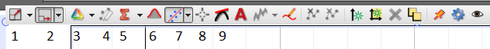
Menu | Description
1
4
6
7
8
9
- Acceleration due to gravity
Flag Spacing on the picket fence = _______________
Write down the kinematic equations below:
v vs. t:______________________ x vs. t:_________________________
Trial | Measured Acceleration due to gravity |  |  | Accepted (m/s²) | % Error
 | v vs. t  (linear fit) | x vs. t  (Quadratic fit) | Average
1. |  |  |  | 9.8
2. |  |  |  | 9.8
3. |  |  |  | 9.8
4. |  |  |  | 9.8
5. With 50-g mass

C. Newton’s Second Law
Purpose: Verify Newton’s second law using Atwood’s Machine.
Apparatus: PC, interface, photogate sensor (head, rod, cable, and pulley), two mass sets, string, and lab stand.
Theory: Newton’s second law is: Net Force = Mass X Acceleration.
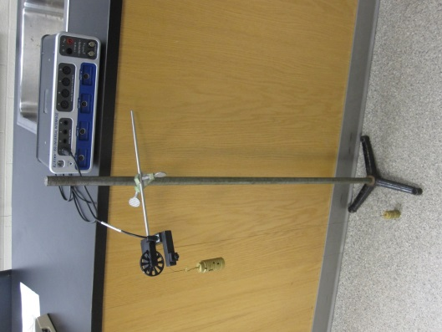
Keeping the total mass = M = m₁+ m₂ constant, measure the acceleration as you change the net force (m₁-m₂)g. Collect 8 sets of data, tabulate your data, and plot an appropriate graph to verify Newton’s second law.
m₁ (gram) | m₂ (gram) | m₁ ₊ m₂ (gram) | m₁-m₂ (gram) | a (m/s²)

