**Data Collection with a PC** Name:_____________________________  
  
Partner(s):_______________________________________________________________  
 **A. Pre-lab:**

For the Atwood Machine experiment shown in the video, calculate the acceleration using,  
a. Kinematic Equations b. Newton’s second law, and turn in your work, during pre-lab.   
<http://www.youtube.com/watch?v=4ovhEkSIqV0>

**B. Introduction:** PASCO’s 850 interface and Capstone software.   
Pasco Capstone display menu descriptions:



1. Maximize graph (Scale axes to show all active data)
2. Automatically scale axes during data collection.
3. Select visible runs.
4. Select ranges of data (for example during curve fitting).
5. Statistics.
6. Display area under active data
7. Curve fitting.
8. Show coordinates tool.
9. Determining slope.
10. Annotation.
11. Add new Y-axis.
12. Add new plot area.
13. Remove data.

**C. MOTION:**   
  
Purpose: To analyze the motion of a cart down an inclined track using a motion sensor.

Apparatus: PC, Interface, Motion Sensor, Dynamics Track w/End Stop, Collision Cart, Brass Weight, blocks of mass for the cart, and Wooden Block.

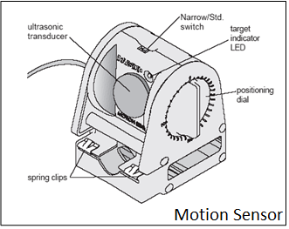

Procedure:

1. Look at the motion sensor and identify the smallest distance it can detect.
2. Incline the Dynamics Track using the Wooden Block and attach the Motion Sensor at the 0-cm end.
3. Place the Collision Cart so that the front of the cart is about 20-cm from the motion sensor and use the Brass Weight to hold the cart in place.
4. Connect the motion sensor to the interface (yellow-1, black-2), set the beam to narrow, and make the detection-surface perpendicular to the track.
5. Open PASCO Capstone software from the desktop.
6. Click Hardware Setup under Tools on the left, click on the interface input where the sensor is connected, and select Motion Sensor. Click Hardware Setup again to close it.
7. Double-Click Graph under Displays on the right, click Select Measurement on the Y-axis, and choose Position.
8. Click Record, and after a while remove the Brass Weight in order for the cart to roll down and collide with the End Stop.
9. Stop the data collection, have your data checked by the instructor, and complete the data sheet.
10. Velocity and acceleration data can be obtained by clicking on position and selecting velocity and acceleration, respectively.

**DATA for MOTION:**

Smallest distance the motion sensor can detect = ______________

|  |  |  |  |  |
| --- | --- | --- | --- | --- |
|  | Using *x* vs. *t* Graph | Using *v* vs. *t* Graph | Using *a* vs. *t* Graph | % Difference |
| Describe  the  Graph |  |  |  | XXXXXX XXXXXX XXXXXX XXXXXX |
| Initial/resting position |  | XXXXXX XXXXXX XXXXXX | XXXXXX XXXXXX XXXXXX | XXXXXX XXXXXX XXXXXX |
| Final position |  | XXXXXX XXXXXX XXXXXX | XXXXXX XXXXXX XXXXXX | XXXXXX XXXXXX XXXXXX |
| Distance Travelled |  |  | XXXXXX XXXXXX XXXXXX |  |
| Initial Velocity |  |  | XXXXXX XXXXXX XXXXXX |  |
| Final Velocity |  |  | XXXXXX XXXXXX XXXXXX |  |
| Acceleration | XXXXXX XXXXXX XXXXXX |  | *1 |  |

*1. Do this before reading the acceleration: Click the Show Coordinates button, right-click the y-coordinate, and select Tool Properties, and change the significant figure to 4.

Predictions: (Use Velocity Data Source for checking your predictions)

a. What will happen to the acceleration down the track, when the mass of the cart is increased?____________________ Check your prediction________________________

b. What will happen to the acceleration down the track, when the angle of inclination is increased?_____________________ Check your prediction__________________________  
  
c. Explain your observation.

**D. Acceleration due to gravity:**

Purpose: Determine the acceleration due to gravity.

Apparatus: PC, interface (Pasco 850), photogate sensor (head, rod, and cable), stand, soft box, and picket fence.

1. Measure and record the Flag Spacing on the picket fence.
2. Make sure that the Pasco 850 interface is connected to the PC and it is turned on.
3. Assemble the photogate, plug it in to DIGITAL INPUT 1, and attach the rod to a lab stand so that the head is horizontal.

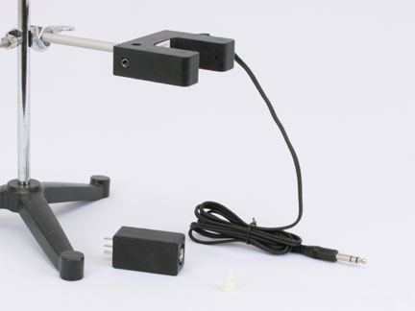

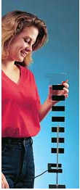

1. Open PASCO Capstone software from the desktop.
2. Click Hardware Setup under Tools on the left, click on the interface input where the sensor is connected, and select Photogate.
3. Click Timer Setup under Tools, click Next (with Pre-Configured Timer), click Next (with Photogate Ch1), click the drop-down-menu for Select a Timer, and select Picket Fence. Click Next (with Speed and Position checked), click Next (with Flag Spacing of 0.05 m), and click Finish. Click Timer Setup again to close it.
4. Double-Click Graph under Displays on the right, click Select Measurement on the Y-axis, and choose speed.
5. Click Record in the bottom, and drop the picket fence through the photogate, onto something soft on the ground.
6. Stop the data collection.
7. Re-scale the graph, by clicking the Scale Axis button, the first on top of the graph,   
   so that your graph takes up most of the space.
8. From the Speed (or Velocity) VS. Time graph, obtain the acceleration due to gravity   
   by curve fitting the Speed/Velocity VS. Time data.
9. Click Speed, select the position, and obtain the acceleration due to gravity   
   by curve fitting the Position VS. Time data.
10. Complete the data table for acceleration due to gravity in the data sheet.

**DATA:**

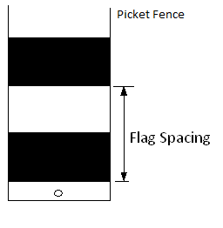  
Flag Spacing on the picket fence = _______________



Write down the kinematic equations below:  
  
*v* vs. *t*:______________________ *x* vs. *t*:_________________________

|  |  |  |  |  |  |
| --- | --- | --- | --- | --- | --- |
| Trial | Measured Acceleration due to gravity | | | Accepted (m/s2) | % Error |
| *v* vs. *t* | *x* vs. *t* | Average |
| 1. |  |  |  | 9.8 |  |
| 2. |  |  |  | 9.8 |  |
| 3. |  |  |  | 9.8 |  |
| 4. |  |  |  | 9.8 |  |

Prediction: What will happen to the acceleration, when the mass of the picket fence is increased?____________________ Check your prediction________________________

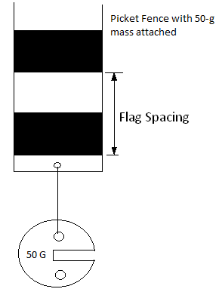

Conclusion:

E. Newton’s Second Law

Purpose: Verify Newton’s second law using Atwood’s Machine.

Apparatus: PC, interface, photogate sensor (head, rod, cable, and pulley), two mass sets, string, and lab stand.

Theory: Newton’s second law is: Net Force = Mass X Acceleration.

Procedure (Experimental Set-Up):

1)               Assemble the photogate with the pulley (Atwood's machine), plug it in to digital input 1 on the Interface, and attach the rod to a lab stand so that the head is horizontal.



2)               Cut a piece of string approximately a meter long. Place the string into the groove of the pulley.

3)               Tie the two mass sets (m1 and m2) to the ends of the string, as shown below.



4) Setting up the Interface:   
a. Make sure that the power for the interface is turned on.  
b. Open **PASCO Capstone** software from the desktop.   
c. Click **File** (top-left corner), click **Open Experiment**, click the drop-down menu for **Files of type**, and choose **DataStudio 1.9 files**, open **P10_Atwood’s.ds** from desktop, and OK **USB 850 interface.**d. Open the Velocity VS. Time graph, by clicking on the velocity graph tab.

5)               Now, pull the m1 mass up and hold it there to keep it from moving down.

6)           Click "Record" and release the M1 mass. Stop recording data after M1 reaches the table.

7)           Determine the experimental acceleration by finding the slope for the linear portion of the Velocity VS Time graph.

8)           Repeat steps 5-8 for the following two cases.

c) Data Collection & Analysis

Case I: Keeping the total mass = M = m1+ m2 constant, measure the acceleration as you change the net force. Collect 8 sets of data, tabulate your data, and plot an appropriate graph to verify Newton’s second law.

Case II: Keeping the net force constant, measure the acceleration as you change the total mass. Collect 8 sets of data, tabulate your data, and plot an appropriate graph to verify Newton’s second law.

d) Write a conclusion for E.