Name:____________________________Date:__________Time:_________
Partner(s):____________________________________________________
Kinetic Friction
Purpose: To study the laws of friction and to determine the coefficient of kinetic friction (µ_{k}) between two surfaces.
Activity I: Wood block moving at constant velocity on lab-table top.
Apparatus: pulley, supporting rod, pulley clamp, wood block, mass set, mass hanger (5g), string, and balance.
Theory:
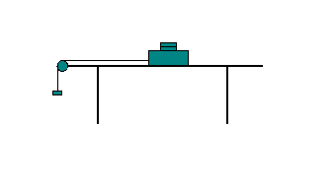
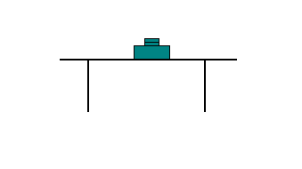

In the above diagram, a wood block of total mass, M (M = M_{b} + M_{t,} where M_{b} is the mass of the block and M_{t} is the mass on top) is placed on the laboratory table. Draw a free-body-diagram for the mass, M.
Now, a string is attached to the wood block and it is passed over a pulley and a hanging mass, m is hanged as shown above. Draw a free-body-diagram for the mass, M and the hanging mass, m.
Write the equation for kinetic friction and describe below how you will determine the coefficient of kinetic friction, µ_{k}. Need to collect multiple (at least 8) sets of data and get the value of µ_{k} from a graph.
Procedure:
1) Attach the pulley clamp at the side-end of the lab table.
2) Thread in the pulley to the supporting rod and attach it to the pulley clamp.
3) Find the mass of the wooden block and place it on the lab table. Make sure that the surfaces of both the wood block and the lab-table are clean. Wipe them off with a paper wipe if necessary. Do not touch the surfaces with your hands.
4) Place a 50 gram mass on top of the wooden block and attach one end of the string to the wooden block.
5) Run the other end of the string over the pulley and attach it to the mass hanger. Make sure the string is parallel to the lab-table's surface.
Q: Why is it necessary that the string is parallel to the surface of the lab-table?
________________________________________________________________
6) Determine the least amount of mass, m, necessary to slide the block with a constant speed after it has been started with a very small push. Record the value of m in data table I.
Q: Why is it necessary to find the least amount of mass, m that will make the block to move?
________________________________________________________________
7) Repeat procedure-6 for other masses on top of the block and complete table I.
8) Plot a graph and determine the value of µ_{k}. Attach a copy of your data table and graph to the report.
9) List the value of µ_{k} here___________ and in the conclusion.
Sample DATA TABLE I Mass of the wooden block, M_{b} = ---------
M_{t} (g) | M = M_{b} + M_{t} | m

Activity II: Wood block accelerating on wood plank.
Apparatus: PC, interface, photogate, cord, pulley, supporting rod, pulley clamp, wood block, wood plank, mass set, 5-g mass hanger , string, and balance.
Theory:
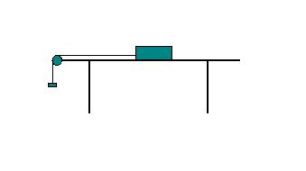
Now we will hang the mass so that the pulling force is greater than the frictional force, and hence the block will accelerate.
Show all the forces acting on the block, and the acceleration in the diagram above and derive an expression for µ_{k} in terms of m- hanging mass, M- total block mass, a- acceleration of the block-mass system, and g- acceleration due to gravity below.

Procedure:
1) Place the wood plank on the corner of the lab table and clamp it with the pulley clamp.
2) Find the mass of the wood block and place it on the far end of the plank. Make sure that the surfaces of both the wood block and the plank are clean. Wipe them off with a paper wipe if necessary. Do not touch the surfaces with your hands.
Mass of the wood block = M = ____________
3) Place the photogate in the supporting rod and thread in the pulley. Attach the cord and then attach the rod to the pulley clamp.
4) Attach one end of the string to the wooden block and run the other end of the string over the pulley and attach it to the mass hanger. Adjust the height of the pulley until the string is parallel to the plank's surface.
5) Connect the Photogate/Pulley system to digital channel one on the Interface.
6) Open PASCO Capstone software from the desktop.
7) Click Hardware Setup under Tools on the left, click on the interface input where the sensor is connected, and select Photogate with Pulley. Click Hardware Setup again to close it.
8) Double-Click Graph under Displays on the right, click Select Measurement on the Y-axis, and choose Linear Speed.
9) Click on the Record button, add a 100-g mass to the hanger (total hanging mass = m= 105-g) which will make the block to move. Click on the Stop button after the block reaches the pulley.
10) Determine the experimental acceleration, a. (The slope of the linear portion of the Linear Speed vs. time, plot). Tabulate your data in Excel, and calculate the coefficient of kinetic friction to two significant figures.
11) Repeat steps 9-10 for total hanging masses, 115 g, 125 g, 135 g, 145 g, and 155 g.
12) After attaching the graph from activity I and data table from activity II, write a conclusion.

