VECTORS Name:_______________________________
Partners:____________________________________ Course:________________

Addition | Resultant Vector |  | Force Table Check
 | From website:  http://www.1728.org/vectors.htm | Analytical method
50 g @ 20⁰  150 g @ 150⁰  200 g @ 250⁰ | F_{R}=  θ_{R} = | F_{R}=  θ_{R} =  θ_{E} = | ________

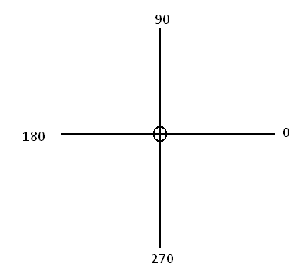

Addition | Resultant Vector |  | Force Table Check
 | From website | Analytical method
50 g @ 0⁰  and  100 g @ 90⁰ | F_{R}=  θ_{R} = | F_{R}=  θ_{R}=  θ_{E}= | ________
50 g @ 20⁰  and  250 g @ 120⁰ | F_{R}=  θ_{R} = | F_{R}=  θ_{R} =  θ_{E}= | ________
50 g @ 20⁰  250 g @ 120⁰  300 g @ 300⁰ | F_{R}=  θ_{R} = | F_{R}=  θ_{R} =  θ_{E} = | ________
100 g @ 30⁰  150 g @ 140⁰  125 g @ 200⁰  200 g @ 300⁰ | F_{R}=  θ_{R} = | F_{R}=  θ_{R} =  θ_{E} = | _________
Resolution | XXXXXXXXXXXX | XXXXXXXXXXX | XXXXXXXXXXXX
300 g @ 30⁰ | XXXXXXXXXXXX | F_{x}=  F_{y}= | _________

Exercise
1. Use the definition of scalar product, , and the fact that to calculate the angle between the two vectors given by:
A = 2 i - 5 j + 5 k and B = 5 i + 2 j - 4 k.

2. Here are three vectors in meters: (P63-HRW9)

What results from (a) 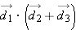, (b) 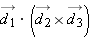, and (c) 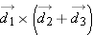 including unit?

