Hooke's Law and Simple Harmonic Motion        Name:__________________________

Partner(s):__________________    Course:______________    Time:____________

1. [Hooke’s Law](http://www.youtube.com/watch?v=OaiynlvxFbk)

Purpose: To verify Hooke’s law and determine the spring constants of elastic springs.

Apparatus: 3 springs, pendulum clamp, motion sensor, plumb-line, meter stick, tall lab stand, mass set, and mass hanger.

Theory: Think about stretching a spring. The more stretching force you apply, the more stretch you get. Robert Hooke (1635-1703), a British physicist, discovered this empirical relationship between the restoring force (F) and the stretch (x), known as Hooke's law,   
F = - kX.

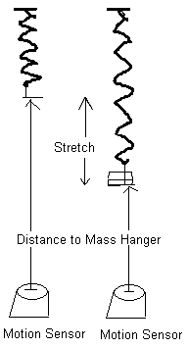

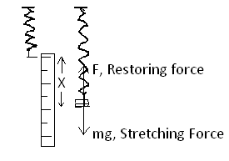

According to Hooke's law, the magnitude of the stretching force is given by:  
   
 Stretching Force = (Spring constant) X Stretch.  
  
The stretching force is provided by the added mass. You can also plot Stretching Force VERSUS Stretch. Hooke’s law is verified when there is a linear relationship between Stretching Force & Stretch.

The Spring Constant is given by the slope of the Stretching Force versus Stretch graph.

Procedure:

1. Attach the mass hanger to the hard spring and hang it from the pendulum clamp.  
2. Set up the motion sensor about 50-cm below the bottom of the mass hanger, using a plum-line.  
3. Connect the motion sensor to the interface (yellow-1, black-2), set the beam to narrow.  
4. Setting up the Interface for data collection:  
 a. Open **PASCO Capstone** software from the desktop.   
 b. Click **Hardware Setup** under Tools on the left, click on the interface input  
 where the sensor is connected and select **Motion Sensor II**.   
 Click **Hardware Setup** again to close it.   
 c. Double-Click **Digits** under Displays on the right, click Select Measurement, and select  
 **Position.**    
5. Click **Record** and record the distance to the bottom of mass hanger from the motion sensor. Stop the data collection.  
6. Add an appropriate mass to make the spring stretch about 2 cm and measure the distance to the bottom of mass hanger, again, and record it.  
7. Measure the stretches for other added masses and complete the data table.  
8. Repeat 1-7 for the other two springs.  
9. Enter the above data in Excel and for each spring; create two more columns for Stretch (m) and Stretching force (N). Calculate these values and make a single XY scatter Plot Stretching force VS. Stretch for all three springs, and find the spring constant for each spring.  
10. Attach your data table & plot (Excel) and conclusion (Word).

|  |  |  |  |  |  |  |  |  |  |  |  |  |
| --- | --- | --- | --- | --- | --- | --- | --- | --- | --- | --- | --- | --- |
| [SAMPLE DATA](Hooke.xlsx) | | | |  | | | |  | | | |  |
|  |  |  |  |  |  | |  |  |  | |  |  |
|  |  |  |  |  | |  |  |  | |  |  | |
|  |  |  |  |  |  |  |  |  |  |  |  |  |
|  |  |  |  |  |  |  |  |  |  |  |  |  |

B. Simple Harmonic Motion

Pre-lab on Simple Harmonic Motion   
Read sections 15-2 & 15-3, p387-390 in your text (HRW) and answer the following questions.

1. Define frequency and express its unit.
2. Define period and express its unit.
3. The displacement of a simple harmonic motion is, *X(t) = xm Cos (ωt + Φ)*.

Describe the following terms in the above equation.

a. *xm  __________________* b. (*ωt + Φ) _______________*c. *ω ___________________* d*. Φ ____________________*

1. Express *ω* in terms of period, *T* and frequency, *f*.
2. Obtain the velocity of the simple harmonic motion, *v(t)* by differentiating the displacement, *X(t)* above.
3. Obtain the acceleration of the simple harmonic motion, *a(t)* by differentiating the velocity, *V(t)* above.
4. What type of force is needed for a simple harmonic motion?

Purpose: Investigate a simple harmonic motion.

Apparatus: PC, interface, motion sensor, plumb-line, meter stick, hard spring, mass hanger, mass set, pendulum clamp, and electronic balance.

Theory:   
  
A mass, *m* is attached to the end of an elastic spring of spring constant, *k* and made to oscillate in simple harmonic motion of amplitude, *xm* and period, *T*.  
 The displacement is given by, , where .  
 The period (in terms of mass and spring constant) is also given by,



The velocity is given by,.

The magnitude of the maximum velocity is given by,    
  or 

The acceleration is given by,.  
   
 The magnitude of the maximum acceleration is given by,    
  or 

Procedure:

1) Connect the motion sensor to the Interface: yellow-1, black-2, and set the beam to narrow.

2) Attach 500-g mass (50-g mass hanger + 450-g) to the hard spring and hang it from the pendulum clamp. Record the total hanging mass.

3) Place the motion sensor directly under the hanging mass (use a plumb-line), on the lab table, and leave about 30-cm between the motion sensor and the hanging mass.

4. Setting up the Interface for data collection:  
a. Open **PASCO Capstone** software from the desktop.   
b. Click **Hardware Setup** under Tools on the left, click on the interface input where the sensor is connected and select **Motion Sensor II**. Click **Hardware Setup** again to close.   
c. Double-Click **Graph** under Displays on the right, click Select Measurement, and select **Position.**    
  
5)  Click Record, and after about 5 seconds, pull down the mass (about 5 cm) and release it, after collecting data for about 10 oscillations, stop the data collection.

6) The curve should resemble a cosine function. If not, delete the data and realign the motion sensor beneath the mass hanger, and try again.

7) Click on the Scale Axis button and maximize the graph.

DATA: Oscillating Mass = m = _____________Spring Constant = k = _________________

I) From the Position VS. Time graph obtain the following:  
  
a. Equilibrium Position = ______________________

b. Amplitude of the Oscillation = __________________________

c. Period of the Oscillation = _______________________________

d. Calculate the period (using spring constant and oscillating mass) = _______________  
  
  
II) Click Position, choose velocity, and from the Velocity VS. Time graph obtain the following:  
  
a. Maximum Velocity =___________________________

b. Period of the Oscillation = ___________________________

c. Calculate the period (using amplitude and maximum velocity) = ____________________

III) Click Velocity, choose acceleration, and from the Acceleration VS. Time graph obtain the following:  
  
a. Maximum Acceleration =___________________________

b. Period of the Oscillation = ___________________________

c. Calculate the Maximum force = ______________________

d. Calculate the period (using amplitude and maximum acceleration) = ____________________

IV) To Display Position, Velocity, and Acceleration together:  
a. Click Acceleration, choose Position, and obtain the Position VS. Time graph, on the display.  
b. Click the “Add new plot area to the Graph Display” button (6th from right), click “Select Measuremnet”, and choose velocity.  
c. Click the “Add new plot area to the Graph Display” button (6th from right), click “Select Measurement”, and choose acceleration.   
d. Your display should looks like the following:

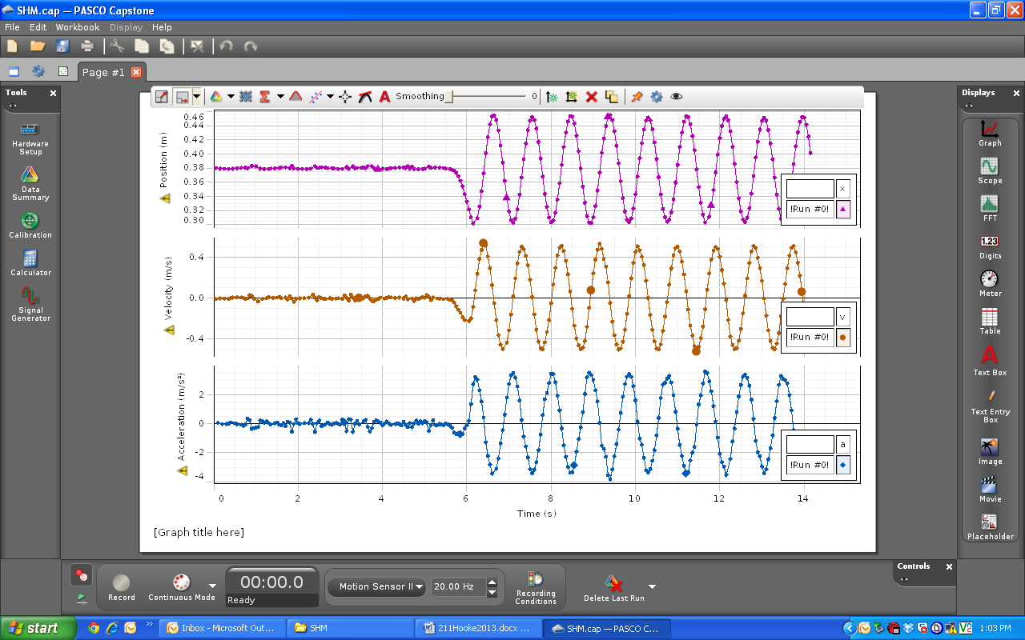

Answer the following questions, using your display:

During the oscillation when the mass is at the equilibrium position, what is the,

1. Velocity ____________________b. Acceleration __________________

During the oscillation when the velocity of the mass is zero, what is the,

1. Position ____________________b. Acceleration __________________

During the oscillation when the acceleration of the mass is zero, what is the,

1. Position ____________________b. Velocity __________________