PHYS 211 F 2013 Test #3 Name:__________________________
1. An automobile has a total mass of 1300 kg, which includes 100 kg for the 4 wheels, each of which can be approximated as a uniform disk of diameter 66 cm. It starts from rest and the wheels turns through 22 revolutions in 12 seconds. Find the following at the end of 12 seconds. (1 revolution = 2π rad)
a. Angular speed of a wheel.
b. Linear speed of the automobile.
c. Translational kinetic energy of a wheel.
d. Rotational kinetic energy of a wheel.
e. Total kinetic energy of a wheel.
f. Total kinetic energy of the automobile.

2. In the figure, a solid cylinder starts from rest and rolls without slipping a distance L = 6.0 m down a roof that is inclined at the angle θ = 30°. Use conservation of energy and find the linear speed of cylinder as it leaves the roof?
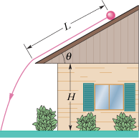

3. The uniform solid rectangular block shown below has mass M = 0.25 kg and edge lengths a =
4.0 cm and b = 9.0 cm. Four point masses, m = 0.05 kg are located at the corners. Calculate its rotational inertia about the axis shown, through one corner and perpendicular to the large face.
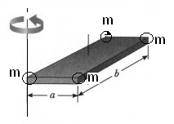
4. The uniform rod (length 0.60 m, mass 1.2 kg) shown below, rotates in the plane of the figure about an axis through one end. As the rod swings through its lowest position, it collides with a 0.30 kg putty wad that sticks to the end of the rod. If the rod's angular speed just before collision is 2.4 rad/s, what is the angular speed of the rod–putty system immediately after collision?
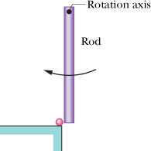

5. A uniform beam of mass of 63 kg is supported in a horizontal position by a hinge and a cable, with angle θ = 60°.
a. Draw a free body diagram for the beam.
b. Write down three equations, two by balancing the forces, and one by balancing the torque.
c. In unit-vector notation, what is the force on the beam from the hinge?

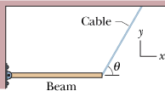

6. At time t, r = 2t²i – 3t³j +k gives the position of a 2.0 kg particle relative to the origin of an xy coordinate system ( is in meters and t is in seconds).
I. Find an expression as a function of time for a) the velocity b) the linear momentum c) the acceleration d) the force, of the particle relative to the origin.
II. About the origin, at t = 1s, determine d) the torque and e) the angular momentum of the particle in unit–vector notation.
III. At t = 1s, what is the angle between the position and linear momentum vectors.

