PHYS 211 Homework on Vector Addition Name:_________________________ Due: 9/9/13
1. Find the resultant (sum) of the following 3 vectors shown below.
Need help, watch this video: https://www.youtube.com/watch?v=g_TnqKX5ybY
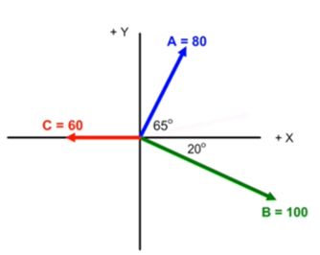

2. Find the sum of the following four vectors in (a) unit-vector notation, and as (b) a magnitude and (c) an angle relative to +x.

