PHYS 202L Transistor and Measuring e/k Name:_____________________
1. Fundamental constants are used extensively in the sciences. Can you name the one we already measured in one of the labs this semester?__________________________________________
In this lab we will measure the ratio of two fundamental constants, namely e/k, using a transistor.
Record the e (electron charge) and k (Boltzmann constant) values from the above link, in the data table on page 4. These values will be used to calculate the accepted value of e/k.
2. Watch the following video for an introduction of Transistor, and answer the following questions:
a. Where can you find transistors?
b. What is a transistor?

c. What is a semiconductor?
d. What is doping in semiconductor technology?
d. What is an n-type semiconductor?
e. What is a p-type semiconductor?
f. What is a hole in semiconductor terminology?
g. Number of valence electrons in Silicon_____, Phosphorous______, and Boron_______.
h. What is Moore’s law?

II. h_{FE} (or β) of a transistor: (http://www.learningaboutelectronics.com/Articles/What-is-hfe-of-a-transistor)
h_{FE} of a transistor is the current gain or amplification factor of a transistor.
h_{FE} (which is also referred to as β) is the factor by which the base current is amplified.
A transistor works by feeding a base current into the base of the transistor. The base current (I_{B}) is then amplified by h_{FE} to yield its amplified collector current (I_{C}).
I_{C} = h_{FE}I_{B} or I_{C} = βI_{B}

So, if 1mA is fed into the base of a transistor and it has a h_{FE} of 100, the collector current will be 100 mA. Every transistor has its own unique h_{FE}. The h_{FE} is normally seen to be a constant value, normally around 10 to 500, but it may change slightly with temperature and with changes in collector-to-emitter voltage.
In this activity; emitter (E), base (B), and collector (C) of the transistor are identified and its value is measured for a PNP transistor, as shown below, using the blue digital multimeter (DMM). Its value, h_{FE} = β = 196.

 | 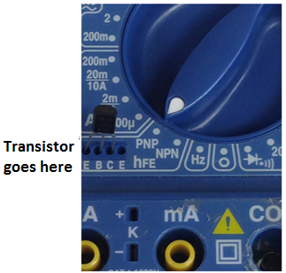 | 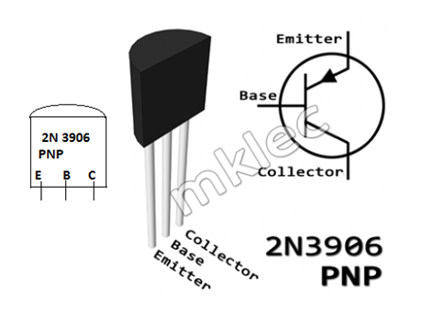

III. Purpose: Experimentally measure e/k, where e is the electronic charge and k is the Boltzmann’s constant, and compare it with the accepted value.
Apparatus: Temperature sensor, PNP transistor, proto-board, 2-digital-multimeters (A and V), rheostat, D-cell battery w/holder, 3 proto-board wires, 5 alligator clips, 4 red banana plug wires, and 4 black banana plug wires.
The figure below shows how to insert and connect a transistor in a breadboard.
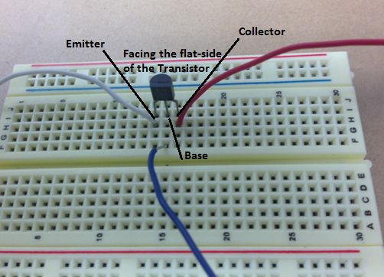
The figure below shows the circuit diagram to measure the emitter-base voltage, V [0.453 V] and collector- current, I [0.4 µA]. Connect similar polarities: + of the battery with + of the meter.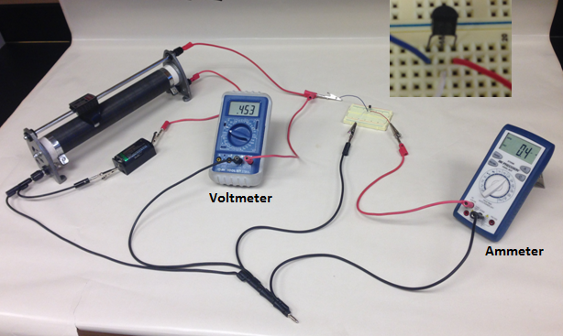
Circuit set-up video: https://www.youtube.com/watch?v=g1IKqPv2GGc&t=33s
Procedure:
1. Set up the above circuit. V: 2V DC, A: DC µA, and slider at the bottom.
2. Slide up the control in the rheostat until the ammeter reads a very low current, say 0.5 µA.
3. Record the voltage, V and current, I in the data table.
4. Increase the current and collect I and V data. [About 30 set of data, evenly spread with the voltage, until the current reaches about 50 µA]. Record the data from the video.
DATA collection video: https://www.youtube.com/watch?v=zGbUn1fzmEU&t=141s
Don’t use the first 5 data points, start with (0.47 V, 0.8 μA) and finish it with (0.582 volt, 50.3 μA)
5. The current (I) and the voltage (V) are related by the following equation: (where k is the Boltzmann constant, e is the electronic charge, and T is the temperature in K)
$I=I_{0}exp⁡\left(\frac{eV}{kT}\right)$ or $I=I_{0}e^{\frac{eV}{kT}}$
6. Plot I versus V, fit the data with an appropriate Trendline, and obtain
I₀ and e/kT from the trendline equation.
7. Manipulate the above equation and identify the variables for a linear plot.
$I=I_{0}exp⁡\left(\frac{eV}{kT}\right)$
DATA TABLE
Voltage (V) | Current (µA)

8. Calculate the new variables, plot the linear graph, and obtain I₀ and e/kT.
9. Measure the room temperature, use it with the above slope, and calculate e/k.
10. Attach your plots, and write a conclusion for part III.
DATA (Include Units):
Magnitude of electron charge = e = _________________
Boltzmann constant = k = ___________________
Room temperature = T= 27.0⁰C = _________K
 | I₀  ( ) | $$\frac{e}{kT}$$  ( ) | e/k ( ) |  | % Error
 |  |  | Measured | Accepted
From I VS. V graph
From linear graph

