PHYS Remote Lab on Spectra Name:______________________
1. Watch the following video and answer the questions below:
https://www.youtube.com/watch?v=jjy-eqWM38g
- What is light?

- How is the energy (E) of a photon of light related to its wavelength (λ)?

- What are spectra (plural for spectrum)?

- Expain the origin of light (or how light is produced)?

- Wavelength of light emitted by a body depends on the body’s _______________.

- Name three subatomic particles the atoms are made of?

- What is the analogy used for quantization of electron energy in the video?

- What is the key to the universe, according to the video?

- Name the device that measures the wavelength of light?_________________.

- What is Doppler effect?

- How do we know that the universe is expanding?

2. Energy levels of the electron of the hydrogen atom are shown below. Calculate and list the energy values, $E_{n}=-\frac{13.6}{n^{2}}$ eV, with the orbitals.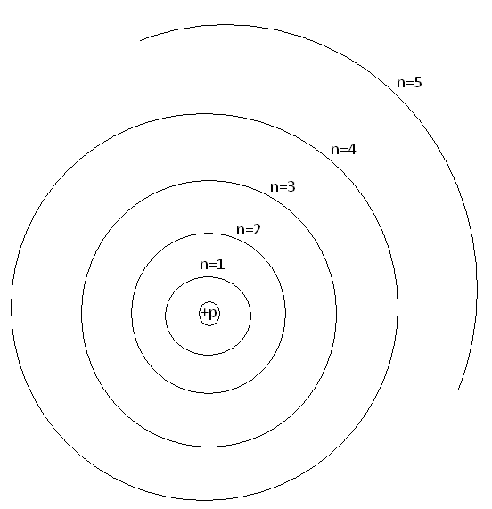
a. Watch this video for an understanding of electron transitions.
https://www.youtube.com/watch?v=wiINTUZoAiw
Identify one error made in the video____________________
b. Show the transitions of electron for the Lyman (Higher level1), Balmer (Higher level2), and Paschen (Higher level3) series in the above diagram.
c. A photon of light is emitted when the electron transitions to a lower energy. The wavelength (λ) of emitted light is given by:
$∆E=\frac{hc}{λ}$; h = 6.626x10⁻³⁴J.s and c = 2.998x10⁸m/s. 1eV=1.602x10⁻¹⁹J
1. Calculate the value of hc, in the unit eV.nm.

2. Calculate the 4 of the highest wavelengths (λ) of the Balmer series.

3. Visit this simulation: https://javalab.org/en/spectrum_of_hydrogen_en/
a. The simulation shows the light emission for the hydrogen atom. Make a note of the wavelength (λ), energy difference (ΔE), and energy levels involved for the light emitted.
λ = ____________ΔE = ____________Energy levels (E₁, E₂, etc) involved =_________
b. To find out the transitions to which electron orbit will result in the visible spectra:
Move Electron to get transition: | Wavelength (nm) | ΔE (eV) | Visible (Yes or No)
E₂ E₁
E₃ E₁
E₄ E₁
E₅ E₁
E₆ E₁
E₇ E₁
E₈ E₁
Move Electron to get transition: | Wavelength (nm) | ΔE (eV) | Visible (Yes or No)
E₃ E₂
E₄ E₂
E₅ E₂
E₆ E₂
E₇ E₂
E₈ E₂
E₉ E₂
Move Electron to get transition: | Wavelength (nm) | ΔE (eV) | Visible (Yes or No)
E₄ E₃
E₅ E₃
E₆ E₃
E₇ E₃
E₈ E₃
E₉ E₃
c. Go to Excel, and enter the wavelength, λ and absolute values of ΔE, $\left|∆E\right|$ values, for the visible spectrum. Also insert a column after the first column, and calculate 1/λ.
d. Plot $\left|∆E\right|$ versus 1/λ, determine the slope with unit. Slope = ______________
e. What is the theoretical value for the slope in the same unit?________________
f. Calculate the % difference for the above two values_______________________
g. Write a conclusion for this last section, 3.

