PHYS 202L RESISTANCE Name:________________________
Partner(s):_______________________________________________________________
Purpose I: To investigate the resistance of metal wires and determine the resistivity.
Apparatus: Resistance apparatus, metal wires: nichrome and stainless steel, galvanometer sensor, digital multimeter, and banana-plug wires (1-black and 2-red).
Theory: Resistance, R of a metal wire of length L and cross-sectional area A is given by:
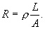 where, ρ is the resistivity.
According to Ohm’s law, $V=IR$ or $V=I\frac{ρL}{A}$ or $V= \frac{Iρ}{A}L$
The plot of V versus L will yield a slope of Iρ/A. Knowing A and I, the resistivity can be determined.
Procedure:
In this activity the resistance of metal wires will be measured as a function of length, and the resistivity will be determined.
- On the Resistance Apparatus, move the Reference Probe and the Slider Probe to the Park position. The probes should be as far left and right respectively as possible so the probe lifts up to allow installation of the sample wire. They will click into position.
(See the online version for the figure)

- Turn the two black handles counterclockwise to open the clamps to allow the sample wire to slide into position.
(See the online version for the figure)
- Install the nichrome wire in the apparatus. Slide from left or right using the white line-up hash marks. Figure below shows the left hand side as the wire slides in. Note that on the right hand side, the wire is on the far side of the silver clamp (with black handle), but on the left hand side the wire will be on the near side of the clamp as shown. This prevents the wire from bowing as you tighten the clamps.

- Tighten the clamps by turning the black handles clockwise.
(See the online version for the figure)
- Set up the following circuit and have the construction checked by instructor.
(See the online version for the figure)
- Position the reference probe (black) at the 0 cm mark and the slider probe (red) at the 4 cm mark.
- TARE the galvanometer sensor.
- Open the Capstone activity, “Resistance” from the desktop.
- Click “Signal Generator” on the left and click “ON”. Click “Signal Generator” again to close it.
- Click “Preview” on the bottom, and increase the voltage data digits to 4.
- Record the current, I from the DMM, in the data table below.
- Click “Keep Sample” to collect the voltage data for the length, 4 cm.
- Change the length to 8 cm, collect the voltage data, and continue this for other lengths.
- Stop the data collection.
- Maximize the graph display, high-light the data, and find the slope.
- Measure the diameter of the wire with a micrometer, calculate the cross-sectional area, and calculate the resistivity of the metal.
- Repeat the measurements for stainless steel, and complete the data table.
- Write a conclusion for purpose I only.
DATA
slope = Iρ/A
Wire Type | Diameter (cm) | Cross-Sectional Area (cm²) | I (A) | Slope (V/cm) | Resistivity, ρ (µΩ.cm)  Measured | Resistivity, ρ (µΩ.cm)  Accepted | % Error
Nichrome |  |  |  |  |  | 110
Stainless Steel |  |  |  |  |  | 80

Purpose II: To investigate various combinations of resistors.
Apparatus: Three resistors, DMM (digital multi meter), and 5-banana plug wires.
Theory: When two or more resistances are connected in series the equivalent resistance, R_{S} is given by;
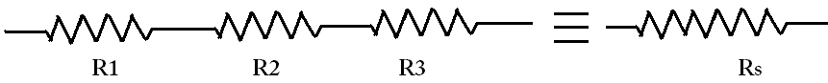
When two or more resistances are connected in parallel the equivalent resistance, R_{P} is given by:
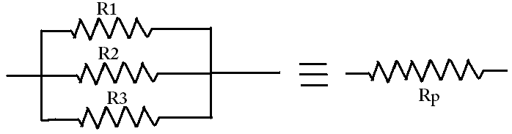
Procedure:
1. Determine the values of the three resistors using the resistor color code.
2. Measure the values of the three resistors using the digital multimeter (DMM).
3. Observe the tolerance values and record them in the data table.
 | R₁ | R₂ | R₃
From resistor color code
From digital multi- meter
Tolerance
4. Connect R₁ and R₂ in series and measure the equivalent resistance. Also calculate it.
5. Connect R₁ and R₂ in parallel and measure the equivalent resistance. Also calculate it.
Diagram | Measured | Calculated
R₁ and R₂ in series:
R₁ and R₂ in parallel:
6. Rank the values of R₁, R₂, R₁ series R₂, R₁ parallel R₂ in descending order:

7. Connect the three resistors in various combinations and obtain various values of resistances. Measure the equivalent resistances. Also calculate the equivalent resistances using the measured values for R₁, R₂, and R₃.
8. Identify the lowest and highest resistance values in the table.
Resistor combination diagram | Resistance Values
 | Measured | Calculated

