Ohm’s Law Name:_______________________________________
Partner(s):______________________Date:______Time:_______Course:___________
Purpose: To investigate Ohm’s law, measure resistances, and study I-V characteristics.
Theory: Georg Simon Ohm (1787-1854), a German physicist, discovered Ohm’s law in 1826. This is an experimental law, valid for both alternating current (ac) and direct current (dc) circuits. When you pass an electric current (I) through a resistance (R) there will be an electric potential difference (V), also known as voltage, created across the resistance as shown below.
Positive end of the power supply or battery has the high electric potential. Negative end has the lower potential. Electric current flows from high potential to low potential. In the box above draw the circuit diagram with a voltmeter to measure voltage and ammeter to measure current.
Ohm’s law says that the current (I) is directly proportional to the potential difference (V). The resistance R can be obtained using the following equation:
V = I R Units: V------> volt (V), I------> ampere (A), R-----> ohm (Ω).
Electric power, P is given by the following equation:
Power = Current x Voltage. P = I V, Unit: P------> watt (W)
For ohmic resistances, V versus I is a linear relationship, and they have a constant resistance. Resistance can be calculated using, R = V/I. The slope of the V versus I, line will also give the resistance, R.
For non-ohmic resistances, V versus I is a non-linear relationship, and they have a varying resistance. The resistance at a particular point can be determined using the slope of the V versus I curve, at that point.
In the first part of this activity, investigate the relationship between current and voltage in a standard 5-ohm and 10-ohm resistors. Then, investigate the relationship between current and voltage in the filament of a small incandescent light bulb. Finally, investigate the relationship between current and voltage in a p-n junction diode (Si).
Answer the following:
1. Electricity comes in two types. Name these two types and give an example for each.
____________________________________________________________________
2. Name five quantities and their units, used in electricity.
Terms in Electricity
Physical Quantity | Unit (unit abbreviation)

3. Go to the following simulation.
http://phet.colorado.edu/sims/ohms-law/ohms-law_en.html
a. Keep the resistance constant; change the voltage, Observe what happens. Describe the relationship between current and voltage. Also, include a plot.

b. Keep the voltage constant; change the resistance, Observe what happens. Describe the relationship between current and resistance. Also, include a plot.

Apparatus: DC power supply, connecting wires-3 (red-2 and black-1), 2-alligator clips, 5-ohm resistor, 10-ohm resistor, light bulb, diode, voltage sensor, high-current sensor, and PASCO 850 interface w/Capstone.
Procedure:
- Turn on the power supply and turn down the voltage and current controls to zero.
- Set up the following circuit:
a. Plug-in the high-current sensor to the interface, bottom-left corner.
b. Connect the power supply, 5-ohm resistor, and the current sensor in series. (Keep track of the polarities: positive with positive and negative with negative).
c. Connect the voltage sensor across the 5-ohm resistor, and plug-in to the interface. 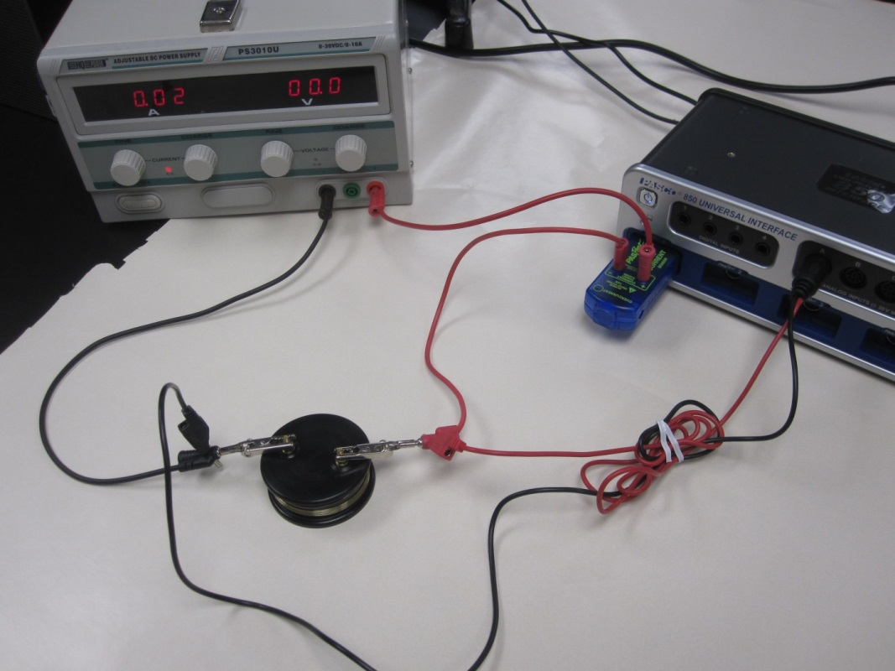
- Setting up the interface/PC for data collection using the Keep Mode:
a. Open PASCO Capstone software from the desktop.
b. Click Hardware Setup under Tools on the left.
c. Make sure that the Pasport current sensor is identified by the interface.
d. Click on the interface input where the voltage sensor is connected and select Voltage Sensor. Click Hardware Setup again to close it.
e. Click on “Continuous Mode” in the bottom, and select Keep Mode.
f. Click Table and Graph, click Select Measurement on the first column, and select Current. Click Select Measurement on the second column, and select Voltage. For the graph, choose current on the x-axis and voltage on the y-axis.
g. Click Preview.
- Increase the current to about 1A. Voltage will also increase. When the current and voltage are steady, Click Keep Sample to collect the first set of data. Collect more data by lowering the current by 0.1 A, until the current goes to zero.
- Reverse the connections to the power supply. Continue collecting data by lowering the current by 0.1A, until you reach a current of -1A. [The power supply won’t indicate -].
- Stop the data collection and safe your results.
- Click Preview, and Repeat the measurements for a 10-ohm resistor, and safe your results in BB.
- Repeat the measurements for a light bulb for the following conditions:
Maximum current = 0.3 A, collect data by lowering current by 0.05 A till about 0.1 A, then by lowering 0.02 A, until the current goes to zero, and for negative values.
- Safe your results in BB.
- Repeat the measurements for a diode for the following conditions:
For the graph, choose Voltage on the x-axis and Current on the y-axis.
Maximum current = 2.0 A, collect data by lowering current by 0.2 A till about 0.2 A, then by lowering 0.02 A, and for negative values, use voltage values up to about 2V. Safe your results in BB.
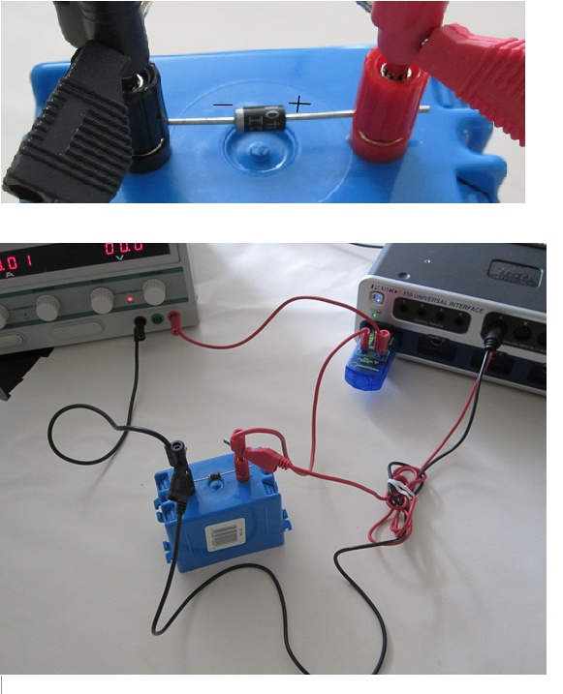
Data Analysis
I. Constant Resistances 5-Ω and 10-Ω
 | 5-Ω Resistance | 10-Ω Resistance
Measured value from slope of
V vs. I plot
% Difference
II. Light Bulb
- Use the “Slope” feature in the Voltage VS. Current graph, determine the resistance of the bulb for the following:
Resistance of the bulb
Zero current & voltage
Intermediate current & voltage
Maximum current & voltage
- Copy the voltage and current data in Excel, and calculate power. Safe the data table in BB.
III. Si Diode
Range of voltage that makes the diode conducting:________________________
IV. Write a conclusion for the entire lab.

