**Induction and Permeability Constant**                **Name: _______________________**

**Course:_______________Time:__________    Partner(s):______________________**

**I. Electromagnetic Induction: Faraday’s Law**

When a magnet is passed through a coil there is a changing magnetic flux, Φ through the coil which induces an electromotive force, emf, also known as voltage. According to Faraday's law of induction the induced emf, *ξ* is given by; where *B*┴ is the magnetic field perpendicular to the area *A* and *N* is the number of turns in the coil.

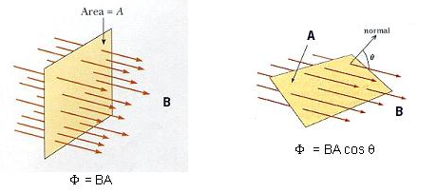

 ****is the magnetic flux for one turn.

**Demo: Inducing emf/Current using magnetic field**Apparatus: Galvanometer, solenoid, banana-plug wires, and horse-shoe magnet.

|  |  |  |
| --- | --- | --- |
| Procedure | Observation | Explanation |
| 1. Magnet placed in the solenoid, not moving |  |  |
| 2. Moving the magnet, out |  |  |
| 3. Moving the magnet, in |  |  |
| 4. Moving the magnet faster VS. slower |  |  |

**Purpose:** Investigate the electromotive force (emf), also known as voltage, induced in a solenoid by a moving magnet.

|  |  |  |
| --- | --- | --- |
|  |  |  |

**Theory:**When a magnet is passed through a coil there is a changing magnetic flux   
through the coil which induces an electromotive force, emf. According to   
Faraday's law of induction the induced emf, *ξ* is given by; where *B*┴ is the   
magnetic field perpendicular to the area *A* and *N* is the number of turns in   
the coil.   
In this activity, a plot of the emf (or Voltage) *versus* time is made and   
the area under the curve represents the magnetic flux.

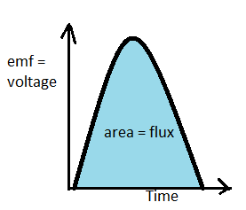

**Apparatus:** PC w/interface (Pasco 850), voltage sensor, solenoid (# of turns =540), magnets (bar and horse-shoe), foot-ruler, banana-plug wires (2), and soft-box (to catch the magnet).

**Procedure:**1. Setting up the Interface:   
a. Make sure that the power for the interface is turned on.  
b. Connect the voltage sensor to analog input A.  
c. Plug in the red and black leads from the voltage sensor to the solenoid, place the solenoid vertically on the lab table.   
d. Open **PASCO Capstone** software from the desktop.   
e. Click Hardware Setup under Tools on the left, click on the interface input where the sensor is connected, and select **Voltage Sensor**. Click Hardware Setup again to close it.  
f. In the bottom panel, middle, increase the sample rate to 200 Hz.  
g. Click **Recording Conditions**, in the bottom-panel, and do the following:

|  |  |  |
| --- | --- | --- |
| I. Start Condition: | II. Stop Condition: | III.Click, OK. |
| Condition type = Measurement Based  Data Source = Voltage (V)  Condition = Is above  Value = 0.05  Pre-Record = Box checked Pre-Recording time = 0.3 s | Condition type = Time Based  Record time = 0.4s |

h. Click **Graph** under displays on the right, click **Select Measurement** on the Y-axis, and choose Voltage (V).

2. Place one end of the horse-shoe magnet inside the solenoid.  
3. Click **Record** and remove the horse-shoe magnet.   
4. If nothing is displayed; stop the data collection, place the other side of the horse-shoe magnet and try Procedure (3) again.  
5. Maximize the graph display.  
6. Measure the peak value of the induced voltage using the **Show Coordinates Tool** and the magnetic flux (area under the V vs. t graph) using the **Display area under active data tool**.  
Safe a screenshot of the display.   
7. Repeat procedures 3-6, for removing the magnet quicker, and complete the data table for the horse-shoe magnet.   
8. Place the soft-box on the floor close to the edge of the table and hold the solenoid vertically above it.  
9. Click **Record** and drop the bar magnet, N-pole down, through the solenoid.   
10. The data collection will stop automatically. You should see two peaks.  
11. Magnetic flux is obtained by finding the area under the V vs. t graph. Safe a screenshot of the display.  
12. After completing the data tables, and answering the questions, close Pasco Capstone.

DATA: a. Horse-shoe magnet: Include Units.

|  |  |  |
| --- | --- | --- |
|  | Slow removal | Quick removal |
| Peak value of the induced emf |  |  |
| Magnetic flux  (Area under the V vs. t graph) |  |  |
| Average speed |  |  |

Q1. Why the magnitude of the peak value of the induced emf is higher for the quick removal?

 ___________________________________________________________________

Q2. Is the magnitude of the magnetic flux equal for the two peaks? Explain why.

___________________________________________________________________

Q3. Calculate the average magnetic field strength, B for the horse-shoe magnet by assuming the following properties for the solenoid: number of turns in the solenoid is 540 and the diameter is 4 cm. (Magnetic Flux = N∙B∙A)  
___________________________________________________________________

___________________________________________________________________

b. Bar magnet: Include Units.

|  |  |  |  |  |
| --- | --- | --- | --- | --- |
| Bar Magnet | Dropping the magnet from closer to the solenoid | | Dropping the magnet from further to the solenoid | |
| First Peak | Second Peak | First Peak | Second Peak |
| Peak value of the induced emf |  |  |  |  |
| Magnetic flux (Area under the V vs. t graph) |  |  |  |  |
| Average speed for the moving magnet |  | |  | |

Q1. Is the magnitude of the magnetic flux equal for the peaks? Explain why.

__________________________________________________________________

__________________________________________________________________

Q2. Why the magnitude of the peak value of the induced emf is higher for dropping from further from the solenoid and for the second peak?  
  
__________________________________________________________________

__________________________________________________________________

Q3. Describe how the display will change if the S-pole is down when the bar magnet is dropped.

____________________________________________________________________

____________________________________________________________________

 Q4. Click Start again and drop the bar magnet, this time S-pole down, through the solenoid. Describe and explain what you see. Does this support your prediction in Q3?  
  
_____________________________________________________________________

_____________________________________________________________________

II. Purpose: Determine the [permeability of free space](http://scienceworld.wolfram.com/physics/PermeabilityofFreeSpace.html) (µ0) by measuring the magnetic field of a solenoid as a function of the electric current passing through it.

Apparatus: Solenoid (# of turns =540), magnetic field sensor, small wooden block, PC with Pasco 850-interface, foot-ruler, power supply, and two banana-plug wires.

Theory: <http://www.pa.msu.edu/courses/2000fall/PHY232/lectures/ampereslaw/solenoid.html>

|  |  |  |
| --- | --- | --- |
| http://edugen.wiley.com/edugen/courses/crs1650/art/images/halliday8019c29/image_t/tfg020.gif | http://hyperphysics.phy-astr.gsu.edu/hbase/magnetic/imgmag/amlaw.gif |  |

Procedure:

1. Set the magnetic field sensor as follows: Range Select = 1X and AXIAL, as shown below.

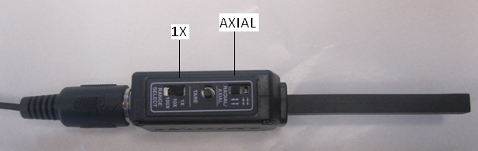

1. Connect the solenoid to the power supply, Magnetic Field Sensor to analog input A,   
   insert the magnetic field sensor inside the solenoid, and place it on the small wooden block, as shown below.

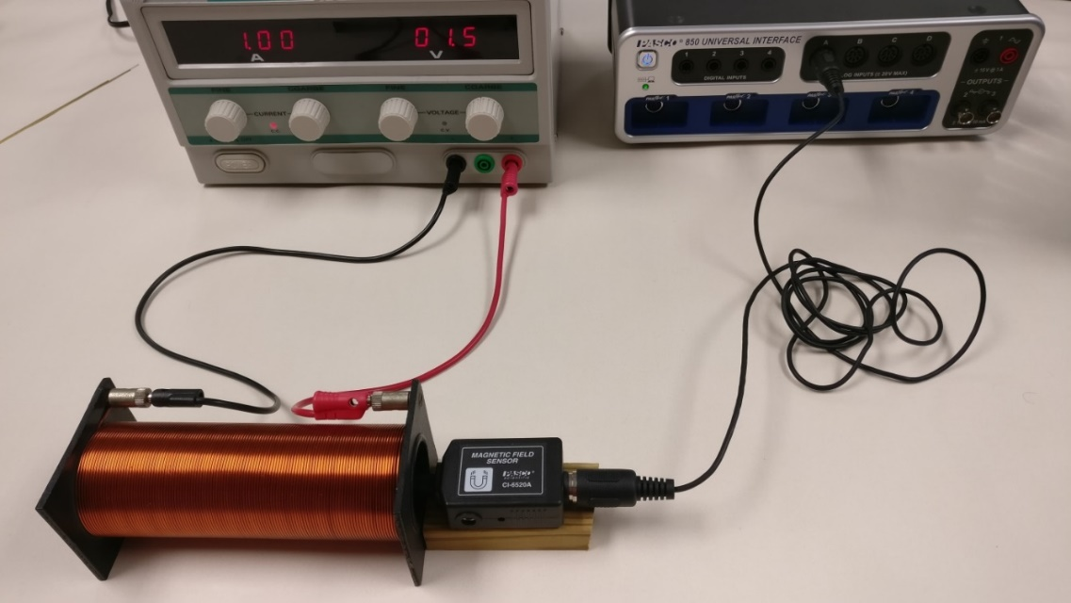

3. Setting up the Interface:  
a. Open Pasco Capstone from Desktop.  
b. Click **Hardware Setup** under Tools on the left, click on the interface input where the sensor is connected and select **Magnetic Field Sensor**.   
c. Click **Hardware Setup** again to close it.   
d. Click **Data Summary** on the left, click **Magnetic Field Strength (1X)(T)**.   
e. Click on the **gear symbol** on the right, under **Numerical Format**, and change the **fixed decimals** to 5.   
f. Click **Data Summary** again to close it.  
g. Click **Digits** under Displays, click **Select Measurement**, and select **Magnetic Field Strength (1X)(T).**

4. Tare the magnetic field sensor, when the current is zero.

5. Set the current to about 0.5A, it doesn’t have to be exactly 0.5 A, click **Record**, and measure the magnetic field. If the reading is negative, reverse the connections to the solenoid.

6. Tabulate your Current and magnetic field data in Excel.

7. Repeat the measurements by increasing the current by about 0.5A, until you reach about 4A. Do not increase the current more than 4A and turn off power supply after the measurements.

8. Plot a graph, obtain the permeability of free space, compare it to the accepted value, and write a conclusion for II. Attach your graph. Magnetic field of a solenoid is given by:

$B= μ_{0}\frac{N}{L}I$

DATA: # of turns = N = 540 Length of solenoid = L = _________________

|  |  |  |
| --- | --- | --- |
| Current, I (A) | Magnetic Field, B (T) | µ0, (T.m/A) |
|  |  |  |
|  |  |  |
|  |  |  |
|  |  |  |
|  |  |  |
|  |  |  |
|  |  |  |
|  |  |  |

Slope of the B VS.I plot: ___________________

____________________________________________________

Measured permeability of free space, using the slope from the plot: µ0 = _________________

Accepted permeability of free space = µ0 = 1.257 x 10-6 T.m/A

% Error = __________________