PHYS LAB Gas Laws Name:_______________________________________
Pre-LAB
1. Write down five state properties of a gas. (Refer your textbook).
State Properties of a gas | Name
 | Symbol
2. State the following gas laws in equation form using the above symbols and give an example or device that uses each law.
 | Law | Example/Device
Boyle's law
Charles's law
Gay-Lussac's law
3. In order to verify Charles' law, visit the following Java site. As you increase the temperature, the volume will increase and it will also fluctuate. Collect three volume data and find the average volume. Set N= 30, P =30.

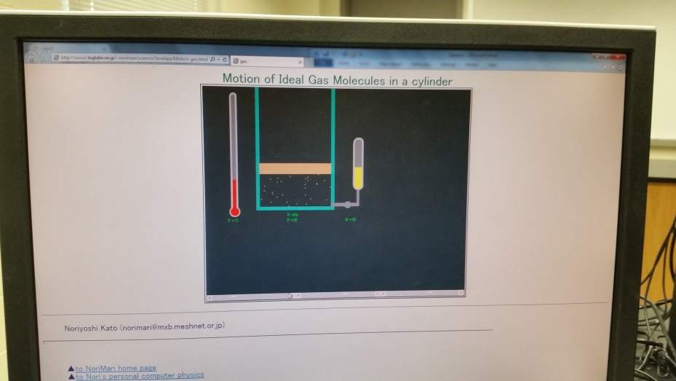

Temperature (K) | Volume-1 | Volume-2 | Volume-3 | Average  Volume (mL)
0 | 0 | 0 | 0 | 0
50
100
150
200
250
300
Plot Average Volume versus Temperature, attach the graph, and describe how your results verify Charles's law.
A. Pressure sensor check
Equipment needed: PC, interface, and pressure sensor.
- Look at the pressure sensor and find out the following:
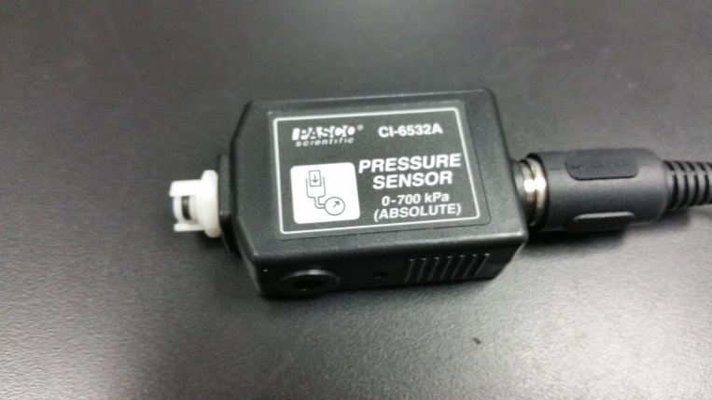
a. What type (absolute or gauge) of pressure it measures?_____________
b. Range of pressure it can measure?______________________________
2) To measure the atmospheric pressure:
a. Make sure that the power for the interface is turned on.
b. Plug in the pressure sensor to analog input A on the interface.
c. Open PASCO Capstone software from the desktop.
d. Click Hardware Setup under Tools on the left, click on the interface input where the sensor is connected and select Pressure Sensor, absolute. Click Hardware Setup again to close it.
e. Double-Click Digits under Displays on the right, click Select Measurement, and select Absolute pressure.
f. Click Record and measure the atmospheric pressure.
Atmospheric pressure = _______________________
3) Is the above atmospheric pressure reasonable? Explain using the atmospheric pressure at sea level.
________________________________________________________________________
________________________________________________________________________
B. Boyle's law: Pressure vs. Volume
Equipment needed: PC, interface, pressure sensor, and syringe.
- Go to Excel and create data columns for Volume (mL) and Pressure (kPa). In the Volume column enter volume values 60, 55, 50, 45, 40, 35, and 30.
- Take the syringe, and pull out the piston to the 60 ml mark.
- Connect the syringe to the pressure sensor. (Line up the quick-release connector with the corresponding end of the pressure sensor. Push it in and turn it clockwise until you hear a small click).
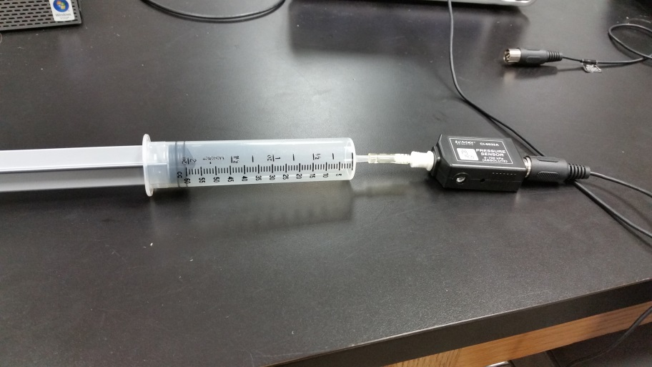
4) Pressure sensor is connected to analog input A on the Interface.
5) Click “Start” and record the pressure for the volume 60-mL.
6) Repeat the pressure measurements for other volumes.
7) Enter the recorded values of the pressure P into the excel table.
8) Remove the pressure sensor, connect the temperature sensor, and measure the room temperature, T.
a. Make sure that the power for the interface is turned on.
b. Plug in the temperature sensor to analog input A, white arrow on top.
c. Open PASCO Capstone software from the desktop.
d. Click Hardware Setup under Tools on the left, click on the interface input where the sensor is connected and select Temperature Sensor. Click Hardware Setup again to close it.
e. Double-Click Digits under Displays on the right, click Select Measurement, and select Temperature.
f. Click Record. _____________________________________
9) Using your data calculate the number of moles of air trapped in the syringe during the experiment. (R = 8.314 Pa.m³/mole.K = 8314 kPa.mL/mole.K)
____________________________________________________________________
____________________________________________________________________
____________________________________________________________________
____________________________________________________________________
10) Analyze the data to verify Boyle’s law (calculate P*V and make two graphs: P vs. V and P vs. 1/V, also find the slope of P vs. 1/V). Attach the data table and graphs.
11) Calculate a theoretical value for the slope of P vs. 1/V and compare it with that from the plot.
Slope of P vs. 1/V, from the plot = ________________
Slope of P vs. 1/V, theoretical = ________________
% Error = _________________
12) Close PASCO capstone.

C. Gay Lussac's law: Pressure versus Temperature
Apparatus: Pressure sensor, passport temperature sensor connector, PC w/interface, hot plate, magnetic stirrer, 2000-mL beaker, lab stand w/clamp, absolute zero apparatus, water, and ice.
Procedure:
- Place the stirrer in the beaker and place the beaker on the hot plate. Place the absolute zero apparatus in the middle of the beaker and clamp it to the lab stand. Fill the beaker with ice & water mixture. Turn on the stirrer of the hot plate. Do not turn on the heater now.
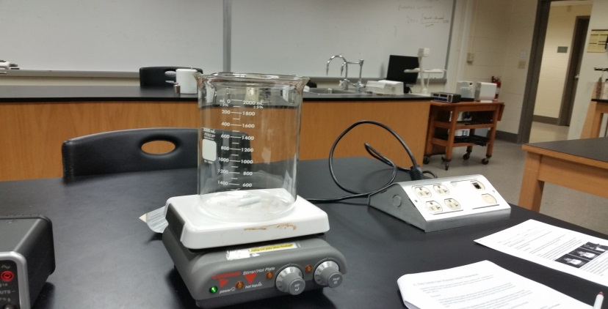
2. The absolute zero apparatus comes with a PASport temperature sensor. Connect the temperature sensor to the PASport connector and connect it to the PASport 1 input on the interface. Connect the pressure sensor to analog input A on the interface. Do not connect the pressure sensor to the absolute zero apparatus now.
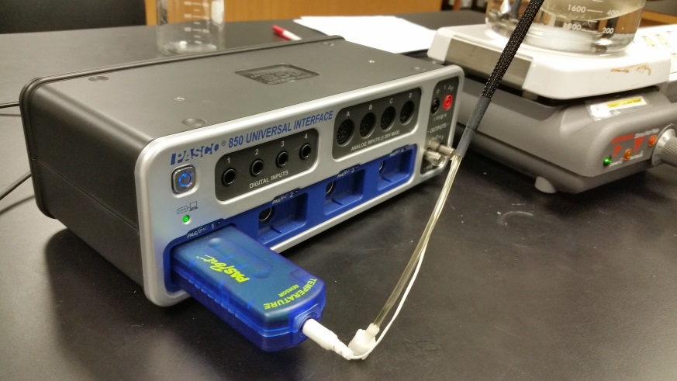
Add the absolute zero apparatus
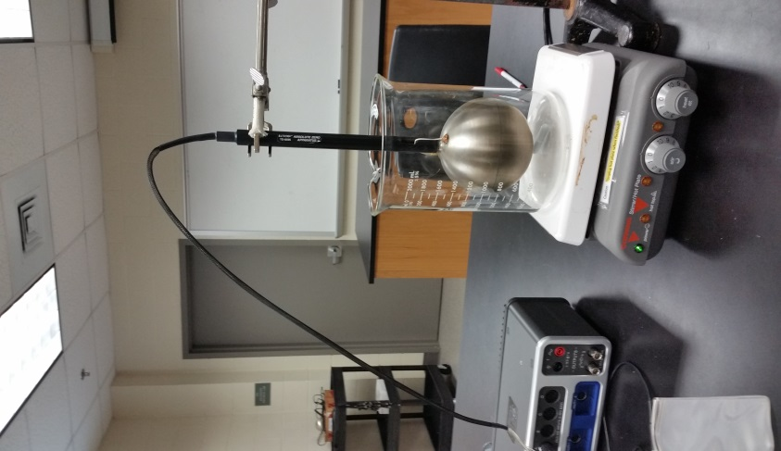
Add Ice and water to the beaker
3. Setting up the interface/PC for data collection using the Keep Mode:
a. Open PASCO Capstone software from the desktop.
b. Click Hardware Setup under Tools on the left.
c. Make sure that the PASport temperature sensor is identified by the interface.
d. Click on the interface input where the pressure sensor is connected and select Pressure Sensor, absolute. Click Hardware Setup again to close it.
e. Click on “Continuous Mode” in the bottom, and select Keep Mode.
f. Double-Click Tables under Displays on the right, click Select Measurement on the first column, and select Temperature. Click Select Measurement on the second column, and select absolute pressure.
g. Click Preview.
4. If the low temperature (close to 0ºC) is reached, connect the pressure sensor to the absolute zero apparatus. DO NOT CONNNECT THE SENSOR before reaching 0°C
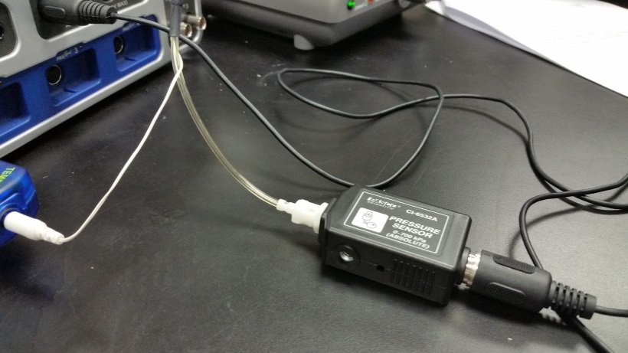
5. Click "Keep Sample" to collect the first temperature and pressure data.
6. Turn on the heater on the hot-plate and watch the temperature.
7. When the temperature reaches about 5 degrees, on the Preview, click "Keep Sample" to collect the second temperature and pressure data. It is important that the water is stirred well during the experiment.
8. Continue collecting data, every 5 degree temperature change, and until the water boils. It is important that the water is stirred well during the experiment. DO NOT STOP until the end of the experiments.
9. Stop the data collection at the end, by clicking “Stop”.
10. Make Pressure vs. Temperature graph, and determine the relationship between pressure and temperature.

Describe it below.
______________________________________________________________
- Chick on the graph on the right side of the program
- Select x as the temperature and y as the absolute pressure
- Add a trendline, and fit your graph, then move the Pressure scale to zero.
12. Using your Pressure vs. Temperature graph, determine the value of absolute zero.
Absolute zero temperature (experimental) = ____________
Absolute zero temperature (accepted) = ________________ % Error = ____________
12. Attach the graph showing the absolute zero temperature.
13. Include the following in your conclusion and attach it as the last page of your report.
a. Start with an overall purpose.
b. Describe how your results verify Boyle’s law.
c. Describe how your results verify Gay Lussac's law.
d. Comment about your experimental value of the absolute zero temperature.
e. Describe possible causes for errors, if any, and suggestions for improvement.

