**PHYS 202 HWK on Transformers for 3/31/15** Name:__________________Due 4/2

Read section 22.9, Transformers, Chapter 22, Textbook.

As you read, take notes of important concepts, and attach it.

<https://www.youtube.com/watch?v=ZjwzpoCiF8A> (8 min)

As you watch this, take notes, and attach it.

<https://www.youtube.com/watch?v=jDuxFEgtSAQ> (18 min)  
As you watch this, take notes, and attach it.

<https://www.youtube.com/watch?v=VucsoEhB0NA> (2 min. Animation)

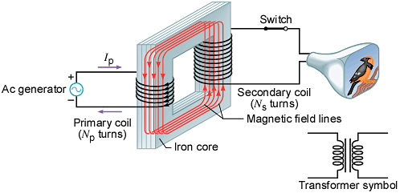

1. Transformer equations are given below. Explain them.

 

2. Under what assumption the above second equation is valid.

3. (Problem-67) A generating station is producing 1.2pixel×pixel106 W of power that is to be sent to a small town located 7.0 km away. Each of the two wires that comprise the transmission line has a resistance per kilometer of length of 5.0pixel×pixel10–2 Ω/km. (a) Find the power lost in heating the wires if the power is transmitted at 1200 V. (b) A 100:1 step-up transformer is used to raise the voltage before the power is transmitted. How much power is now lost in heating the wires? (Power loss in transmission lines,)