PHYS 202 Equations Sheet You may tear this page

1. Force on a moving electric charge in a magnetic field: .

2. Force on a moving electric charge in an electric field. 

3. Centripetal force:

4. Force on a current in a magnetic field. 

5. Magnetic field produced by electric current: 

6. Faraday’s law of induction and Magnetic flux:   

7. Equations for transformers and power loss during transmission are shown below:   
  P = IV  V = IR   
8. Reactance (XC) of a capacitor and Reactance (XL) of an inductor:  
 

9. Impedance (Z) of a series RCL circuit:

sgt3s03

10. Resonant frequency (f0) of a series RCL circuit: resFreq

11. Electromagnetic waves:

12. Circumference, C and Area, A of a circle (radius *r*): $C=2πr$ $A= πr^{2}$ 
 Area of a rectangle = length x width. Area of a triangle =

13. Proton charge = 1.6 x 10-19C. Proton mass = 1.673 x 10-27 kg

PHYS 202 Spring 2023 Test #3 Name:_____________________________

A. Select the correct answer for the multiple choices questions and write your answer in the line next to the question number. Write down your answers for other questions/problems.

____1. The angle that the magnetic field of the earth makes with respect to the surface at  
 any point is:

a. angle of declination b. angle of rotation

c. angle of dip d. angle of latitude

2-3) The magnetic force, F on a moving charge in a magnetic field is given by:  
   
2. Define *θ* , in the above equation:___________________________________________  
  
_______________________________________________________________________  
  
____3. The SI unit for magnetic field, T is equivalent to:   
a. $\frac{N.m}{C.s}$ b. $\frac{N.s}{C.m}$ c. $\frac{N}{C.s}$ d. $\frac{N.s}{C}$ e. $\frac{N.m}{C}$

____4. At a location near the equator, the earth's magnetic field is horizontal and points north. An electron is moving vertically downward to the ground. What is the direction of the magnetic force that acts on the electron?  
a. North b. South c. East d. West

____5. Which one of the following is a unit for electromagnetic power?   
a. C b. W c. J d. T e. Wb f. A

____6. Who is credited for generating and detecting electromagnetic waves for the first time?   
a. Maxwell b. Henry c. Tesla d. Hertz e. Faraday

____7. What is the angle between the E and B fields in an electromagnetic wave?  
a. 00 b. 450 c. 900 d. 1200 e. 1800

____8. Which one of the following is not a ferromagnetic material?  
a. iron b. aluminum c. cobalt d. alnico e. chromium

____9. Which one of the electromagnetic waves is used for medical imaging of the human body?  
A. radio wave B. ultraviolet C. Gamma D. X-ray E. Infrared

____10. Refer the figure to the right. The magnetic field is

into the page. What is the direction of the magnetic force

on the bottom charge, which is proton and moving to the left?

a. UP b. DOWN c. LEFT

d. RIGHT e. OUT f. IN

11-12) Consider the ac voltage shown to the right:

____11. What is the rms voltage for the ac voltage?

a. 7.1 V b. 10 V b. 14 V d. 20 V

____12. What is the frequency of the ac voltage?  
a. 250 Hz b. 500 Hz c. 750 Hz e. 1000 Hz

____13. Which one of the following is a FM wave?14-16) The drawing shows a straight wire carrying a current *I*.   
Above the wire is a rectangular loop that contains a resistor *R*,  
located in the same plane as straight wire.   
  
____14. What is the direction of the magnetic field inside the loop?  
a. coming out (·) b. going in (X)  
  
____15. If the current *I* is constant, what is the direction   
of the induced current through the loop?  
____16. If the current *I* is decreasing in time, what is the direction   
of the induced current through the loop?  
Answers for 15 & 16  
a. clockwise b. counterclockwise c. no current

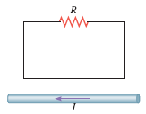

____17. Radio waves travel at the speed of light, 3.0 x 108 m/s. What is the wavelength of the 1000 kHz radio wave? (k = 103)

a. 0.3 m b. 3 m c. 30 m d. 300 m e. 3.0 x 105 m

____18. Identify the capacitor among the circuit elements shown below:  
____19. Identify the diode among the circuit elements shown below:

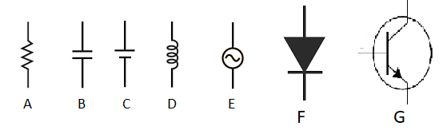

____20. Which one of the following figures correctly shows the variation of reactance of an inductor as a function of frequency?

B. The magnetic field (B) due to a long straight wire, carrying a current (I), at a distance (r) is given by:

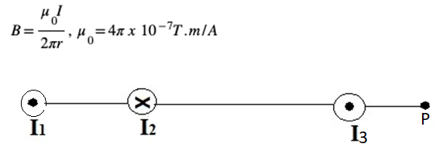

Three long straight current carrying conductors 1, 2, and 3 are located perpendicular to the page, as shown above. They are carrying currents, I1 = 3.5 A (coming out of the page), I2 = 2.5 A (going into the page), and I3 = 1.5 A (coming out of the page), as shown above. Conductors 1 and 2 are separated by 10 cm, conductors 2 and 3 are separated by 25 cm, and point P is 8.0 cm from I3.   
1. Draw the magnetic field with direction by I3 at point P.  
2. Calculate the net magnetic field (magnitude and direction) at point P due to all three currents.

C. A velocity selector is shown for positively charged particles. Between the capacitor plates, magnetic field is perpendicular and coming out of the page. Show the charges in the capacitor plates, magnetic field, magnetic force, and the electric force in the diagram,   
when the charge is inside the plates.

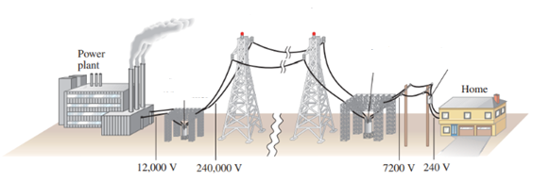D. Power generation and transmission   
  
1. Identify a step-down transformer, step-up transformer, and high-voltage transmission lines in the diagram above.  
  
2. If there are 50 turns in the primary of the step-up transformer, how many turns are there in the secondary?

3. If 2.2 MW of power is transmitted to a town located 37 km away, how much power is lost in the transmission lines? Assume that each of the two transmission lines has a resistance per kilometer of length of 4.5pixel×pixel10–2 Ω/km.

4. What happens to the lost power in 3, above?

E. Faraday’s law of induction:  Ohm’s law: V = IR $f=\frac{1}{T}$

A loop of wire has the initial shape shown in the drawing. The top part of the wire is bent into a semi-circle of diameter 0.30 m, which can be rotated with the handle. A constant magnetic field of magnitude 0.35 T is directed out of the paper.

|  |  |
| --- | --- |
| Initial Shape of the loop | Shape of the loop after ½ a revolution |
|  |  |

1. Sketch the shape of the loop in the box above when the semi-circular side is rotated through ½ of a revolution.

2. What is the change in magnetic flux when the semi-circular side is rotated through ½ of a revolution, starting from the position shown?

3. If the above ½ of a revolution takes 4.5 ms, what is the average induced emf in the loop?

4. If the resistance shown in the loop is 1.8 ohm, what is the induced current?

5. Show the direction of the induced current in the loop?

6. What is the frequency of the above rotation?

7. Describe 4 ways to increase the induced current in the loop.