PHYS 202 Equations Sheet You may tear this page

1. Force on a moving electric charge in a magnetic field. 

2. Force on a moving electric charge in an electric field. 

3. Centripetal force:

4. Force on a current in a magnetic field. 

5. Magnetic field produced by electric current: 

6. Faraday’s law of induction and Magnetic flux:   

7. Equations for transformers and power loss during transmission are shown below:   
  P = IV  V = IR   
8. Reactance (XC) of a capacitor and Reactance (XL) of an inductor:  
 

9. Impedance (Z) of a series RCL circuit:

sgt3s03

10. Resonant frequency (f0) of a series RCL circuit: resFreq

11. Electromagnetic waves:

12. Circumference, C and Area, A of a circle (radius *r*): $C=2πr$ $A= πr^{2}$ 
 Area of a rectangle = length x width. Area of a triangle =

13. Proton charge = 1.6 x 10-19C. Proton mass = 1.673 x 10-27 kg

PHYS 202 Spring 2022 Test #3 Name:_____________________________

A. Select the correct answer for the multiple choices questions and write your answer in the line next to the question number.

____1. The angular difference between the magnetic north and the geographical north is called the

a. angle of declination b. angle of rotation

c. angle of dip d. angle of latitude  
  
____2. A horseshoe magnet and a current-carrying wire are shown in the drawing. The wire is perpendicular to the paper, and the current is directed out of the paper. What is the direction of the magnetic force on the current, in between the poles?

a. Up b. Down   
c. To the Left d. To the Right   
e. in f. out

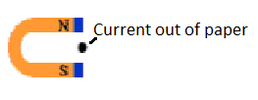

____3. Three particles (A, B, and C) released from a radioactive sample are moving perpendicular to a uniform magnetic field (see the drawing). What are the signs of the charges in the particles?

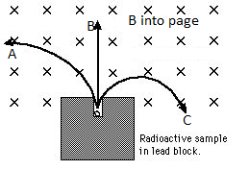

a. All three are positive.

b. All three are negative.

c. All three are neutral.

d. A is positive, B is neutral, and C is negative.

e. C is positive, B is neutral, and A is negative.

f. A is positive, C is neutral, and B is negative.

_____4. Among the electromagnetic waves, which one is used for communications?  
A. radio wave B. ultraviolet C. Gamma D. X-ray E. Infrared

_____5. Who is credited with the development of alternating current electrical system:  
_____6. Who is credited with the development of electromagnetic induction:  
Answers for 5 & 6  
a. Maxwell b. Henry c. Tesla d. Hertz e. Faraday

_____7. Which one of the following is a unit for magnetic field?

_____8. Which one of the following is a unit for magnetic flux?

_____9. Which one of the following is a unit for magnetic energy?

Answers for 7,8,9  
a. C b. W c. J d. T e. Wb f. A

____10. The transformer shown below is:   
a. step-up b. step-down



____11. Identify two quantities (among 1-6) that are the same between the primary and secondary windings of an ideal transformer?  
a. 1 and 2 b. 2 and 3 c. 3 and 4 d. 4 and 5 e. 5 and 6 f. 3 and 6

1. voltage 2. current 3. power   
4. # of turns 5. magnetic flux 6. magnetic field

Magnetic flux is given below; 



____12. Magnetic field lines (B = 0.6 T) are passing through   
a rectangular loop of length 12 cm and width 8.0 cm as shown.  
The angle between the magnetic field and the normal to the   
loop-surface, θ = 250. What is the magnetic flux through   
the loop?  
a. 57.6 T.cm2 b. 24.3 T.cm2

c. 96.6 T.cm2 d. 52.2 T.cm2

e. 96.0 T.cm2 f. 12.0 T.cm2

13-15) The drawing shows a straight wire carrying a current *I*. Below the wire is a rectangular loop that contains a resistor *R*.   
  
____13. What is the direction of the magnetic field inside the loop?  
a. coming out (·) b. going in (X)  
  
____14. If the current *I* is constant, what is the direction   
of the induced current through the resistor *R*?   
____15. If the current *I* is increasing in time, what is the direction   
of the induced current through the resistor *R*?   
Answers to 14 and 15  
a. left to right b. right to left c. no current

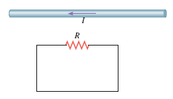

____16. Radio waves travel at the speed of light, 3.0 x 108 m/s. What is the wavelength of the 88.1 MHz radio wave? (M = 106) Speed of light = $C=λf$

a. 3.0 m b. 3.4 m c. 34 m d. 340 m e. 3.4 x 106 m

17-18) Various circuit elements are shown below.   
_____17. Which one represents an inductor?  
_____18. Which one represents a transistor?

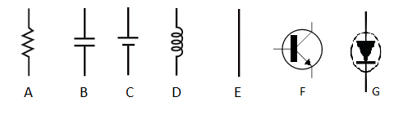

____19. What is the angle between the electric and magnetic fields in an electromagnetic wave?  
a. 00 b. 450 c. 900 d. 1200 e. 1800

____20. Which one of the following is an unmodulated career wave?

____21. Which one of the following is an AM wave?  
____22. Which one of the following is a FM wave?

|  |  |
| --- | --- |
| Answers for 20,21,22 | Figure for Q23 |
|  |  |

____23. The resonance curves for an RLC circuit are shown for various resistances above. Using the plot, determine the Vrms for the 5 ohm resistor at the resonance?   
a. 0.4 mV b. 0.45 mV c. 0.8 mV d. 1.0 mV e. 1.4 mV f. 5.0 mV

____24. In a RCL circuit, a 16.0- resistor, a 4.10-**F capacitor, and a 5.30-mH inductor are connected in series. What is the resonance frequency of this circuit?  
a. 108 Hz b. 546 Hz c. 732 Hz d. 1080 Hz e. 6780 Hz   
  
-----------------------------------------------------------end of MC questions--------------------  P = IV

B. A generating station is producing 1.8 x 106 W of power at 2500 V. A transformer with 50 turns in the primary and 19,000 turns in the secondary is used to change the voltage before the power is transmitted. What is the current in the transmission lines?

|  |  |
| --- | --- |
| Force (*F*) on a moving charge in a magnetic field is given by: | Centripetal force is given by: |
|  |  |

C1. Using the above two equations, Derive an expression for the velocity of a charge particle in circular motion in terms of radius, charge, magnetic field, and mass.

C2. A proton with a speed of 2.8 x 106 m/s is shot into a region between two plates that are separated by a distance of 0.29 m. As the drawing shows, a magnetic field exists between the plates, and it is perpendicular to the velocity of the proton. What must be the (a) magnitude of the magnetic field so the proton just misses colliding with the opposite plate and leaves parallel to the second plate?  
(b) how long the proton takes to clear the magnetic field?

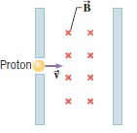

D. Show that the following equation is dimensionally correct, ie, the units match on both sides. $$c=\frac{E}{B}$$

E. The magnetic field due to a long straight wire, carrying a current I, at a distance r is given by; (μ0= 4πx10-7 T.m/A)

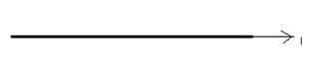



1. Show the cross-section of the magnetic field for the above current, using dots and crosses in the diagram above.

2. Sketch the above magnetic field as a function of the radial distance and current, below, also name the axes.

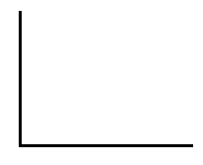

3. Two long straight wires, carrying currents 3.0 A and 4.0 A are separated by a distance of 0.40 m, lie as shown below. Determine the net magnetic field (magnitude and direction) from both currents at point A which is located 0.20 m from the bottom wire, as shown below.

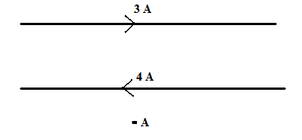

F. Faraday’s law of induction:  Ohm’s law: V = IR

A loop of wire has the shape shown in the drawing.   
The top part of the wire is bent into a triangle of base 0.16 m and   
height 0.08 m. A constant magnetic field of magnitude 0.35 T is   
directed into the paper.   
a. What is the change in magnetic flux when the triangular side   
is rotated through quarter of a revolution, starting from the position   
shown?   
b. If the above quarter of a revolution takes 5.5 ms, what  
is the induced emf in the loop?



c. If the resistance shown in the loop is 1.8 ohm, what is the   
induced current?

d. Show the direction of the induced current in the loop?  
f. What is the frequency of the above rotation?

|  |
| --- |
|  |