PHYS 202 Equations Sheet You may tear this page

1. Force on a moving electric charge in a magnetic field. 

2. Force on a moving electric charge in an electric field. 

3. Centripetal force:

4. Force on a current in a magnetic field. 

5. Magnetic field produced by electric current: 

6. Faraday’s law of induction and Magnetic flux:   

7. Equations for transformers and power loss during transmission are shown below:   
  

1. Reactance (XC) of a capacitor and Reactance (XL) of an inductor:  
 

2. Impedance (Z) of a series RCL circuit:

sgt3s03

3. Resonant frequency (f0) of a series RCL circuit:

resFreq

Electromagnetic waves: 

PHYS 202 Spring 2016 Test #3 Name:\_\_\_\_\_\_\_\_\_\_\_\_\_\_\_\_\_\_\_\_\_\_\_\_\_\_\_\_\_

A. Select the correct answer for the multiple choices questions and write your answer in the line next to the question number. Write down your answers for other questions/problems.

\_\_\_\_1. The angle that the magnetic field of the earth makes with respect to the surface at  
 any point is:   
\_\_\_\_2. The angular difference between the magnetic north and the geographical north is called the

a. angle of declination b. angle of rotation

c. angle of dip d. angle of latitude

3-4) The magnetic force, F on a moving charge in a magnetic field is given by:   
 F = qVB Sin θ  
\_\_\_\_3. What is V in the above equation?  
a. Voltage b. Velocity c. Volume d. Vector   
\_\_\_\_4. The SI unit for magnetic field, T is equivalent to:   
a.  b.  c.  d.  e. 

\_\_\_\_5. At a location near the equator, the earth's magnetic field is horizontal and points north. An electron is moving vertically upward from the ground. What is the direction of the magnetic force that acts on the electron?  
a. North b. South c. East d. West   
e. Vertically upward f. Vertically downward

\_\_\_\_6. In a velocity selector the charged particles experience a magnetic force that is,  
a. equal in magnitude but opposite in direction to that of the electric force  
b. equal to that of the electric force  
c. different in magnitude and direction to that of the electric force

\_\_\_\_7. An electron passes through two rectangular regions that contain uniform magnetic fields, **B1** and **B2**. Each field fills the region completely. Which one of the following is a correct statement?

1. Fields are the same in both regions.
2. **B1** is stronger than **B2**, because the electron bends more in region 1.
3. **B2** is stronger than **B1**, because the electron bends less in region 2.
4. **B1** is stronger than **B2**, because the electron bends less in region 1.
5. **B2** is stronger than **B1**, because the electron bends more in region 2.

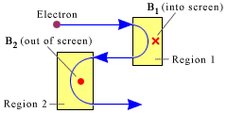

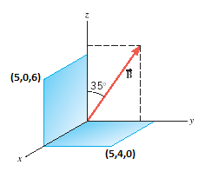

5Bottom of Form

Magnetic flux is given below; 

\_\_\_8. Two surfaces and a magnetic field (B = 0.5T) are   
shown in the xyz coordinate system. The coordinates   
of the corners: (5,0,6) and (5,4,0) are in cm. What is   
the magnetic flux through the surface in the xy plane?  
a. 5.74 T.cm2 b. 8.19 T.cm2

c. 10.0 T.cm2 d. 11.5 T.cm2

e. 15.0 T.cm2 f. 16.4 T.cm2

g. 17.2 T.cm2 h. 24.6 T.cm2

\_\_\_\_9. A loop of wire has the shape shown in the drawing.   
The top part of the wire is bent into a rectangle of length 0.30 m   
and width 0.20 m. A constant magnetic field of magnitude 0.80 T   
is directed into the paper. What is the change in magnetic flux   
when the rectangular side is rotated through ¼ of a revolution,   
starting from the position shown?   
a. 0.012 T.m2 b. 0.024 T.m2   
c. 0.048 T.m2 d. 0.096 T.m2

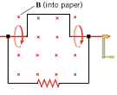

\_\_\_\_10. Which one of the following is not a ferromagnetic material?

a. iron b. nickel c. cobalt d. alnico e. copper

\_\_\_\_11. Which one of the following is the same between the primary and secondary coils of an ideal transformer?

a. voltage b. current c. magnetic flux d. resistance e. power

\_\_\_\_12. A square current-carrying loop is placed in a uniform magnetic field **B** with the plane of the loop parallel to the magnetic field (see the drawing). The dashed line is the axis of rotation. There is \_\_\_\_\_\_\_\_\_\_\_\_\_

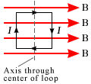

a. a net force and a net torque on the loop.

b. a net force, but not a net torque, on the loop.

c. a net torque, but not a net force, on the loop.

d. neither a net force nor a net torque on the loop.

\_\_\_\_13. A pyroelectric thermometer measures body [temperature](javascript:top.newWin('keywords','content/index/index18.htm',20,20)) by determining the amount of \_\_\_\_\_\_\_\_\_\_\_radiation emitted by the eardrum and surrounding tissue.  
A. radio wave B. ultraviolet C. Gamma D. X-ray E. Infrared

14-16) The drawing shows a straight wire carrying a current *I*.   
Above the wire is a rectangular loop that contains a resistor *R*.   
  
\_\_\_\_14. What is the direction of the magnetic field inside the loop?  
a. coming out (·) b. going in (X)  
  
\_\_\_\_15. If the current *I* is constant, what is the direction   
of the induced current through the resistor *R*?  
\_\_\_\_16. If the current *I* is increasing in time, what is the direction   
of the induced current through the resistor *R*?  
Answers for 15 & 16  
a. left to right b. right to left c. no current

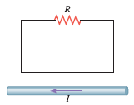

\_\_\_\_17. A truck driver is broadcasting at a frequency of 26.96 x 106 Hz with a CB (citizen's band) radio. Determine the wavelength of the electromagnetic wave being used. Assume a speed of 2.998 x 108 m/s for the electromagnetic waves. Speed of light = $C=λf$  
A. 11.12 m B. 8.993 m C. 8.083 x 1015 m D. 26.96 m E. 2.998 m

    

\_\_\_\_18. Identify the ac source among the circuit elements shown below:

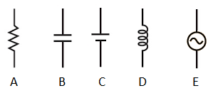

\_\_\_\_19. The reactance/resistance of which of the following increases linearly as a function of frequency?

a. Capacitor b. Inductor c. Resistor  
  
\_\_\_\_20. The resonance curves for an RLC circuit are shown for   
various resistances. Using the plot, determine the angular   
frequency, ω of the resonance?  
a. 10 rad/s b. 104 rad/s c. 105 rad/s   
d. 106 rad/s e. 107 rad/s f. 108 rad/s

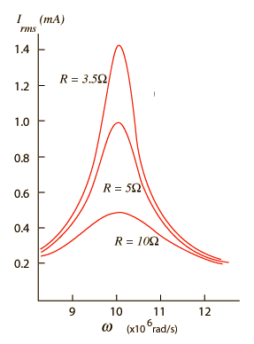

B. The magnetic field (B) due to a long straight wire, carrying a current (I), at a distance (r) is given by:  (μ0= 4πx10-7 T.m/A)

The drawing below shows two perpendicular, long, straight wires, both of which lie in the plane of the paper. The current in each of the wires are shown in the diagram. In the drawing *d*H = 0.13 m and *d*V = 0.30 m. Find the magnitude and direction of the net magnetic fields at points *A*, B, C, and D.

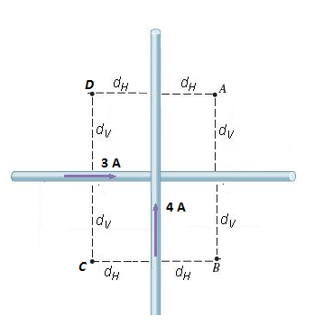

|  |  |
| --- | --- |
|  | fig22_29 |

C. Equations for transformers and power transmission are shown below:   
    
1. Identify a step-down and a step-up transformer in the diagram above.  
  
2. Power plant shown in the figure is a\_\_\_\_\_\_\_\_\_\_\_\_\_\_\_plant.  
a. Nuclear b. Hydroelectric c. Coal-burning d. Solar

3. A generating station is producing 1.8pixel×pixel106 W of power that is to be sent to a small town located 17 km away. Each of the two wires that comprise the transmission line has a resistance per kilometer of length of 4.0pixel×pixel10–2 Ω/km.   
(a) Calculate the total resistance of the two wires.  
(b) Find the power lost in heating the wires if the power is transmitted at 1200 V.  
(c) A 100:1 step-up transformer is used to raise the voltage before the power is transmitted. How much power is now lost in heating the wires?   
(d) A 1000:1 step-up transformer is used to raise the voltage before the power is transmitted. How much power is now lost in heating the wires?

|  |
| --- |
|  |