PHYS 202 Equations Sheet You may tear this page

1. Force on a moving electric charge in a magnetic field. 

2. Force on a moving electric charge in an electric field. 

3. Centripetal force:

4. Force on a current in a magnetic field. 

5. Magnetic field produced by electric current: 

6. Faraday’s law of induction and Magnetic flux:   

7. Equations for transformers and power loss during transmission are shown below:   
  P = IV   
8. Reactance (XC) of a capacitor and Reactance (XL) of an inductor:  
 

9. Impedance (Z) of a series RCL circuit:

sgt3s03

10. Resonant frequency (f0) of a series RCL circuit: resFreq

11. Electromagnetic waves: $c=\frac{E}{B}$ $c= λf$

PHYS 202 Spring 2017 Test #3 Name:_____________________________

A. Select the correct answer for the multiple choices questions and write your answer in the line next to the question number.

____1. The angle that the magnetic field of the earth makes with respect to the surface at  
 any point is:   
____2. The angular difference between the magnetic north and the geographical north is called the

a. angle of rotation b. angle of declination

c. angle of latitude d. angle of dip

3-4) The magnetic force, F on a moving charge in a magnetic field is given by:   
 F = qVB Sin θ   
____3. The SI unit for magnetic field, T is equivalent to:   
a.  b.  c.  d. 

_____4. A 6.5 μC charge is moving with a velocity of 4.2 x 107 m/s in a magnetic field of 0.45 T. The angle between the velocity and magnetic field is 230. What is the magnetic force on the charge?  
a. 123 μN b. 48 μN c. 123 N d. 48 N e. 107 N f. 107 μN

____5. At a location near the equator, the earth's magnetic field is horizontal and points north. A proton is moving east. What is the direction of the magnetic force that acts on the proton?  
a. North b. South c. East d. West   
e. Vertically upward f. Vertically downward

____6. Which one of the following is not a ferromagnetic material?

a. iron b. nickel c. aluminum d. alnico e. cobalt

____7. In Figure I, below, the path of a proton that passes through two regions containing magnetic fields of magnitudes *B*1 and *B*2. Its path in each region is a half-circle. Among the statements below, select the true statements.

a. 1 and 4 b. 2 and 3 c. 2 and 4 d. 1 and 3

|  |  |
| --- | --- |
| http://edugen.wileyplus.com/edugen/courses/crs4957/art/qb/qu/c28/image_eprof05545_c28q_concept_questions_1_7_eat_11897805267690_24905585082570048.jpg Figure I | 1. ***B*1** is into the page and ***B*2** is out of the page. 2. ***B*1** is out of the page and ***B*2** is into the page. 3. ***B*1** is stronger than ***B*2**. 4. ***B*1** is weaker than ***B*2**. |

____8. Three particles are moving perpendicular to a uniform magnetic field and travel on circular paths (see the drawing). They have the same mass and speed. List the particles in order of their charge magnitude, largest to smallest.

|  |  |  |  |  |  |  |  |  |  |  |  |
| --- | --- | --- | --- | --- | --- | --- | --- | --- | --- | --- | --- |
| http://higheredbcs.wiley.com/legacy/college/cutnell/0471663158/sat/media/graphics/sat_c21/sat_c21_q1_06/sat_c21_q1_06_1.gif | |  |  | | --- | --- | | a. | 3, 2, 1 |  |  |  | | --- | --- | | b. | 3, 1, 2 |  |  |  | | --- | --- | | c. | 2, 3, 1 |  |  |  | | --- | --- | | d. | 1, 3, 2 |  |  |  | | --- | --- | | e. | 1, 2, 3 | |

____9. What are the signs for the above charges?  
a. All are positive b. All are negative c. All are neutral  
d. 1 and 2 are positive, 3 is negative  
e. 1 and 2 are negative, 3 is positive

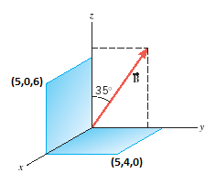

5Bottom of Form

Magnetic flux is given below; 

____10. Two surfaces and a magnetic field (B = 0.5T) are   
shown in the xyz coordinate system. The coordinates   
of the corners: (5,0,6) and (5,4,0) are in cm. What is   
the magnetic flux through the surface in the xz plane?  
a. 5.74 T.cm2 b. 8.19 T.cm2

c. 10.0 T.cm2 d. 11.5 T.cm2

e. 15.0 T.cm2 f. 16.4 T.cm2

g. 17.2 T.cm2 h. 8.6 T.cm2

____11. Identify two quantities (among 1-6) that are the same between the primary and secondary coils of an ideal transformer?  
a. 1 and 2 b. 2 and 3 c. 3 and 4 d. 4 and 5 e. 5 and 6

1. voltage 2. current 3. magnetic flux   
4. resistance 5. power 6. magnetic field

____12. CT scans use which one of the following electromagnetic waves?  
a. Ultraviolet b. Infrared c. X-rays d. Gamma rays e. Microwaves

13-16) The drawing shows a straight wire carrying a current *I*.   
Above the wire is a rectangular loop that contains a resistor *R*.   
  
____13. What is the direction of the magnetic field inside the loop?  
a. coming out (·) b. going in (X)  
  
____14. If the current *I* is constant, what is the direction   
of the induced current through the resistor *R*?   
____15. If the current *I* is increasing in time, what is the direction   
of the induced current through the resistor *R*?   
____16. If the current *I* is decreasing in time, what is the direction   
of the induced current through the resistor *R*?  
Answers for 15 & 16  
a. left to right b. right to left c. no current

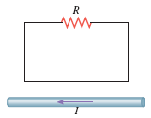

____17. Radio waves travel at the speed of light, 3.0 x 108 m/s. What is the wavelength of the 100 MHz radio wave? (M = 106) Speed of light = $C=λf$

a. 0.3 m b. 3 m c. 30 m d. 300 m e. 3.0 x 106 m

    

____18. Identify the dc source among the circuit elements shown below:

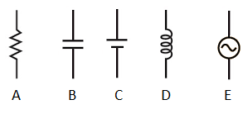

____19. The reactance/resistance of which of the following increases linearly as a function of frequency?

a. Capacitor b. Inductor c. Resistor

____20. Which one of the following shows the reactance of a resistor as a function of frequency?  
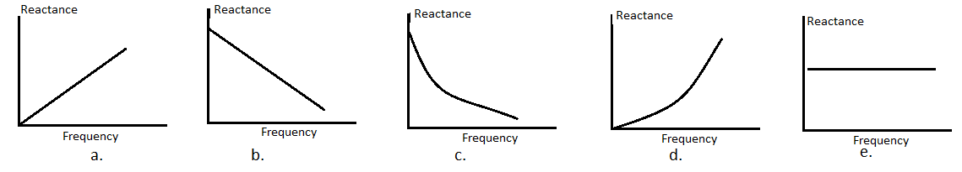____21. What is the angle between the electric and magnetic fields in an electromagnetic wave?  
a. 00 b. 450 c. 900 d. 1200 e. 1800

____22. What type of radio waves are used to communicate with submerged submarines?  
a. AM b. FM c. ELF d. VHF e. SW f. UHF

____23. Which one of the following is a FM wave?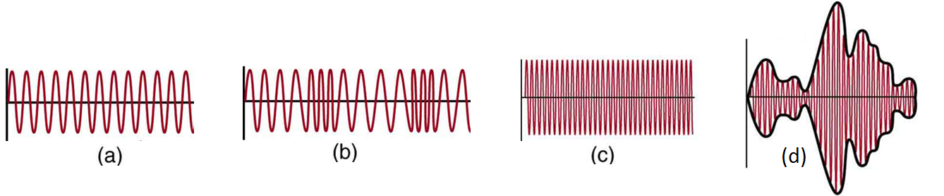  
-----------------------------------------------------------end of MC questions--------------------

B. A generating station is producing 1.6 x 106 W of power at 1100 V. A transformer with 30 turns in the primary and 18,000 turns in the secondary is used to change the voltage before the power is transmitted. What is the current in the transmission lines?

C. In a RCL circuit, a 16.0- resistor, a 4.10-**F capacitor, and a 5.30-mH inductor are connected in series. Calculate the resonance frequency of this circuit.

D. The operation of a positive ion mass spectrometer is illustrated below. Sketch a similar diagram for a negative ion mass spectrometer, inside the empty box on the right.

|  |  |
| --- | --- |
| http://edugen.wiley.com/edugen/courses/crs1650/art/images/halliday8019c28/image_t/tfg014.gif |  |

|  |  |  |
| --- | --- | --- |
| Force (*F*) on a moving charge in a magnetic field is given by: | Centripetal force is given by: | Circumference of a circle: |
|  |  | C = 2πr |

E. A charge (magnitude = 9.2 x 10-4C and mass 6 x 10-4 kg) particle moving with uniform velocity, enters the magnetic field (0.68 T) at right angle, and leaves the field at right angle after travelling quarter of a circle.   
a. Determine the sign of the charge.________________

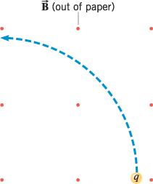

b. How long will it take for the particle to travel the quarter circle?

F. Faraday’s law of induction:  Ohm’s law: V = IR

A loop of wire has the shape shown in the drawing.   
The top part of the wire is bent into a rectangle of length 0.30 m   
and width 0.20 m. A constant magnetic field of magnitude 0.80 T   
is directed into the paper.   
a. What is the change in magnetic flux when the rectangular side   
is rotated through half a revolution, starting from the position   
shown?   
b. If the above rotation of half a revolution takes 8 ms, what  
is the induced emf in the loop?

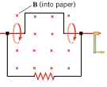

c. If the resistance shown in the loop is 0.15 ohm, what is the   
induced current?

d. What is the direction of the induced current?

G. The magnetic field (B) due to a long straight wire, carrying a current (I), at a distance   
(r) is given by:  (μ0= 4πx10-7 T.m/A)

The drawing below shows three perpendicular, long, straight wires, all of which lie in the plane of the paper. The current in each of the wires are shown in the diagram. Point C is 0.30 m from the 3A current, 0.15 m from the 4A current. The 4A and 5A currents are separated by 0.25 m. Find the magnitude and direction of the net magnetic field at C.

