PHYS 202 Spring 2024 Test #2 Equations Sheet

0. Heat transfer:

1. Ohm’s law: V = IR 2. Electric Power = P = IV 3. Electrical energy =IVt

4. Resistance in terms of resistivity and dimensions: $R=ρ\frac{L}{A}$

|  |  |  |  |
| --- | --- | --- | --- |
| 6. Electric potential due to a point charge (Q) at a distance r: | 7. Electric potential in terms of EPE and point charge (Q): | 8. Electric field due to a point charge (Q) at a distance r: | 9. Electric field (E) from potential gradient: |
| sgt2VduetoQ |  |  |  |

5. Capacitors:   

|  |  |  |
| --- | --- | --- |
| 10. Combination | Resistors | Capacitors |
| Series |  |  |
| Parralel |  |  |

11. Magnitude of the electron charge = 1.6 x 10-19 C.

mp = 1.673 x 10-27kg, qp = 1.6 x 10-19C]

12. 1 Btu = 1055 J 1 calorie = 4.2 J 1 food Calorie = 1000 calorie

RC circuits:   
Time constant = τ = RC, Discharging Equations: $q=q_{0}e^{-\frac{t}{RC}}$ $V=V_{0}e^{-\frac{t}{RC}}$

PHYS 202 Spring 2024 Test #2 Name:___________________________

I. Select the correct answer for the following multiple-choice questions and write your answer in the line next to the question number.

____1. What is the SI unit for *electromotive force*?  
a. N b. A c. W d. J e. V f. Ω

____2. Identify the largest energy unit among the units below:   
a. joule b. watt c. eV d. kWH e. kW f. calorie

____3. Which one of the following biomedical application deals with the eye?  
a. Electroencephalograph b. Electrocardiograph c. Electroretinograph

4-5) Two charges one positive (+Q) and one negative (–Q) are located as shown below. Point A is at equal distance, r from the charges.   
  
_____4. What is the direction of the net electric field at A?  
a. Vertical and down b. Vertical and up

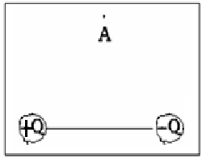

c. Horizontal and to the right d. Horizontal and to the left

e. There is none

_____5. What is the net electric potential at A?  
a. 0 b. $\frac{kQ}{r}$ c. $2\frac{kQ}{r}$ d. $–\frac{kQ}{r}$ e. $–2\frac{kQ}{r}$

_____6. Three capacitors of different capacitances are connected in series and the combination is connected to a battery. Which one of the following is the same across all the capacitances?

a. Voltage b. Current c. Charge d. Resistance e. Capacitance

_____7. Five bulbs are connected to a voltage source, and all are lighting up. Removing any one of the bulbs turns off all the bulbs. How are the bulbs connected?

a. Series b. Parallel

8-10) Refer to the capacitor circuit shown to the right:

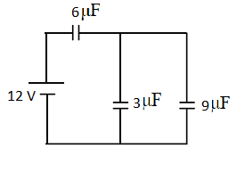

____8. What is the equivalent capacitance?

a. 1.64 µF b. 4.0 µF c. 8.25 µF d. 12 µF e. 18 µF 12 µF

_____9. What is the charge in the 6µF capacitor?

a. 20 µC b. 48 µC c. 99 µC d. 144 µC e. 216 µC

_____10. What is the voltage across the 3µF capacitor?

a. 12 V b. 10 V c. 8 V d. 4 V e. 2 V

11-13) Refers to the circuit shown on the right:

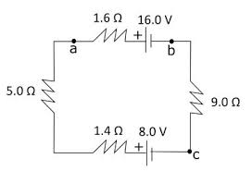

____11. What is the direction of current?  
a. Clockwise b. Counter-clockwise

____12. What is the magnitude of the current?  
a. 2.02 A b. 1.41 A c. 0.74 A   
d. 0.57 A e. 0.47 A

____13. How much is (*Va* – *Vb*)?  
a. 13.74 V b. 15.25 V c. 16.75 V d. 18.26 V

____14. A metal wire of length L and cross-sectional area A, has a resistance R. What will be the resistance of the wire of same material but twice the length and radius?  
a. 4R b. 2R c. R d. ½ R e. ¼ R

____15. Which one of the following is a unit for energy?  
a. Volt • Ampere b. Volt • Ampere • second c. (Volt/Ampere) • second  
d. (Volt/Ampere) • Farad e. Ampere • Second f. (Ampere • Second)/Volt

_____________________________________________________End of MC questions_

II. A lightning bolt of potential difference 65 kilo volt strikes a toll metal pole, of mass 45 kg and raises its temperature by 29 C0. If the charge content of the lighting strike is 19 C, calculate the specific heat of the metal?

III. An appliance is connected to a 220-volt outlet and it draws a current of 1.5 A.

a. What is the resistance of the appliance?

b. What is the power of the appliance?

c. Estimate the cost (in $) for using this appliance for 20 minutes a day for 18 days a month for 6 months? Assume a cost of 13 cents per kWh.

IV. At a distance *r* from a point charge Q, the electric potential, V is given by: .  
1. Identify electric potential as a vector or scalar and state its SI unit in terms of newton (N), meter (m), and Coulomb (C).

2. Three point charges lie in a Cartesian coordinate system as follows: +5nC at (-2 m, 0), +3nC at (-3 m, 4 m), and – 4nC at (0, 3 m). Find the net elec­tric potential at the origin.  
Coulomb constant = k = 9 x 109 (SI), n = 10-9.

V. A heart defibrillator being used on a patient has an RC time constant of 12.0 ms due to the resistance of the patient and the capacitance of the defibrillator.   
(a) If the defibrillator has an 9.00-μF capacitance, what is the resistance of the path through the patient?   
(b) If the initial voltage is 15.0 kV, how long does it take to decline to 500 V ?

VI. For the circuit shown:  
a. Find the equivalent resistance of   
the resistors.  
b. Find the current through the   
7 ohm resistor.  
c. Find the voltage across the   
vertical 6 ohm resistor.

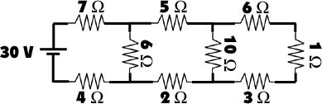

VII. Kirchhoff’s Rules.

|  |  |
| --- | --- |
| For the circuit shown:  1. Assign unknown currents.  2. Identify the low and high potentials for the resistors and batteries.  3. Write down the potential differences across the resistors in terms of the assigned currents and the given resistance values.  4. Write down the junction rule equation using the assigned currents.  5. Write down the loop rule equation, for 2 different loops.  [No need to solve the simultaneous equations] | 4. |

5.