PHYS 202 Spring 2023 Test #2 Equations Sheet

1. Ohm’s law: V = IR 2. Electric Power = P = IV 3. Electrical energy =IVt

4. Resistance in terms of resistivity and dimensions: $R=ρ\frac{L}{A}$

|  |  |  |  |
| --- | --- | --- | --- |
| 6. Electric potential due to a point charge (Q) at a distance r: | 7. Electric potential in terms of EPE and point charge (Q): | 8. Electric field due to a point charge (Q) at a distance r: | 9. Electric field (E) from potential gradient: |
| sgt2VduetoQ |  |  |  |

5. Capacitors:   

|  |  |  |
| --- | --- | --- |
| 10. Combination | Resistors | Capacitors |
| Series |  |  |
| Parralel |  |  |

11. Magnitude of the electron charge = 1.6 x 10-19 C. 1 Btu = 1055 J 1 cal = 4.2 J

PHYS 202 Spring 2023 Test #2 Name:___________________________

I. Select the correct answer for the following multiple choice questions and write your answer in the line next to the question number.

____1. What is the SI unit for *electromotive force*?  
a. N b. A c. W d. J e. V f. Ω

____2. Identify the smallest energy unit below:   
a. joule b. Btu c. eV d. food Calorie e. calorie

____3. An appliance is connected to a 120-volt outlet and it draws a current of 0.25 A. What is the power of the appliance?

a. 30 W b. 60 W c. 80 W d. 120 W e. 240 W

____4. Which one of the following biomedical application deals with the brain?  
a. EGK b. EKG c. EEG d. ERG e. CEG

____5. In a common household circuit, devices are connected in

A. Series B. Parallel

____6. A metal wire of length L and cross-sectional area A, has a resistance R. What will be the resistance of the same material and length but twice the radius?  
a. 4R b. 2R c. R d. ½ R e. ¼ R

____7. Which one of the following is placed between capacitor plates to increase the capacitance?  
a. Conductor b. Dielectric c. Resistance d. Semiconductor

____8. Identify the scalars among the quantities below? (Multiple Answers)

a. Electric potential b. Electric field c. Electric force   
d. Electric energy e. Electric power

____9. What is the charge in the 3 µF capacitor for the capacitor circuit shown below?

1. 18 µC

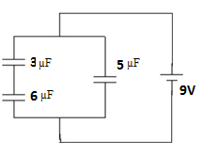

1. 27 µC
2. 45 µC
3. 54 µC
4. 63 µC

_____10. What is the voltage across the 7 Ω resistor in the circuit shown below?

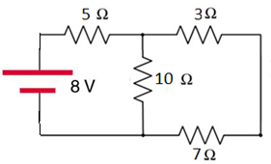

1. 1.2 V b. 2.0 V
2. 2.8 V d. 6.0 V e. 8.0 V

11-12) A light bulb is connected to a battery as shown below.   
____11. What is the direction of the current flow?   
____12. What is the direction of the electron flow?  
Answers for 11 & 12  
a. Clockwise b. Counterclockwise

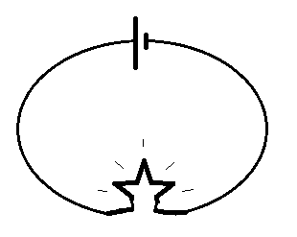

End of MC questions--------------------------------------------

II. Consider the circuit shown in the right.

a. Show the direction of current for the circuit shown, in the circuit?

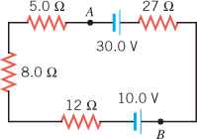

b. Determine the magnitude of the current for the circuit shown?

c. Determine $V_{A}-V_{B}:$

III. Estimate the cost of electricity for operating a clothes iron which consumes 4.5 A of current when plugged in a 120-V outlet. It is used 15 minutes a day for 20 days a month for 1 year. Assume a cost of 14 cents per kWh.

IV. An evacuated tube uses an accelerating voltage of 48.4 kV to accelerate electrons to hit a copper plate and produce x rays. Non-relativistically, what would be the maximum speed of these electrons? [me = 9.11 x 10-31kg, │Qe│= 1.6 x 10-19C]   
 Voltage = $V=\frac{EPE}{Q}$

V. At a distance *r* from a point charge Q, the electric potential, V is given by: .  
Four point charges lie in a Cartesian coordinate system as follows: +6nC at (-1 m, 0), +5nC at (0, 0), +3nC at (2 m, 0), and – 4nC at (0, 3 m). Find the net elec­tric potential at (2 m, 3 m). Coulomb constant = k = 9 x 109 (SI), n = 10-9.

VI. Combine all the resistances into a single one, between A & B, for the circuit shown:

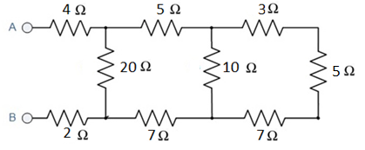

VII. Kirchhoff’s Rules.

For the circuit shown:

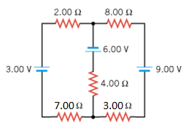

1. Assign three unknown currents.

2. Identify the low and high potentials for the resistors and   
batteries.

3. Write down the potential differences across the resistors   
in terms of the assigned currents and the given resistance   
values.

4. Write down the junction rule equation using the assigned   
currents.

5. Write down the loop rule equation, for the left loop.

6. Write down the loop rule equation, for the right loop.

[No need to solve the simultaneous equations]

VIII. RC circuits: Time constant = τ = RC, $I=I_{0}e^{-\frac{t}{RC}}$  
  
The variation of the Current as a function of time is shown below for an RC circuit.

1. Read the current at t = 0? _________________

2. Read the current at t = 1ms?________________

3. Calculate the time constant using $I=I_{0}e^{-\frac{t}{RC}}$.