PHYS 202 Spring 2018 Test #2 Equations Sheet

1. Ohm’s law: V = IR 2. Electric Power = P = IV 3. Electrical energy =IVt

4. Resistance in terms of resistivity and dimensions: $R=ρ\frac{L}{A}$

|  |  |  |  |
| --- | --- | --- | --- |
| 6. Electric potential due to a point charge (Q) at a distance r: | 7. Electric potential in terms of EPE and point charge (Q): | 8. Electric field due to a point charge (Q) at a distance r: | 9. Electric field (E) from potential gradient: |
| sgt2VduetoQ |  |  |  |

5. Capacitors:   

|  |  |  |
| --- | --- | --- |
| 10. Combination | Resistors | Capacitors |
| Series |  |  |
| Parralel |  |  |

PHYS 202 Spring 2018 Test #2 Name:___________________________

I. Select the correct answer for the following multiple choice questions and write your answer in the line next to the question number.

____1. What is the SI unit for *electromotive force*?  
a. N b. A c. W d. J e. V f. Ω

____2. Identify the smallest energy unit below:   
a. joule b. watt c. eV d. kWH e. kW f. calorie

____3. An appliance is connected to a 120-volt outlet and it draws a current of 0.25 A. What is the power of the appliance?

a. 30 W b. 60 W c. 80 W d. 120 W e. 240 W

____4. An appliance with a power rating of 600-W is connected to a 120-volt outlet. What is the current through the appliance?

a. 10 A b. 1 A c. 18 A d. 12 A e. 5 A

___5. Estimate the cost of electricity for operating a 650-W electric kettle for 15 minutes a day for 30 days. Assume a cost of 9 cents per kWh.  
a. 4.9 cents b. 44 cents c. 4.4 cents d. $26 e. $44 f. 49 cents

____6. Which one of the following biomedical application deals with the heart?  
a. EGK b. EKG c. EEG d. ERG e. CEG

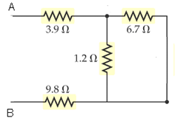

____7. What is the equivalent resistance between A and B for the   
network shown:

1. 1.02 Ω
2. 3.9 Ω
3. 9.8 Ω
4. 14.7 Ω
5. 21.6 Ω

8-9) Refer the figure to the right of a material. The resistance   
depends on the path that the current takes. The drawing shows a   
situation in which the battery is connected as shown.   
  
___8. To calculate the resistance what length should be used?

1. *L0* b. 2*L0* c. 3*L0* d. 4*L0*

___9. To calculate the resistance what cross sectional area   
 should be used?  
 a. *L0*2 b. 2*L0*2 c. 4*L0*2 d. 8*L0*2

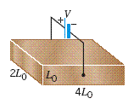

____10. Which one of the following is placed between capacitor plates to increase the capacitance?  
a. Conductor b. Dielectric c. Resistance d. Semiconductor

____11. Which one of the following is a scalar?

a. Electric potential b. Electric field c. Electric force d. Acceleration

12-13) Two identical negative charges (–Q) are located as shown below. Point A is at equal distance, r from the charges.   
_____12. What is the net electric field at A?  
a. Vertical and down b. Vertical and up

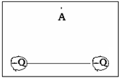

c. Horizontal and to the right d. Horizontal and to the left

e. There is none

_____13. What is the net electric potential at A?  
a. 0 b. $\frac{kQ}{r}$ c. $2\frac{kQ}{r}$ d. $–\frac{kQ}{r}$ e. $–2\frac{kQ}{r}$

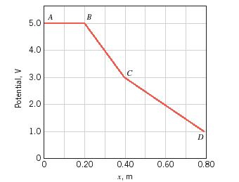

14-15) Refer the figure to the right which shows the electric   
potential as a function of distance along the *x* axis.

____14. What is the potential in V at 0.30 m?  
a. 1 b. 2 c. 3 d. 4 e. 5

____15. Determine the magnitude of the electric field in V/m   
in the region *C* to *D*?  
a. 10 b. 2 c. 3 d. 4 e. 5 f. 0

___16. What is the charge in the 3 µF capacitor for the circuit shown below?

1. 18 µC

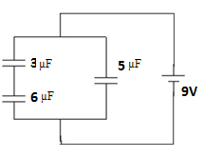

1. 27 µC
2. 45 µC
3. 54 µC
4. 63 µC

____17. What is the direction of current for the circuit shown?  
a. Clockwise b. Counter clockwise

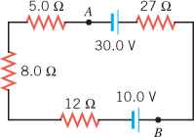

____18. Determine the magnitude of the current for the circuit shown?  
a. 0.048 A b. 0.14 A c. 0.62 d. 0.77 A e. 0.38 A

19-20) Deals with the electric field lines of two charges as shown:

____19. The polarities of the charges are,

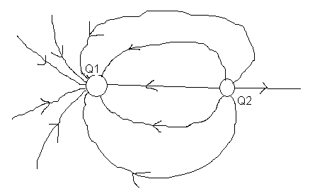

A. Q1 is positive and Q2 is negative

B. Q2 is positive and Q1 is negative

C. Both are positive

D. Both are negative

____20. The ratio Q1/Q2 is given by,

A. 1 B. 2 C. 3   
D. 4 E. 5 F. 1.5

____21. In a common household circuit, devices are connected in

A. Series B. Parallel

____22. A proton and an electron are released from rest at the midpoint between the plates of a charged parallel plate capacitor. Except for these particles, nothing else is between the plates. Ignore the attraction between the proton and the electron, and decide which particle strikes a capacitor plate first and why?  
a. The proton will strike first since it will experience a greater force  
b. The proton will strike first since it will experience a greater acceleration  
c. The electron will strike first since it will experience a greater acceleration  
d. The electron will strike first since it will experience a greater force

____23. What is the shape of one of the equipotential surfaces for an isolated point charge?

a. plane b. circle c. sphere d. parabola e. ellipse  
_______________________________________End of MC questions_________________

II. An evacuated tube uses an accelerating voltage of 48.4 kV to accelerate electrons to hit a copper plate and produce x rays. Non-relativistically, what would be the maximum speed of these electrons? [me = 9.11 x 10-31kg, │qe│= 1.6 x 10-19C]   
 Voltage = $V=\frac{EPE}{Q}$

|  |  |  |  |  |
| --- | --- | --- | --- | --- |
|  |  |  |  | $$\vec{F}=m\vec{a}$$ $$\vec{E}=\frac{\vec{F}}{q}$$ |

III. Figure below shows a proton passing between two charged metal plates that create an electric field of 45 N/C, perpendicular to the proton’s original horizontal velocity. The initial speed of the proton is 2.00×104 m/s, and the horizontal distance it travels in the uniform field is 8.00 cm.   
(a) Sketch the electric field between the plates.  
(b) Sketch the path of the proton as it travels between the plates and exits.   
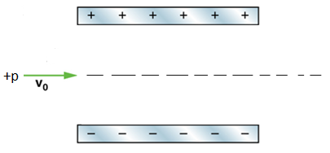  
(c) How long will it take the proton to cross the plates?

(d) What is the vertical acceleration of the proton?   
[mp = 1.673 x 10-27kg, qp = 1.6 x 10-19C]

(e) What is its vertical deflection of the proton?

(f) What is the vertical component of its final velocity?

(g) At what angle, with the horizontal, does the proton exit?

IV. At a distance *r* from a point charge Q, the electric potential, V is given by: .  
1. Identify electric potential as a vector or scalar and state its SI unit.

2. Three point charges lie in a Cartesian coordinate system as follows: +5nC at (0, 0), +3nC at (2 m, 0), and – 4nC at (0, 3 m). Find the net elec­tric potential at (2 m, 3 m).  
Coulomb constant = k = 9 x 109 (SI), n = 10-9.

V. Combine all the capacitances into a single one, between A & B, for the circuit shown:

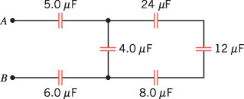

VI. Kirchhoff’s Rules.

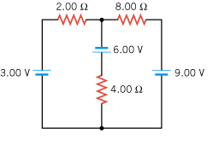  
For the circuit shown above:

1. Assign three unknown currents: *I1*, *I2*, and *I3*.

2. Identify the low and high potentials for the resistors and batteries.

3. Write down the potential differences across the resistors in terms of the assigned currents and the given resistance values.

4. Write down the junction rule equation using the assigned currents.

5. Write down the loop rule equation, for 2 different loops.

[No need to solve the simultaneous equations]