PHYS 202 Spring 2017 Test #2 Equations Sheet

1. Ohm’s law: V = IR 2. Electric Power = P = IV 3. Electrical energy =IVt

4. Resistance in terms of resistivity and dimensions:

5. Capacitors:   

|  |  |  |
| --- | --- | --- |
| 6. Electric potential due to a point charge (Q) at a distance r: | 7. Electric field due to a point charge (Q) at a distance r: | 8. Electric field (E) from potential gradient: |
| sgt2VduetoQ |  |  |

|  |  |  |
| --- | --- | --- |
| 9. Combination | Resistors | Capacitors |
| Series |  |  |
| Parralel |  |  |

10. Time constant of an RC circuit = RC.

PHYS 202 Spring 2017 Test #2 Name:___________________________

I. Select the correct answer for the following multiple choice questions and write your answer in the line next to the question number.

____1. The *electromotive force* is also known as  
a. Force b. Current c. Power d. Energy e. Voltage

____2. The *electron volt* is a unit of  
a. Voltage b. Current c. Power d. Energy e. Force

____3. An appliance is connected to a 120-volt outlet and it draws a current of 0.50 A. What is the power of the appliance?

a. 30 W b. 60 W c. 80 W d. 120 W e. 240 W

____4. An appliance with a power rating of 2200-W is connected to a 120-volt outlet. What is the current through the appliance?

a. 10 A b. 1 A c. 18 A d. 12 A e. 5 A

____5. Estimate the cost of electricity for operating a dozen 15-W LCD panels for 4 hours a day for 20 days a month for nine months. Assume a cost of 8 cents per kWh.

a. $ 0.52 b. $ 0.86 c. $ 1.15 d. $ 1.30 e. $ 10.37

____6. Which one of the following biomedical application deals with eye?  
a. EKG b. ECG c. EEG d. ERG e. CEG

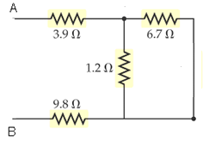

____7. Which one of the following you should do as the first step,   
to find the equivalent resistance between A and B for the network   
shown:

1. Combining 1.2 Ω and 6.7 Ω in series
2. Combining 1.2 Ω and 6.7 Ω in parallel
3. Combining 3.9 Ω, 1.2 Ω, and 9.8 Ω in series
4. Combining 3.9 Ω, 6.7 Ω, 1.2 Ω, and 9.8 Ω in series

____8. Which one of the following is placed between capacitor plates to increase the capacitance?  
a. Conductor b. Insulator c. Dielectric d. Resistance e. Semiconductor

____9. Determine the length necessary to obtain a resistance of 0.456 Ω using a Cu wire of diameter 0.180 mm. Resistivity of Cu = ρ = 1.72 x 10-6 Ω.cm.

a. 57.6 cm b. 65.7 cm c. 67.5 cm d. 130 cm e. 270 cm

____10. Two parallel capacitor plates, separated by, d = 0.30 cm,   
are connected across a 9-V battery. What is the magnitude of the  
electric field between the plates?  
a. 100 V/m b. 200 V/m c. 300 V/m d. 270 V/m e. 30 V/m

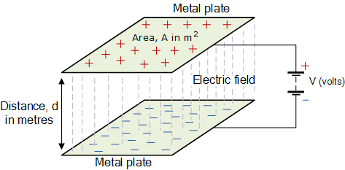

____11. Which one of the following is a vector?

a. Electric potential b. Electric field c. Electric energy d. Electric power

12-13) Two charges –Q and +Q with equal magnitudes are located as shown below. Point A is at equal distance from the charges.   
_____12. What is the net electric field at A?  
_____13. What is the net electric potential at A?

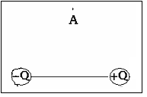

a. Vertical and down b. Vertical and up

c. Horizontal and to the right d. Horizontal and to the left

e. There is none

___14. What is the charge in the 5 µF capacitor for the circuit shown below?

1. 18 µC

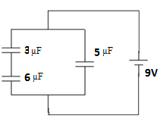

1. 27 µC
2. 45 µC
3. 54 µC
4. 63 µC

____15. What is the charge in the 2 µF capacitor for the circuit shown below?

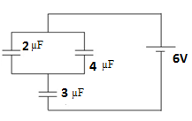

1. 4 µC
2. 8 µC
3. 10 µC
4. 12 µC
5. 16 µC

____16. What is the SI unit for RC, where R is the resistance and C is the capacitance?  
a. meter b. coulomb c. volt d. second e. farad f. ohm

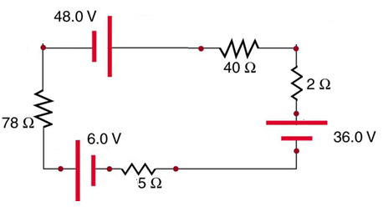

____17. What is the direction of current for the circuit shown?  
a. Clockwise b. Counter clockwise

____18. Determine the magnitude of the current for the circuit shown?  
a. 0.048 A b. 0.14 A c. 0.62 d. 0.72 A e. 0.41 A

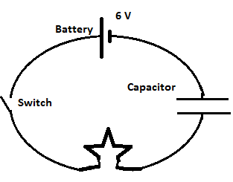

19-20) A 6-V battery, capacitor (uncharged), bulb, and a switch are connected as shown.  
____19. What will be the potential difference across the bulb   
at the instant, the switch is closed?  
____20. What will be the potential difference across the bulb   
after a long time, from the instant the switch is closed?  
Answers for 19 & 20  
a. 0 b. 1.5 V c. 3 V d. 6 V

II. At a distance *r* from a point charge Q, the electric potential, V is given by: .

1. Identify electric potential as a vector or scalar and state its SI unit.

2. Calculate the total electric potential at D, due to the three charges shown below. Use three significant figures. Coulomb constant, k = 8.99 x 109 (SI).

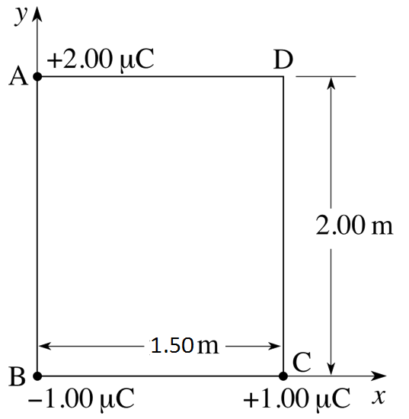

III. Combine all the resistances into a single one, between A & B, for the circuit shown:

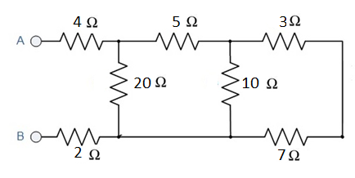

IV. Kirchhoff’s Rules.

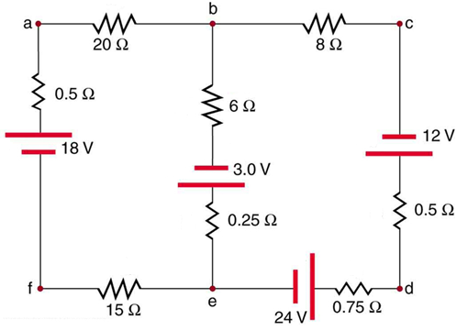  
For the circuit shown above:

1. Assign three unknown currents: *I1*, *I2*, and *I3*.

2. Identify the low and high potentials for the resistors and batteries.

3. Write down the potential differences across the resistors in terms of the assigned currents and the given resistance values.

4. Write down the junction rule equation using the assigned currents.

5. Write down the loop rule equation, for 2 different loops.

[No need to solve the simultaneous equations]