When you sit, Leave space between your neighbors  
No Phone or Internet Use during the Exam  
Use only a Calculator and a pen or pencil  
Tear this page and use it as your worksheet for MC questions. All others show your work in the space under these questions/problems.

PHYS 202 Spring 2017 Test #1 Name:

$T_{F}=\frac{9}{5}T_{C}+32$ $T_{K}=T_{C}+273$____________________________

A. For the multiple choice questions write your answer in the line next to the question #.

____1. Which one of the following temperatures is approximately equal to the typical temperature of a classroom?   
 a. 373 K b. 23 0F c. 23 0C d. 73 0C e. 73 K

____2. Express the temperature 4.2 K in oF unit?  
 a. 39.6 b. – 117 c. – 269 d. – 452 e. – 484  
  
____3. What is the difference in Fo of the two temperatures, -35oC and 62oC?  
 a. 54 F0 b. 15 F0 c. 36 F0 d. -2.7 F0 e. 175 F0   
  
____4. What is the thermometric property of an ear thermometer?  
____5. What is the thermometric property of a constant volume gas thermometer?  
____6. What is the thermometric property of a thermocouple?  
Answers for 4-6  
a. Length of a liquid column b. Voltage c. Pressure of a gas  
d. Infrared radiation e. Ultraviolet radiation f. Resistance  
  
____7. The zeroth law of thermodynamics is,   
____8. The first law of thermodynamics is,  
____9. The second law of thermodynamics is,  
Answers for 7-9  
a. The law of conservation of energy.

b. Heat flows spontaneously from a substance at a higher temperature to a substance at a lower temperature.

c. Heat flows spontaneously from a substance at a lower temperature to a substance at higher temperature.   
d. If two systems individually in thermal equilibrium with a third system, then the two systems are in thermal equilibrium with each other.  
e. It is not possible to lower the temperature of any system to absolute zero in a finite number of steps.  
  
____10. Conductors have free_____________.   
A. Protons B. Neutrons C. Electrons D. Nucleons E. Atoms

____11. What is the shape of one of the equipotential surfaces for an isolated point charge?  
____12. What is the shape of one of the equipotential surfaces for a parallel plate capacitor?  
Answers for 11-12: a. plane b. circle c. sphere d. parabola e. ellipse  
  
____13. How many coulombs of positive charge are there in 9.5 kg of plutonium, given its atomic mass is 244g and that each plutonium atom has 94 protons?   
(qp= +1.6 x 10-19C, NA= 6.022 x 1023)  
a. 3.8 x 106 C b. 3.5 x 105 C c. 3.5 x 108 C d. 5.3 x 108 C

The linear coefficients of thermal expansion are:  
α steel = α concrete = 12x10-6(Co)-1, α aluminum = 23x10-6(Co)-1, α copper = 17x10-6(Co)-1.   
Volume coefficient of expansion of radiator coolant = β = 390 x 10-6 (Co)-1.

 , for solids  
____14. Concrete sidewalks are always laid in sections, with gaps between each section. For example, the drawing shows four identical 2.4-m sections, the outer two of which are against immovable walls. The three identical gaps between the sections are provided so that thermal expansion will not create the thermal stress that could lead to cracks. What is the minimum gap width necessary to account for an increase in temperature of 32 C°?  
a. 0.92 x 10-3m b. 1.0 x 10-3m c. 1.2 x 10-3m d. 1.3 x 10-3m e. 1.4 x 10-3m

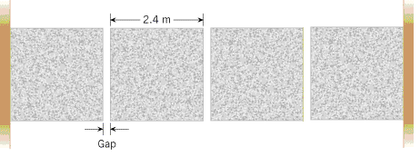

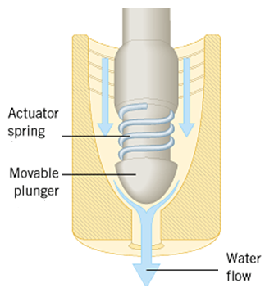

____15. For the highest accuracy, which of the material is ideal for a tape   
rule for year-round outdoor use?  
____16. Anti-scalding device shown to the right uses actuator  
spring to block the flow of hot water. For better results the spring  
should be made of:  
Answers for 15 & 16:   
a. Aluminum b. Steel c. Copper   
  
17-19) A radiator is made of copper and is filled to its 22.0-L capacity when at  What volume of radiator coolant will overflow when the radiator and coolant reach 1250C?  
____17. What is the change in volume of the coolant?  
____18. What is the change in volume of the radiator?  
____19. What volume of coolant will overflow?  
Answers for 17-19:   
a. 0.129 L b. 0.987 L c. 0.858 L d. 1.12 L e. 0.091 L f. 0.896 L

Specific heat of ice = 0.480 cal/(g.C0), Latent heat of fusion of ice = 79.7 cal/g,   
Specific heat of water = 1.00 cal/(g.C0) . Q = mL

B. A 45g ice cube at  is placed in 350g of  water in a very well-insulated container. What is the final equilibrium temperature?

First Law of thermodynamics: ∆U = Q - W. W= P.∆V U = (3/2)nRT

C. An ideal gas is taken through the three processes (A→B, B→C, and C→A) shown in the drawing, where CA is an isotherm.   
  
1. Name the process **AB** ____________________ and **BC**_______________________.  
  
2. For the three processes shown in the drawing, fill in the eight missing entries in the following table.

|  |  |  |  |  |  |  |  |  |  |  |  |  |  |  |  |  |  |
| --- | --- | --- | --- | --- | --- | --- | --- | --- | --- | --- | --- | --- | --- | --- | --- | --- | --- |
|  | |  |  |  |  | | --- | --- | --- | --- | | Process | ∆U | Q | W | | A→B | b. | +70,000 J | a. | | B→C | d. | e. | c. | | C→A | f. | g. | 65,000 J |   h. Area of the shaded shape ABC= |

D. Schematic diagram for a heat engine is shown below. Sketch a similar diagram for a refrigerator in the box below. Also write an expression/equation involving *QH, QL, and W.*

|  |  |  |
| --- | --- | --- |
| http://edugen.wiley.com/edugen/courses/crs1650/art/images/halliday8019c20/image_t/tfg008.gif |  | Expression/equation involving *QH, QL, and W.* ___________________ |
| Heat Engine | Refrigerator |

E. (a) Sketch the electric field lines near a point charge +q. (b) Do the same for a point charge –2q. Both are isolated, not interacting.

+q –2q

F. Coulomb’s law is given by: F:\PHYS202\Study Guides\sgt2CouLaw.gif Coulomb’s constant = k = 9 x 109 (SI)  
1. Express the SI unit of the Coulomb’s constant:__________________________

2. Figure below shows three point charges that lie along the *x* axis in a vacuum, with no gravity.   
a. Draw a free-body diagram for the charge *q2*.  
b. Determine the magnitude and direction of the net electrostatic force on *q2*. (µ=10-6)



|  |  |  |  |  |
| --- | --- | --- | --- | --- |
|  |  |  |  |  |

G. Figure below shows an electron passing between two charged metal plates that create an electric field of 375 N/C, perpendicular to the electron’s original horizontal velocity. The initial speed of the electron is 3.00×106 m/s, and the horizontal distance it travels in the uniform field is 6.00 cm.   
(a) Sketch the electric field between the plates.  
(b) Sketch the path of the electron as it travels between the plates and exits.   
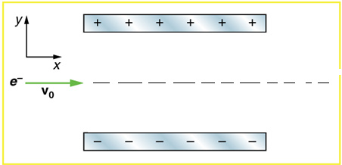  
(c) How long will it take the electron to cross the plates?

(d) What is the vertical acceleration of the electron? [me = 9.11 x 10-31kg, |qe| = 1.6 x 10-19C]

(e) What is its vertical deflection of the electron?

(f) What is the vertical component of its final velocity?

(g) At what angle, with the horizontal, does the electron exit?