PHYS 202 Electric Potential due to point charges Name:______________________
Electric potential due to a point charge at a distance r: 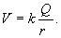
P17) The drawing shows four point charges. The value of q is 1.6 μC, and the distance d is 0.94 m. Find the total potential at the location P. Assume that the potential of a point charge is zero at infinity.
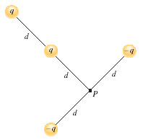

P21) Identical +3.31 μC charges are fixed to adjacent corners of a square. What charge (magnitude and algebraic sign) should be fixed to one of the empty corners, so that the total potential at the remaining empty corner is 0 V?
