PHYS 202 Electric Generator (Electricity) Name:______________________________
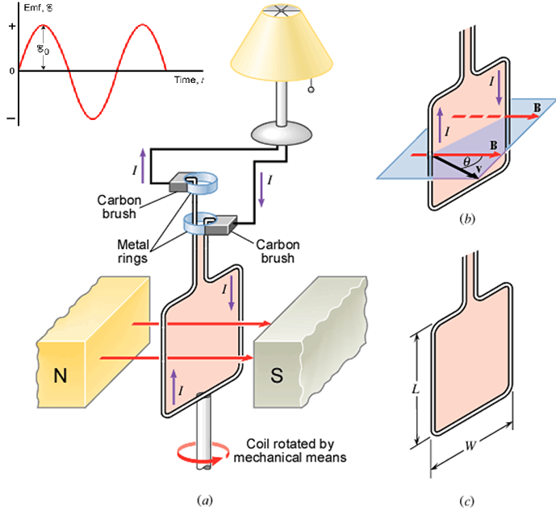
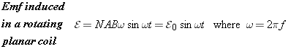
41. A generator has a square coil consisting of 248 turns. The coil rotates at 79.1 rad/s in a 0.170-T magnetic field. The peak output of the generator is 75.0 V. What is the length of one side of the coil?

42. You need to design a 60.0-Hz ac generator that has a maximum emf of 5500 V. The generator is to contain a 150-turn coil that has an area per turn of . What should be the magnitude of the magnetic field in which the coil rotates?

