PHYS 202 HWK on B due to I Name:_________________________

1. Write down an expression for the magnitude of the magnetic field (B) due to a long straight wire, carrying a current I, at a distance r. (μ₀= 4πx10⁻⁷ T.m/A)
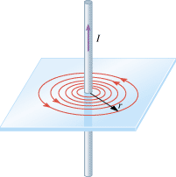

2. The direction of the above magnetic field can be obtained
using right-hand-rule #2. Describe right-hand-rule #2 below.

3. Describe two properties of the above magnetic field.

4. (P59) Two long, straight wires are separated by 0.120 m. The wires carry currents of 8.0 A inopposite directions, as the drawing indicates. Find the magnitude of the net magneticfield at the points labeled (a) A and (b) B. Ans: 4.3 x 10⁻⁵ T, 5.3 x 10⁻⁵ T.
