VIBRATING STRING PHYS 201L Name:__________________________
Partner(s):______________________________________________________________
Consider the ripple waves on a pond: https://www.youtube.com/watch?v=T9QwiBFN9gI

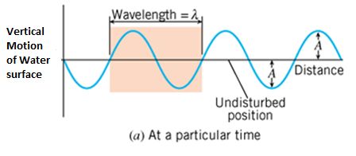 | 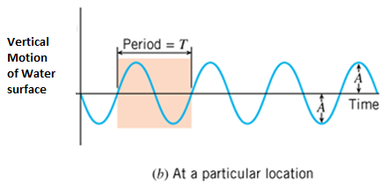

The amplitude, A is the maximum disturbance.

The wavelength, λ is the horizontal length of one cycle of the wave.

The period, T is the time required for one complete up/down cycle of the wave.

The frequency, f is the number of waves per unit time.
$Frequency=\frac{1}{Period}$

Wave Speed = $\frac{Distance}{Time}$ = $\frac{Wavelength}{Period}=Wavelength×\frac{1}{Period}=Wavelength×Frequency$

$$Wave Speed=Wavelength×Frequency$$

Purpose: To investigate standing waves in a stretched string and determine the wave speed.
Apparatus: String vibrator, clamp for string vibrator, string (~2m), mass set, mass hangers (50-g and 5-g), electronic balance (accuracy 0.01-g), meter stick, and pulley w/clamp.
https://www.youtube.com/watch?v=wXRNKz0xMOU&t=16s

Theory: Stringed musical instruments are played by plucking or bowing a stretched string. In the first investigation a string vibrator will make the string to vibrate at a frequency of 60 Hz. The tension will be provided by a hanging mass. The vibrations will travel along the string and get reflected at the other end. The reflected waves and the incoming waves will interfere and form standing waves. By varying the tension, T standing waves with different number of loops can be obtained. The standing waves for two and three loops are shown below. Loop length is obtained by dividing the length of the vibrating string by the number of loops. Wavelength is twice the loop length.
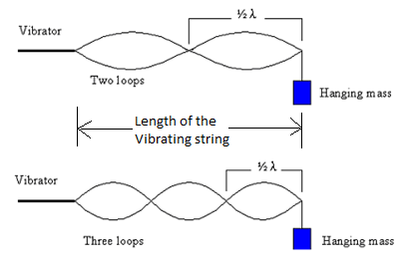
In terms of hanging mass, m and acceleration due to gravity, g tension force, F_{T} is given by:
$F_{T}=mg$
In terms of frequency, f and wavelength, λ the wave speed, v is given by:
In terms of tension, T and strings linear density, μ the wave speed, v is given by:
$v=\sqrt{\frac{F_{T}}{μ}}$
Linear Density: Linear density, μ is a property of the string which tells us whether the string is "heavy" or "light". You may know that the four violin strings are not the same. Some are thick and others are thin. The heavy strings are used for low frequency tones and the light ones are for high frequency tones. In this investigation you will determine μ, by measuring the length (without any knots) and mass of the string before attaching it to the string vibrator, to 3 significant figures.
Show that the following equation is correct unit wise, dimensionally correct:
$v=\sqrt{\frac{F_{T}}{μ}}$

DATA: Use SI units
Total length of string = ________________ Total mass of string = _________________
Linear Density = μ = ________________ Acceleration due to gravity = g = 9.8 m/s²
Length of the vibrating string = _________________
Table I: For a particular # of loops, obtain resonance with the highest amplitude by changing the hanging mass. Frequency = f = 60 Hz. Use Excel to construct this data table.
# of Loops | Loop length | Wavelength, λ | Hanging mass, m | Tension,  $$F_{T}=mg$$ | Wave Speed, V |  | % Difference
 |  |  |  |  | Using f & λ | Using F_{T} & μ
2
3
4
5
6
Assuming that the frequency is not known, plot an appropriate graph and obtain the frequency.
Table II: For a particular hanging mass, obtain resonance with the highest amplitude by changing the frequency. Keep the #of loops constant. Use Excel to construct this data table.
Hanging Mass (kg) | Loop length | Wavelength, λ | Frequency, f | Tension,  $$F_{T}=mg$$ | Wave Speed, V |  | % Difference
 |  |  |  |  | Using f & λ | Using F_{T} & μ
0.1
0.2
0.3
0.4
0.5
Write a conclusion.

