PHYS-LAB TORQUE Remote Lab Name:_______________________
Purpose: To investigate torque by doing the following activities:
a. Finding the center of gravity of a meter stick
b. Measuring an unknown mass
c. Measuring the mass of a meter stick
d. Calculating clockwise and counter clockwise torques
Apparatus: Meter stick, unknown mass, knife edge clamp, knife edge support, mass-hanger, mass set, lab jack, electronic balance, and string loops.
Theory: Introduction to torque
Think about the everyday activity of opening a door and entering a room, just for a moment.
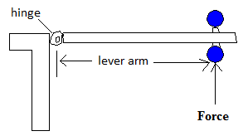
Q: What do you think you do to the door, when you open it? A: You apply a torque.
Torque = Lever-arm X Force; Torque is a vector. Torque comes in clockwise and counter clockwise directions. Clockwise direction is the direction in which a mechanical clock turns. The opposite direction is called counter clockwise.
The door knob is kept away from the hinge in order to have a greater lever-arm. Imagine how hard it will be to open, if the knob is kept closer to the hinge.
Lever-arm is the perpendicular distance between the line of action of the force and axis of rotation. Force, F is applied with different directions to a door below. Show the line of action and lever arm for each of the following cases, and rank the torques in descending order.
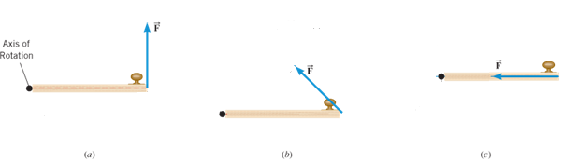
Problem 1. The door knob of a door is located at 80 cm from the hinge. This door can be opened by applying a 10 N force at the knob, perpendicular to the door. Instead if someone wants to open it by apply a force at a distance of 50 cm from the hinge, how much force is necessary?

a. Center of gravity of a meter stick:
- The meter stick was inserted in the knife-edge clamp and balanced as shown below.
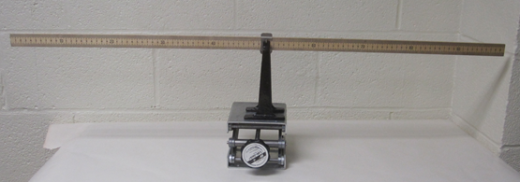
- Read the center of gravity to the tenth of a centimeter, a pencil mark is visible.
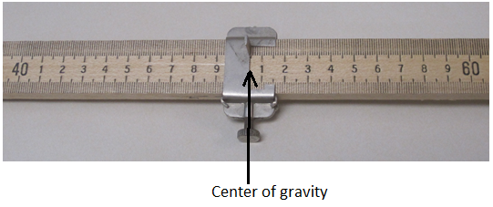
Location of the center of gravity (C.G) = ________ cm.
Also, record the above C.G in Data Tables on pages 3 & 4.
b. Measuring an unknown mass (Meter stick is supported at the center of gravity)
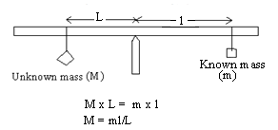
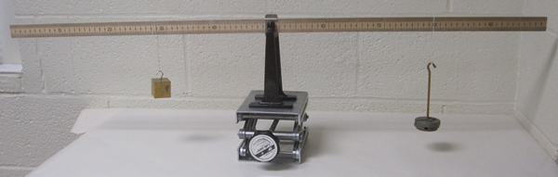
Unknown mass will try to rotate the meter stick counter clockwise and known mass will try to rotate the meter stick clockwise.
For balance, counterclockwise torque = clockwise torque, $M×L=m×l$.
Unknown mass, M can be determined using the equation, $M=\frac{ml}{L}$.
DATA for Unknown Mass
Location of the center of gravity (C.G) = ________ cm
Record the locations of known and unknown masses using this picture link, and complete the table below.
Known mass = ___200 g__ ____250 g____ ____ 300 g___
Location of the known mass = _________ cm _________cm __________cm
Location of the unknown mass = _________ cm _________cm __________cm
Known mass, m (g) | Lever-arm for known mass, l (cm) | Lever-arm for unknown mass, L (cm) | Unknown mass, M (g)
200
250
300
Average of the unknown mass, M
Unknown mass, M measured using electronic balance
% difference
c. Measuring the mass of a meter stick (M)
Now you need to move the support point away from the center of gravity (C.G). This way you get the rotation effect of M, mass of the meter stick.
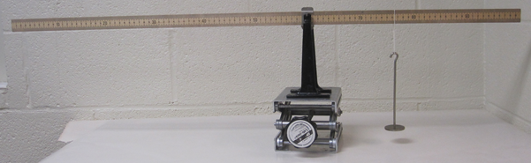
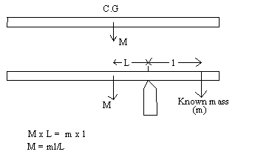
The mass of the meter stick, M can be determined using the equation, $M=\frac{ml}{L}$.
DATA for Mass of Meter Stick
Location of the center of gravity (C.G) = ________ cm.
Known mass = __50 g____ ___100 g__ ___150 g ____
Location of the support point = __65 cm____ __60 cm___ ___70 cm____
Location of the known mass = ________ cm __________cm _________cm
Record the locations of the known mass, above using this picture link, and complete the data table, below.
Known mass, m (g) | Lever-arm for known mass, l (cm) | Lever-arm for mass of meter stick, L (cm) | Mass of meter stick, M (g)
50
100
150
Average of the mass of meter stick
Mass of meter stick measured using electronic balance
% difference
d) Torques
1. With the meter stick on the support stand at X₀ (center of gravity) a 150-g mass is suspended at the 10 cm mark and a 200-g mass is suspended at 90 cm mark. A 100-g mass is suspended and its position is adjusted to obtain static equilibrium, as shown below.
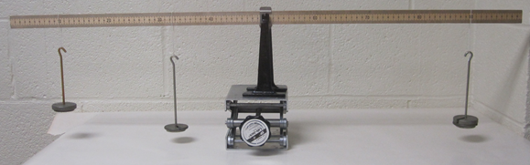
2. Record the location of the 100-g mass, using this picture, as the experimental value on the Data Table for Torques, page 6.
3. Draw a free-body diagram for the meter stick and identify all the forces acting on it. Use masses as force.
4. Write an equation by balancing the torques.
5. Calculate the location for the 100-g mass, using the above equation, and compare it with the experimental value.
6. Use the experimental value of the location for the 100-g mass to calculate the counterclockwise and clockwise torques about X₀ and complete the data below.

DATA for Torques (Include units):
Experimental value of the location for the 100-g mass = ___________
Calculated value of the location for the 100-g mass = ___________
% Difference = ___________
Counterclockwise torque about X₀ = _________
Clockwise torque about X₀ = __________
% difference = _________

Problems:
2. Unit Conversion: Express the torque 8950 g.cm in N.m.

3. A meter stick has a mass of 140-g and center of mass at 49.5 cm. This meter stick is supported at the center of mass using a knife edge clamp of mass 20-g. An unknown mass is hanged at 19.5 cm. Balance is obtained when 150-g is hanged at 69.5 cm. Draw a free body diagram for the meter stick and determine the unknown mass and the normal force (can be expressed in gram, g) exerted by the support stand.

Conclusion:

