PHYS 201L TORQUE Name:____________________________
Purpose: To investigate torque by doing the following activities:
a. Finding the center of gravity of a meter stick
b. Measuring an unknown mass
c. Measuring the mass of a meter stick
d. Calculating clockwise and counter clockwise torques
Apparatus: Meter stick, unknown mass, knife edge clamp, knife edge support, mass-hanger, mass set, lab jack, electronic balance, and string loops.
Theory: Introduction to torque
Think about the everyday activity of opening a door, just for a moment.
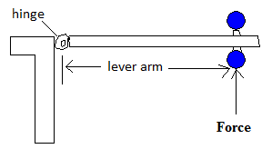
Q: What do you think you do to the door, when you open it? A: You apply a torque.
Torque = Lever-arm X Force; Torque is a vector. Torque comes in clockwise and counter clockwise directions. Clockwise direction is the direction in which a mechanical clock turns. The opposite direction is called counter clockwise.
The door knob is kept away from the hinge in order to have a greater lever-arm. Imagine how hard it will be to open, if the knob is kept closer to the hinge.
Lever-arm is the perpendicular distance between the line of action of the force and axis of rotation.
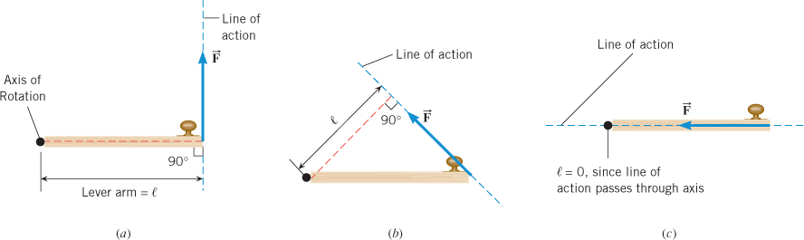
Problem-1: The door knob of a door is located at 80 cm from the hinge. This door can be opened by applying a 10 N force at the knob, perpendicular to the door. Instead if someone wants to open it by apply a force at a distance of 50 cm from the hinge, how much force is necessary?

- Center of gravity of the meter stick:
a. Center of gravity of a meter stick:
- Support the meter stick with a knife-edge clamp and obtain balance as shown below.
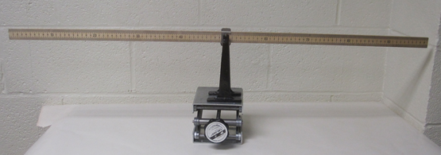
- Read the center of gravity to the tenth of a centimeter.
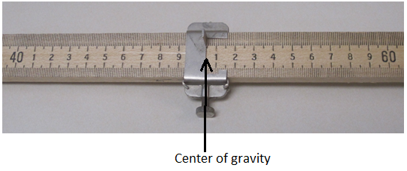
Location of the center of gravity (C.G) = ________ cm

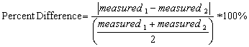
b. Measuring an unknown mass (Meter stick is supported at the center of gravity)
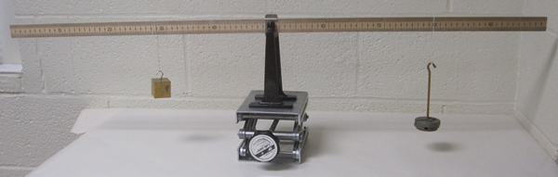
Unknown mass will try to rotate the meter stick counter
clockwise and known mass will try to rotate the meter
stick clockwise.
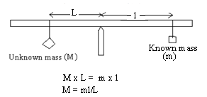
For balance, counterclockwise torque = clockwise torque.
Unknown mass can be determined using the above equation.
DATA for Unknown Mass
Location of the center of gravity (C.G) = ________ cm
Location of the unknown mass = _________ cm _________cm __________cm
Location of the known mass = _________ cm _________cm __________cm
Known mass, m (g) | Lever-arm for known mass, l | Lever-arm for unknown mass, L | Unknown mass, M
200
250
300
Average of the unknown mass, M
Unknown mass measured using electronic balance
% difference
c. Measuring the mass of a meter stick (M)
Now you need to move the support point away from the center of gravity (C.G). This way you get the rotation effect of M, mass of the meter stick.
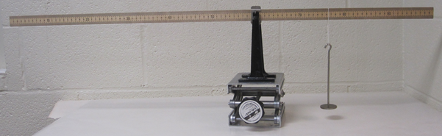
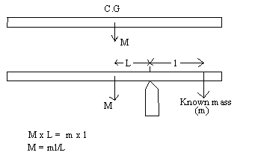

DATA for Mass of Meter Stick
Location of the center of gravity (C.G) = ________ cm.
Location of the support point = ________ cm __________cm _________cm
Location of the known mass = ________ cm __________cm _________cm
Known mass, m (g) | Lever-arm for known mass, l | Lever-arm for mass of meter stick, L | Mass of meter stick, M
50
100
150
Average of the mass of meter stick, M
Mass of meter stick measured using electronic balance
% difference
d) Torques
1. With the meter stick on the support stand at X₀ (center of gravity) suspend a 150-g mass at the 10 cm mark and a 200-g mass at 90 cm mark. Hang a 100-g and adjust its position to obtain static equilibrium.
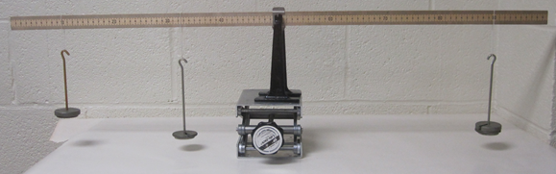
2. Record the location of the 100-g mass.
3. Draw a free-body diagram for the meter stick and identify all the forces acting on it. Use masses as force.
4. Write an equation by balancing the torques.
5. Calculate the location for the 100-g mass, using the above equation, and compare it with the experimental value.
6. Use the experimental value of the location for the 100-g mass to calculate the counterclockwise and clockwise torques about X₀ and complete the data below.

DATA for Torques:
Experimental value of the location for the 100-g mass = ___________
Calculated value of the location for the 100-g mass = ___________
% Difference = ___________
Counterclockwise torque about X₀ = _________
Clockwise torque about X₀ = __________
% difference = _________
Problems (ctd):
2. For the mobile shown the beams have negligible masses. The mass of A is 0.6 kg. Determine the masses of B, C, and F.
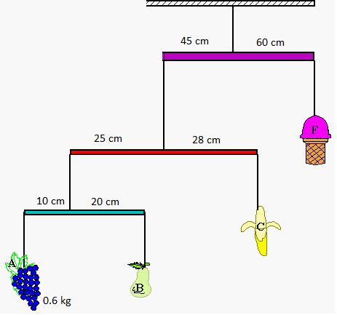
3. Figure below shows a mobile of toy penguins hanging from a ceiling. Each crossbar is horizontal, has negligible mass, and extends three times as far to the right of the wire supporting it as to the left. Penguin 4 has mass m₄ = 1 kg. What are the masses of penguins 3, 2, and 1?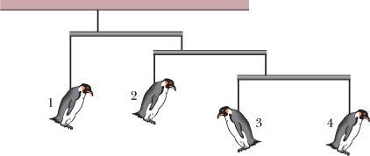
4. A uniform meter stick is supported at the 40.0 cm mark. Balance is obtained when a 45.0 gram mass is suspended at the 10.0 cm mark. Draw a free body diagram for the meter stick and determine the mass of the meter stick.

5. A meter stick has a mass of 140-g and center of mass at 49.5 cm. This meter stick is supported at the center of mass using a knife edge clamp of mass 20-g. An unknown mass is hanged at 19.5 cm. Balance is obtained when 150-g is hanged at 69.5 cm. Draw a free body diagram for the meter stick and determine the unknown mass and the normal force exerted by the support stand.

Conclusion:

