**PHYS 201L Rotational Motion Name:_____________________**Partner(s):____________________________________________________________  
**DATA Table A:** g = 9.8 m/s2

|  |  |  |  |  |
| --- | --- | --- | --- | --- |
|  | Acceleration, *a* (m/s2) | *I*, Exptal*(g.cm2) | *IT*, Theory**(g.cm2) | % Difference |
| Pulley |  |  | XXXXXXXXXXX | XXXXXXX |
| Pulley & Rod |  |  | XXXXXXXXXXX | XXXXXXX |
| Pulley, Rod, & Two Masses at 5 cm |  |  | XXXXXXXXXXX | XXXXXXX |
| Two Masses at 5 cm | XXXXXXXX |  |  |  |
| Rod | XXXXXXXX |  |  |  |
| Pulley & Disk |  |  | XXXXXXXXXXX | XXXXXXX |
| Disk | XXXXXXXX |  |  |  |
| Pulley, Disk & Ring |  |  | XXXXXXXXXXX | XXXXXXX |
| Ring | XXXXXXXX |  |  |  |

\**I*, For 2 point masses are obtained by subtracting the Pulley-Rod value from   
the Pulley-Rod + Two M’s values.   
 \**I*, for the rod is obtained by subtracting the pulley value from the pulley & rod value.  
\**I*, for the disk is obtained by subtracting the pulley value from the pulley & disk value.  
** Moment of inertia of point masses: $I=\sum{mr^{2}}$  
\*\**IT* (rod) = (1/12)m*L2* \*\**IT* (disk) = 0.5 *MR2*;     \*\**IT* (Ring) = 0.5 *M1(R12 +R22 )*;  
  
Data for calculating *IT*:  
Mass of a point mass = ________Length of rod = L = ______Mass of rod = m = ______  
Mass of the gray disk = *M* = _______ Mass of black ring = *M1* = ______________

|  |  |  |
| --- | --- | --- |
| Dimensions of the ring & disk | Diameter (cm) | Radius (cm) |
| Inside of black ring |  | *R1*= |
| Outside of black ring |  | *R2*= |
| Gray disk |  | *R*  = |

**B. Angular Momentum and Rotational Kinetic Energy**

**Purpose**: Investigate what happens to the angular momentum and rotational kinetic energy when a disk is dropped onto a rotating disk.

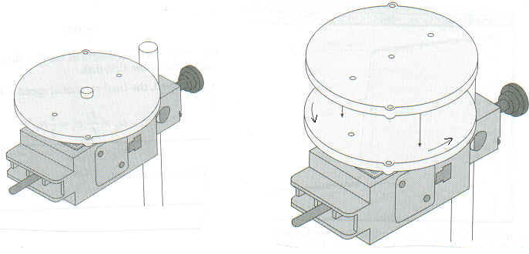

Angular momentum, *L* is given by: Rotational kinetic energy, *K* is given by: 

DATA B: (Include units)  

|  |  |  |  |  |  |  |  |
| --- | --- | --- | --- | --- | --- | --- | --- |
| Trial | *ωi* | *ωf* | Use Data Table A | | *Li = Iiωi* | *Lf = Ifωf* | % Difference |
| *I i* | *I f* |
| 1. |  |  |  |  |  |  |  |
| 2. |  |  |  |  |  |  |  |
| 3. |  |  |  |  |  |  |  |

Calculation of initial and final rotational kinetic energies (in SI unit) for one trial: