**Data Collection with a PC-I** Name:______________________________  
  
Partner(s):________________________________________________Day/Time:______  
 **A. Introduction:** PASCO’s 850 interface and Capstone software.   
1. Open PASCO Capstone software from the desktop.



2. Double click “Graph” under Displays, on the far-right column.

Pasco Capstone display:

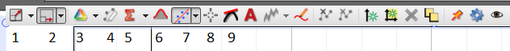

3. You will use some of the above (numbered) menus to manipulate the data. Describe the functions of the following menus:

|  |  |
| --- | --- |
| Menu | Description |
| 1 |  |
| 4 |  |
| 6 |  |
| 7 |  |
| 8 |  |
| 9 |  |

**B1. MOTION:**   
  
Purpose: To analyze the motion of a cart down an inclined track using   
a motion sensor.   
  
Apparatus: PC, Interface, Motion Sensor, Dynamics Track w/End Stop,   
Collision Cart, Brass Weight, blocks of mass for the cart, and   
Wooden Block.

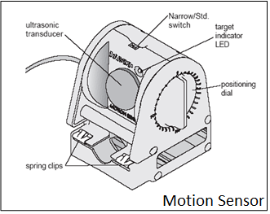

Procedure:

1. Look at the motion sensor and identify the smallest distance it can detect.
2. Incline the Dynamics Track using the Wooden Block and attach the Motion Sensor at the 0-cm end.
3. Place the Collision Cart so that the front of the cart is about 20-cm from the motion sensor and use the Brass Weight to hold the cart in place.
4. Connect the motion sensor to the interface (yellow-1, black-2), set the beam to narrow, and make the detection-surface perpendicular to the track.
5. Open PASCO Capstone software from the desktop.
6. Click Hardware Setup under Tools on the left, click on the interface input where the sensor is connected, and select Motion Sensor. Click Hardware Setup again to close it.
7. Double-Click Graph under Displays on the right, click Select Measurement on the Y-axis, and choose Position.
8. Click Record, and after a while remove the Brass Weight in order for the cart to roll down and collide with the End Stop.
9. Stop the data collection, have your data checked by the instructor, and complete the data sheet.
10. Velocity and acceleration data can be obtained by clicking on position and selecting velocity and acceleration, respectively.

**DATA for MOTION:** Smallest distance the motion sensor can detect = _________

|  |  |  |  |  |
| --- | --- | --- | --- | --- |
|  | Using *x* vs. *t* Graph | Using *v* vs. *t* Graph | Using *a* vs. *t* Graph | % Difference |
| Describe/Plot  the  Graph |  |  |  | XXXXXX XXXXXX XXXXXX XXXXXX |
| Initial/resting position |  | XXXXXX XXXXXX XXXXXX | XXXXXX XXXXXX XXXXXX | XXXXXX XXXXXX XXXXXX |
| Final position |  | XXXXXX XXXXXX XXXXXX | XXXXXX XXXXXX XXXXXX | XXXXXX XXXXXX XXXXXX |
| Distance Travelled |  |  | XXXXXX XXXXXX XXXXXX |  |
| Initial Velocity |  |  | XXXXXX XXXXXX | XXXXXX  XXXXXX |
| Final Velocity |  |  | XXXXXX XXXXXX XXXXXX |  |
| Acceleration | XXXXXX XXXXXX |  | *1 | XXXXXXXXX XXXXXXXXX |
| *1. Do this before reading the acceleration: Click the Show Coordinates button, right-click the y-coordinate, and select Tool Properties, and change the significant figure to 4. | | | | |

B2. Motion Investigations

1. What will happen to the acceleration down the track if the mass of the cart is increased?

Prediction:

Measure the acceleration from the slope of the velocity VS. Time graph and find how the acceleration down the track depends on the mass of the cart. You already have the acceleration for just the cart, from B above. Do a measurement by adding masses (2 rectangular metal blocks) to the cart and summarize your results below.

2. What will happen to the acceleration down the track if the incline is increased?

Prediction:

Measure the acceleration from the slope of the velocity VS. Time graph and find how the acceleration down the track depends on the incline of the track. You already have the acceleration for the incline in B above. Do a measurement for a larger incline, by putting additional blocks to incline the track and summarize your results below.

**C. Coefficient of Kinetic Friction:** (Conclusion is required for this part only)

Purpose: To study the laws of friction and to determine the coefficient of kinetic friction (µk) between two surfaces.

Activity: Wood block moving at constant velocity on lab-table top.

Apparatus: PC, interface, force sensor, wood block, mass-set, and balance.

Theory: Kinetic frictional force, *fk* and normal force, *FN* are related by the following equation, where *µk* is the coefficient of kinetic friction: $f_{k}=μ_{k}F_{N}$

Procedure: A wooden block (later with mass on top) is placed on the lab table. The normal force is given by, Mg, M = Mb + Mt,where Mb is the mass of the block and Mt is the mass on top.

The block will be pushed with a force sensor by overcoming and balancing the frictional force, as shown below. Draw a free-body diagram for the block, below.

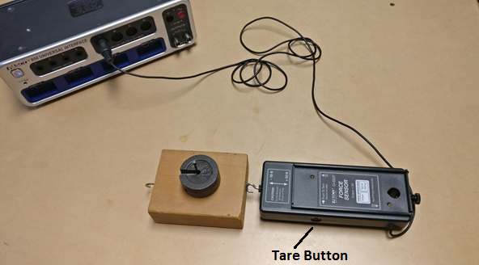

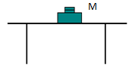

1. Find the mass of the wooden block.  
2. Clean the lab table surface and place wooden block and force sensor, as shown above.   
3. Connect the force sensor to analog input A, on the interface.  
4. Open PASCO Capstone software from the desktop.   
5. Click Hardware Setup under Tools on the left, click on the interface input where the sensor is connected and select Force Sensor.  
6. Click **Hardware Setup** again to close it.  
7. Double-Click Graph under displays on the right, click on “Select Measurement” on the Y-axis, and choose Force (N). Time (s) will be automatically selected for the X-axis.   
8. Tare the Force Sensor, by pushing the tare button on the side.  
9. Click “Record”, and push the wooden block with the force sensor, slowly and gently, without any acceleration, at a steady rate for a while.  
10. Stop the data collection and maximize the display. A sample data is shown below.

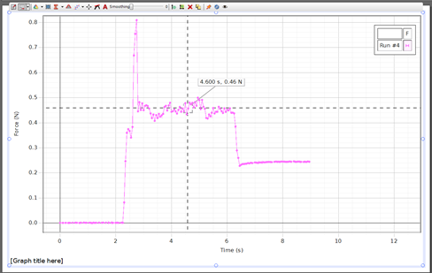  
11. Read the constant force (flat line), which is the frictional force, from the graph display, using the “show coordinates” tool.   
12. Repeat the measurements for other masses on top, and complete the data table.

**DATA TABLE I** Mass of the wooden block, Mb = ---------

|  |  |  |  |  |
| --- | --- | --- | --- | --- |
| Mass on Top Mt (g) | M = Mb + Mt | Normal Force FN (N) | Frictional Force fk (N) | µk |
| 0 |  |  |  |  |
| 100 |  |  |  |  |
| 200 |  |  |  |  |
| 300 |  |  |  |  |
| 400 |  |  |  |  |
| 500 |  |  |  |  |
| 600 |  |  |  |  |
| 700 |  |  |  |  |

Also, plot a graph and determine the value of µk. Attach a copy of your graph to the report. List the value of µk from the graph, here_____________ and in the conclusion for C.