Hooke’s Law Name:__________________________
Partner(s):__________________ Course:______________ Time:____________
Purpose: To verify Hooke’s law and determine the spring constants of elastic springs.
Apparatus: 3 springs, pendulum clamp, motion sensor, plumb-line, meter stick, tall lab stand, mass set, and mass hanger.
Theory: Think about stretching a spring. The more stretching force you apply, the more stretch you get. Robert Hooke (1635-1703), a British physicist, discovered this empirical relationship between the restoring force (F) and the stretch (x), known as Hooke's law,
F = - kX.
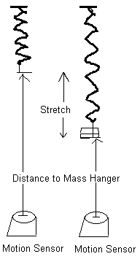
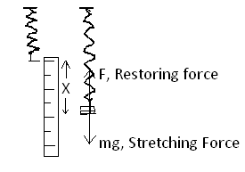
According to Hooke's law, the magnitude of the stretching force is given by:
Stretching Force = (Spring constant) X Stretch.
The stretching force is provided by the added mass. You can also plot Stretching Force VERSUS Stretch. Hooke’s law is verified when there is a linear relationship between Stretching Force & Stretch.
The Spring Constant is given by the slope of the Stretching Force versus Stretch graph.
Procedure:
1. Attach the mass hanger to the hard spring and hang it from the pendulum clamp.
2. Set up the motion sensor about 50-cm below the bottom of the mass hanger, using a plum-line.
3. Connect the motion sensor to the interface (yellow-1, black-2), set the beam to narrow.
4. Setting up the Interface for data collection:
a. Open PASCO Capstone software from the desktop.
b. Click Hardware Setup under Tools on the left, click on the interface input
where the sensor is connected and select Motion Sensor II.
Click Hardware Setup again to close it.
c. Double-Click Digits under Displays on the right, click Select Measurement, and select
Position.
5. Click Record and record the distance to the bottom of mass hanger from the motion sensor.
Stop the data collection.
6. Add an appropriate mass to make the spring stretch about 2 cm and measure the distance to the
bottom of mass hanger, again, and record it.
7. Measure the stretches for other added masses and complete the data table.
8. Repeat 1-7 for the other two springs.
9. Enter the above data in Excel and for each spring; create two more columns for Stretch (m) and Stretching force (N). Calculate these values and make a single XY scatter Plot Stretching force VS. Stretch for all three springs, and find the spring constant for each spring.
10. Attach your data table & plot (Excel) and conclusion (Word).
SAMPLE DATA

