Kinetic Friction Fall 2016 Name:___________________Date:_______Time_____

Partner(s):__________________________________________________________

Purpose: To study the laws of friction and to determine the coefficient of kinetic friction (µk) between two surfaces.

Activity I: Wood block moving at constant velocity on lab-table top.

Apparatus: PC, interface, force sensor, wood block, mass-set, and balance.

Theory: Kinetic frictional force, *fk* and normal force, *FN* are related by the following equation, where *µk* is the coefficient of kinetic friction: $f_{k}=μ_{k}F_{N}$

Procedure: A wooden block (later with mass on top) is placed on the lab table. The normal force is given by, Mg, M = Mb + Mt,where Mb is the mass of the block and Mt is the mass on top.

The block will be pushed with a force sensor by overcoming and balancing the frictional force, as shown below. Draw a free-body diagram for the block, below.

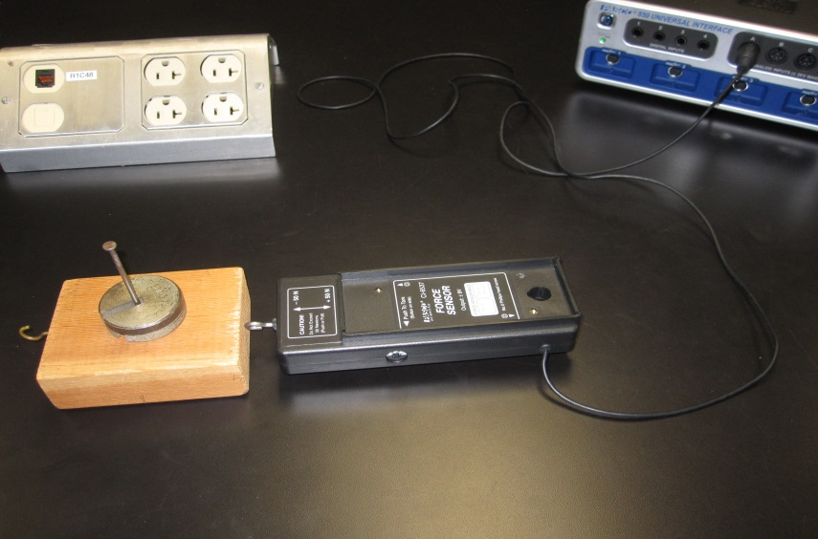

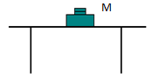

1. Find the mass of the wooden block.  
2. Clean the lab table surface and place wooden block and force sensor, as shown above.   
3. Connect the force sensor to analog input A, on the interface.  
4. Open PASCO Capstone software from the desktop.   
5. Click Hardware Setup under Tools on the left, click on the interface input where the sensor is connected and select Force Sensor.  
6. Click **Hardware Setup** again to close it.  
7. Double-Click Graph under displays on the right, click on “Select Measurement” on the Y-axis, and choose Force (N). Time (s) will be automatically selected for the X-axis.   
8. Tare the Force Sensor, by pushing the tare button on the side.  
9. Click “Record”, and push the wooden block with the force sensor, slowly and gently, without any acceleration, at a steady rate for a while.  
10. Stop the data collection and maximize the display. A sample data is shown below.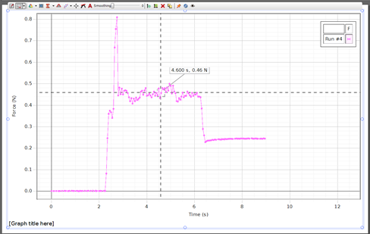  
11. Read the constant force (flat line), which is the frictional force, from the graph display, using the “show coordinates” tool.   
12. Repeat the measurements for masses on top, and complete the data table.

**DATA TABLE I** Mass of the wooden block, Mb = ---------

|  |  |  |  |  |
| --- | --- | --- | --- | --- |
| Mass on Top Mt (g) | M = Mb + Mt | Normal Force FN (N) | Frictional Force fk (N) | µk |
| 0 |  |  |  |  |
| 100 |  |  |  |  |
| 200 |  |  |  |  |
| 300 |  |  |  |  |
| 400 |  |  |  |  |
| 500 |  |  |  |  |
| 600 |  |  |  |  |
| 700 |  |  |  |  |

Also, plot a graph and determine the value of µk. Attach a copy of your graph to the report. List the value of µk from the graph, here_____________ and in the conclusion.

Activity II: Wooden block accelerating on wood-plank.

Apparatus: PC, interface, photogate, cord, pulley, supporting rod, pulley clamp, wooden block, wood-plank, mass set, 5-g mass hanger, string, and balance.  
  
Theory:

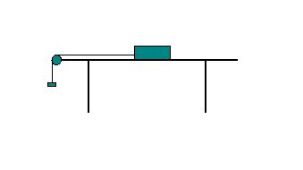

Now we will hang the mass so that the pulling force is greater than the frictional force, and hence the block will accelerate.

Show all the forces acting on the block, and the acceleration in the diagram above and derive an expression for µk in terms of m- hanging mass, M- block mass, a- acceleration of the block-mass system, and g- acceleration due to gravity. 

Procedure for measuring acceleration and determining (µk):  
1) Place the super pulley on the photogate head, as shown below, and thread in the connector rod. Attach the cord and then attach the rod to the pulley clamp.

  
2) Record the mass of the wooden block, place the wood-plank on the lab table, and place the wooden block on the wood-plank.

3) Attach one end of the string to the wooden block and run the other end of the string over the pulley and attach it to the mass hanger. Adjust the height of the pulley until the string is parallel to the surface of the wood-plank.

4) Connect the Photogate/Pulley system to digital channel one on the Interface.

5) Open PASCO Capstone software from the desktop.

6) Click Hardware Setup under Tools on the left, click on the interface input where the sensor is connected, and select **Photogate with Pulley**. Click Hardware Setup again to close it.

7) Double-Click Graph under Displays on the right, click Select Measurement on the Y-axis, and choose Linear Speed.

8)  Click on the Record button, add a 70-g mass to the hanger (total hanging mass = m= 75-g) which will make the block to move. Click on the Stop button after the block reaches the pulley.

9) Determine the experimental acceleration, a.  (The slope of the linear portion of the Linear Speed vs. time, plot). Tabulate your data in Excel, and calculate the coefficient of kinetic friction to two significant figures.    
  
Mass of the wood block = M = ____________ Acceleration due to gravity = g = 9.8 m/s2

|  |  |  |  |  |  |  |
| --- | --- | --- | --- | --- | --- | --- |
| m (g) | 75 | 105 | 125 | 155 | 175 | 205 |
| a (m/s2) |  |  |  |  |  |  |
| µk |  |  |  |  |  |  |

10) After attaching the graph from activity I and data table from activity II, write a conclusion.