PHYS 201 LAB Measurement of density

Name:_____________________________Date:_______________Time:____________

Partner(s):______________________________________________________________   
  
A. Introduction of measuring devices

1) Vernier caliper

Dimensions of the order of tenths of a millimeter (0.1 mm or 0.01 cm) can be measured using a vernier caliper. It consists of a main scale and a movable vernier scale. The main scale is calibrated in centimeters with a millimeter least count, and the vernier scale has 10 divisions that cover 9 divisions on the main scale. The left most mark on the vernier scale is the zero mark, which is often unlabeled.

A measurement is made with the vernier caliper by closing the jaws on the object to be measured and then reading the position where the zero line of the vernier falls on the main scale. The fractional part of a main scale division is obtained by noting which line on the vernier coincides with a line on the main scale. Watch this video and learn how to use a vernier caliper. <http://www.youtube.com/watch?v=4hlNi0jdoeQ>   
  
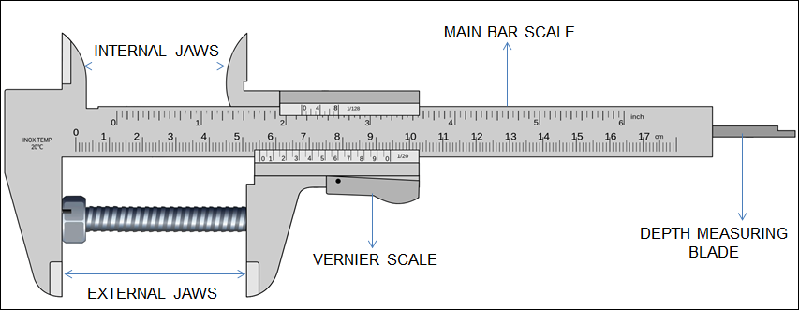

Read the following Vernier readings:

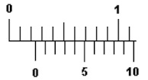 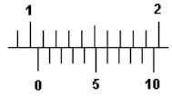 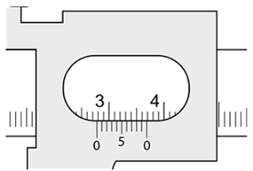

_____________________ _________________ _____________________

2) Micrometer   
    
Dimensions of the order of hundredths of a millimeter (0.01 mm or 0.001 cm) can be measured using the micrometer. It has a movable spindle that is advanced by a rotating thimble. The ratchet allows slippage of the screw mechanism when a small and constant force is exerted on the jaw. This permits the jaw to be tightened on an object with the same amount of force each time. The axial main scale is calibrated in millimeters and the thimble is calibrated in 0.01 mm.   
    
Micrometer should be checked for a zero error, for it may not read zero when the jaws are completely closed. In such cases a zero correction has to be applied to every reading. The zero error may be either positive or negative. The zero correction is always made by subtracting the zero reading from the final reading.

The micrometer is read by noting the position of the edge of the thimble on the main scale which gives the nearest whole main scale division. The position of the axial line on the circular thimble scale gives the fractional part of the main scale. Watch this video and learn how to use a micrometer. <http://www.youtube.com/watch?v=O8vMFFYNIfo>

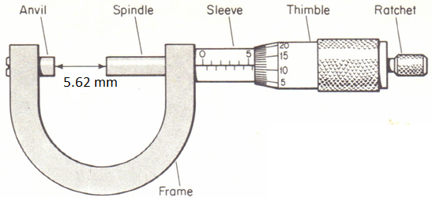

Read the following micrometer readings:

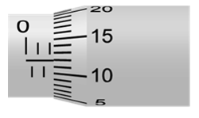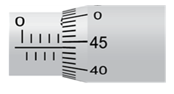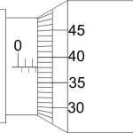

_______________________ _____________________ ___________________

In this experiment the mass will be measured using an electronic balance. Use a 0.01g accuracy scale to measure the mass of tiny items like Cu-wire and penny.



**Purpose: To determine the densities of various regularly shaped solids and liquids.**

B. Rectangular Solids

Apparatus: Electronic balance, foot ruler, vernier caliper, micrometer,   
rectangular solid metals- Al, Cu, Brass, and Fe; sheet metal, and acrylic block.

Theory:            

Data: Rectangular Solids

Create a data table as shown below in Excel spread sheet. Measure and enter the mass, length, width, and height values for the rectangular solids. Add 4 more columns and use Excel to calculate the volumes and densities. Also enter the accepted densities and calculate the %Error using Excel. Use proper significant figures.

|  |  |  |  |  |
| --- | --- | --- | --- | --- |
|  | Mass | Length | Width | Height |
| Al | - | - | - | - |
| Cu | - | - | - | - |
| Fe | - | - | - | - |
| Brass | - | - | - | - |
| Sheet metal | - | - | - | - |
| Acrylic block | - | - | - | - |

If the %Errors are high, check your measurements. Insert your data table.   
  
Accepted densities (in g/cm3):   
Aluminum = 2.70    Copper   = 8.90     Iron     = 7.85        Brass    = 8.40   
Steel    = 7.80        Gold       =19.30     Lead     =11.30     Nickel   = 8.75   
Platinum = 21.54    Silver      =10.5       Zinc      = 7.10        water    = 1.00   
Wood = 0.64        Acrylic    = 1.2    
  
For Al, calculate the %uncertainty in density:

C. Cylinders

Apparatus: Metal cylinders: Cu, Fe, Steel, Brass, and Al; wood, acrylic cylinder, length of Cu wire, electronic balance, foot ruler, vernier caliper, and micrometer.   
 Theory: ,       ; d = diameter, h = height.   
  
Data: Cylinders  
Create a data table as shown below in Excel spread sheet. Measure and enter the mass, height, and diameter values for the cylinders. Add 4 more columns and use Excel to calculate the volumes and densities. Also enter the accepted densities and calculate the %Error using Excel. Use proper significant figures.

|  |  |  |  |  |
| --- | --- | --- | --- | --- |
| Cylinder | | Mass | Height, h | Diameter, d |
| Al | |  |  |  |
| Steel | |  |  |  |
| Cu | |  |  |  |
| Brass | |  |  |  |
| Fe | |  |  |  |
| Wood | |  |  |  |
| Acrylic | |  |  |  |
| Cu wire | |  |  |  |
| Penny | Year: |  |  |  |

Use this [penny composition](https://en.wikipedia.org/wiki/Penny_(United_States_coin)) website to calculate an accepted density for your penny. Show your work below:

If the %Errors are high, check your measurements. Insert your data table.

D. Density of H2O and CuSO4   
Apparatus: Graduated cylinder, electronic balance, water, and CuSO4.  
Procedure:   
1. Collect 10 sets of mass & volume data for water, plot a linear scatter plot, and obtain the average density from the slope.   
2. Repeat the above procedure for CuSo4.  
3. Insert your data table and graph.   
  
Average Density of Water _______________and CuSO4 ________________from graph.

**E. Do the PLQ before midnight, this Thursday. Write an overall Conclusion and upload a digital copy into BB, lab page, before the start of the next lab period.**