|  |  |  |
| --- | --- | --- |
| PHYSICS 201  Equations Sheet | Translational Motion | Rotational Motion |
| LINEAR | ANGULAR |
| Time | t | t |
| Displacement | x; (x = rθ) | θ |
| Velocity | v = Δx/Δt; (v = rω) | ω = Δθ/Δt |
| Acceleration | a = Δv/Δt; (a = rα) | α = Δω/Δt |
| Kinematic Equations | v = v0 + at | ω = ω0 + αt |
| x = ½(v + v0)t | θ = ½(ω + ω0)t |
| x = v0t + ½ at2 | θ = ω0t + ½ αt2 |
| v2 = v02 + 2ax | ω2 = ω02 + 2αθ |
| Inertia | *m* = mass | *I* = Rotational inertia; |
| To create | force = F | torque = τ = LA·F |
| Newton's second law of motion | Σ**F** = m**a** | Σ**τ** = I**α** |
| Σ**F** = Δ**p**/Δt | Σ**τ** = Δ**L**/Δt |
| Work | *F·x* | *τ·θ* |
| Kinetic Energy | Translational Kinetic Energy = TKE = ½ mv2 | Rotational Kinetic  Energy = RKE = ½ Iω2 |
| Momentum | **p** = m·**V** | **L** = I·**ω** |
| Conservation of momentum | Σmivi = Σmfvf | ΣIiωi = ΣIfωf |

Conversion factors:  
1 H = 3600 s, 1 Mile = 1608 m, 1 inch = 2.54 cm, 1 foot = 12 inch, 1 m = 3.281 ft, 1 kg = 1000 g.  
1 m = 100 cm, 1 cm = 10 mm, 1 m = 1000 mm, 1 km = 1000 m, 1 LB (pound) = 4.448 N

Acceleration due to gravity = g = 9.8 m/s2. 1 Revolution = 2π rad.

Frictional force = *Ffr=μkFN* GPE = mgh   
Area of a circle of radius r, Acircle = π r2 .Area of a rectangle of length l, and width w, Arec=l x w; Area of a triangle, Atriangle= 0.5 x base x height.  
  
Volume of a cylinder of radius r and height h; V= π r2h; Volume of a sphere = (4/3) π r3.

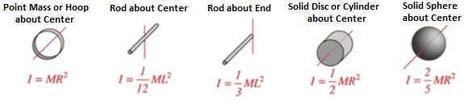

**PHYS 201 Fall 2024 Test #3 Name:___________________________**

I. For the following multiple-choice questions, write your answer in the line next to the question number. For questions 2,4, and 8 show your work.

____1. What is the angular speed in degree/minute of the minute hand of an analog watch? a. 6 b. 12 c. 15 d. 30 e. 36

2-4) The drawing below illustrates an overhead view of a door and its axis of rotation. The axis is perpendicular to the page. There are four forces acting on the door, and they have the same magnitude.   
2. Show the line-of-action and lever-arm for force **F1**   
in the diagram.

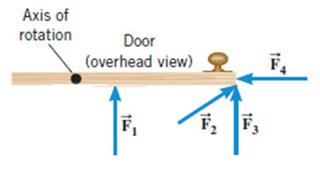

____3. Which force will provide no torque, about the axis

of rotation?  
a. **F1**b. **F2**

c. **F3**d. **F4**

4. Rank the forces, according to the magnitude of the torque they provide, from low to high.

_____________________________

5-6) Five hockey pucks (radius = *R*) are sliding across frictionless ice. The drawing shows a top view of the pucks and the three forces that act on each one. As shown, the forces have different magnitudes (***F***, 2***F***, 3***F***), and are applied at different points on the pucks.  
____5. Which one of the five pucks is in Equilibrium?  
____6. Which one of the five pucks has a net torque of *FR*, clockwise, about the center?

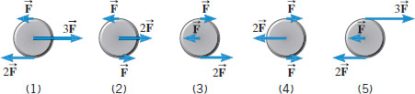

____7. A tornado of 100-m diameter is spinning at 2.8 rad/s. What is the tangential wind speed at the edge?

1. 280 m/s b. 140 m/s c. 35.7 m/s d. 17.9 m/s e. 28 m/s

8-10) A uniform meter stick is supported at the 62 cm mark. Balance is obtained when a 65-gram mass is suspended at the 75 cm mark.   
8. Draw a free-body diagram for the meter stick inside the box.  
___9. What is the mass of the meter stick?

___10. What is the normal force exerted at the support point?  
Answers for 9-10  
a. 60-gram b. 65-gram c. 70.4-gram d. 78.6-gram e. 125-gram f. 135-gram

II. A soccer player extends her lower leg (moment of inertia = 0.75 kg.m2) in a kicking motion by exerting a force with the muscle above the knee in the front of her leg. Starting from rest, she produces a kicking angular velocity of 16 rad/s in 0.40 s. What is the force exerted by the muscle if its effective perpendicular lever arm is 1.8 cm? [Σ**τ** = I**α,** τ = LA·F]

III. A solid disk of radius 0.48 m and mass 9.5 kg is spinning with an angular velocity of 20 rad/s. A tangential resistive force of 5.2 N is applied at the edge of the disk. Calculate the angular deceleration of the disk and the time it takes for the disk to come to a stop.

IV. A playground merry-go-round is shown below, which can rotate about the vertical pole of negligible radius in the middle. The bottom disk’s mass is 35 kg and radius, R = 2.5 m.   
a. Calculate the rotational inertia of the bottom disk.

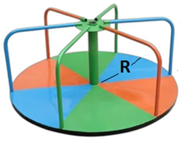

b. If each of the six vertical portion of the holding rod’s mass

is 1.0 kg, calculate its rotational inertia, assuming it as a   
point mass.

c. If each of the six horizontal portion of the holding rod’s   
mass is 1.2 kg, calculate its rotational inertia, assuming it as a   
thin rod.

d. Determine total rotational inertia of the merry-go-round about the vertical pole.

V. Refer to the wheel system shown below. Its axis is at the center, perpendicular to the page. Assume F1 = 60-N, F2 = 40-N, inner radius = 50 cm, and outer radius = 110 cm.

What is the net torque, magnitude and direction, acting on the wheel?



VI. The drawing shows a person, mass = 79 kg, doing forearm push-ups. Distance between the forearm contact point and feet is 1.9 m and the distance between the person’s center of gravity and the feet is 1.2 m.   
a. Show the distances, center of gravity, and draw a free-body-diagram  
b. Find the force exerted by the floor on each forearm, assuming the person holds this position.

VII. In an isometric exercise a person places a hand on a scale and pushes vertically downward, keeping the forearm horizontal. This is possible because the triceps muscle applies an upward force http://edugen.wiley.com/edugen/courses/crs1507/art/math/cutnell3158c09/math193.gifperpendicular to the arm, as the drawing indicates. The forearm weighs 26.0 N and has a center of gravity as indicated. The scale registers 105 N.  
a. Draw a free-body diagram for the forearm.  
b. Determine the magnitude of http://edugen.wiley.com/edugen/courses/crs1507/art/math/cutnell3158c09/math193.gif.

c. Determine the force exerted by the   
 upper arm bone on the forearm.