PHYSICS 201  Equations Sheet | Translational Motion | Rotational Motion
 | LINEAR | ANGULAR
Time | t | t
Displacement | x; (x = rθ) | θ
Velocity | v = Δx/Δt; (v = rω) | ω = Δθ/Δt
Acceleration | a = Δv/Δt; (a = rα) | α = Δω/Δt
Kinematic Equations | v = v₀ + at | ω = ω₀ + αt
 | x = ½(v + v₀)t | θ = ½(ω + ω₀)t
 | x = v₀t + ½ at² | θ = ω₀t + ½ αt²
 | v² = v₀² + 2ax | ω² = ω₀² + 2αθ
Inertia | m = mass | I = Rotational inertia;
To create | force = F | torque = τ = LA· F
Newton's second law of motion | ΣF = ma | Στ = Iα
 | ΣF = Δp/Δt | Στ = ΔL/Δt
Work | F·x | τ·θ
Kinetic Energy | Translational Kinetic Energy = TKE = ½ mv² | Rotational Kinetic  Energy = RKE = ½ Iω²
Momentum | p = m·V | L = I·ω
Conservation of momentum | Σm_{i}v_{i} = Σm_{f}v_{f} | ΣI_{i}ω_{i} = ΣI_{f}ω_{f}

Acceleration due to gravity = g = 9.8 m/s². 1 Revolution = 2π rad.
Area of a circle of radius r, A_{circle} = π r² .
Area of a rectangle of length l, and width w, A_{rec}=l x w.
Area of a triangle, A_{triangle}= 0.5 x base x height.
Volume of a cylinder of radius r and height h; V= π r²h; Volume of a sphere = (4/3) π r³.
Frictional force = F_{fr}=μ_{k}F_{N} GPE = mgh
Hooke’s law: $\vec{F}=-k\vec{x}$ Elastic PE = EPE = $\frac{1}{2}kx^{2}$ Period = 1/Frequency
Period of oscillating mass on spring: $T=2π\sqrt{\frac{m}{k}}$

The moment of inertia, I for a cylinder (or disk) of mass m and radius r is: $I=\frac{1}{2}mr^{2}$

PHYS 201 Fall 2019 Test #3 Name:___________________________
I. For the following multiple choice questions, write your answer in the line next to the question number.

1-2) Moon takes 27 days to make 1 rotation about its own axis.
____1. What is the angular speed of moon’s rotation in degree/day?
a. 6 b. 13 c. 15 d. 30 e. 36
____2. What is the angular speed of moon’s rotation in in rad/s?
a. 0.105 b. 0.556 c. 1.75 x 10⁻³ d. 9.7 x 10⁻³ e. 2.7 x 10⁻⁶ f. 1.6 x 10⁻⁴
____3. The drawing illustrates an overhead view of a door and its axis of rotation. The axis is perpendicular to the page. There are four forces acting on the door, and they have the same magnitude. Which force will provide the highest torque, about the axis of rotation?
a. F₁
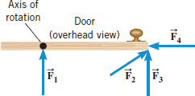
b. F₂
c. F₃
d. F₄

4-6) A uniform meter stick is supported at the 25 cm mark using a 12-g knife-edge clamp. Balance is obtained when a 55 gram mass
is suspended at the 10 cm mark.
4. Draw a free-body diagram for the meter stick.
___5. What is the mass of the meter stick?
___6. What is the normal force in gram?
Answers for 5 & 6
a. 22 g b. 33 g c. 75 g
d. 88 g e. 93 g f. 100 g
4.
___7. When a 54 kg man stands on a pogo stick, the spring is compressed 18 cm. What is the spring constant of the spring, in SI units? (g = 9.8 m/s²)
- 3.0 b. 29.4 c. 300 d. 2940 e. 29400
8-10) A point mass, 2 kg is located at (3m, 4m) in the coordinate system below. Z axis is perpendicular to the X and Y axes.
____8. What is the moment of inertia of this mass about the x axis?
____9. What is the moment of inertia of this mass about the y axis?
____10. What is the moment of inertia of this mass about the z axis?
Answers for 8-10
a. 18 kg.m² b. 32 kg.m² c. 36 kg.m²
d. 50 kg.m² e. 64 kg.m² f. 100 kg.m²
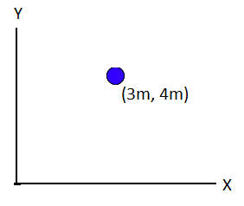
____11. Sit-ups are more difficult to do with your hands placed behind your head instead of on your stomach. This is because,
a. The mass is greater when the hands are placed behind the head instead on the stomach.
b. The mass is smaller when the hands are placed behind the head instead on the stomach.
c. The moment of inertia is greater when the hands are placed behind the head instead on the stomach.
d. The moment of inertia is smaller when the hands are placed behind the head instead on the stomach.
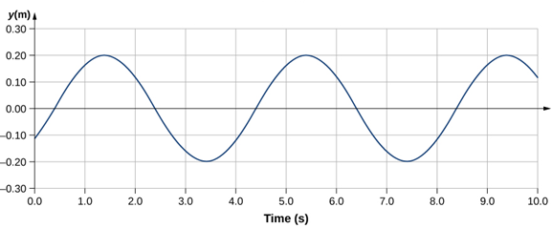

____12. What is the amplitude, in m, for the wave shown above?
____13. What is the period, in s, for the wave shown above?
____14. What is the frequency in Hz for the wave shown above?
Answers for 12-14:
a. 0.20 b. 0.25 c. 0.40 d. 0.50 e. 4.0

____15. Pendulum clocks are made to run at the correct rate by adjusting the pendulum’s length. Suppose you move from one city to another where the acceleration due to gravity is slightly greater, taking your pendulum clock with you, what will you have to do to the length of the pendulum to keep the correct time, other factors remaining constant?
Period of a simple pendulum: $T=2π\sqrt{\frac{L}{g}}$
a. lengthen it b. shorten it c. keeping the length same
______________________________________________________End of MC questions
II. A playground merry-go-round with a child at the rim is rotating with an angular velocity of 2.5 rad/s. If the mass of the child is 19 kg, what will be the angular velocity of the merry-go-round as soon as the child jumps out along a radial direction? (Assume that the merry-go-round is a disk of mass 110 kg and radius 2.2 m)

III. A pulley of moment of inertia 8.5 kg.m² and radius 0.15 m is pulled with an applied force, F = 18 N, as shown below.
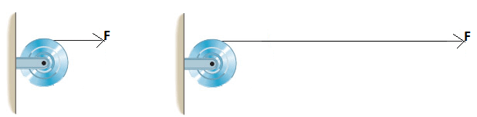
1. Calculate the torque exerted on the pulley.

2. Calculate the angular acceleration of the pulley.

3. If the pulley is at rest initially, how long the force needs to be applied to make the pulley spin at 26 rad/s?

IV. Period of oscillating mass on spring:
$T=2π\sqrt{\frac{m}{k}}$
1. Show that the above equation is correct unit wise.

2. A spring-mounted chair in which the astronaut sits, can be used to find the mass of an astronaut. The chair is then made to oscillate in simple harmonic motion. The spring used in one such device has a spring constant of 596 N/m, and the mass of the chair is 13.0 kg. The measured oscillation period is 2.21 s. Find the mass of the astronaut.

V. The spring-loaded gun in a ballistic pendulum is compressed by 4.3 cm and a 49 gram steel ball is released. If the spring constant of the spring is 750 N/m, calculate the speed of the ball as it leaves.

VI. A 1500-N uniform horizontal beam of length 8.0 m is hinged to a vertical wall at one end and is supported by a cable at the other end as shown below. A fireman of mass 830-N is standing on the beam at 5.0 m from the hinge.
Draw a free-body diagram for the beam, showing
and naming all the forces acting on the beam,
including the horizontal (R_{x}) and vertical (R_{y}) forces
exerted by the hinge on the beam.
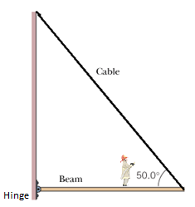

VII. A man holds a 165-N ball in his hand, with the
forearm horizontal (see the drawing below). He can support
the ball in this position because of the flexor muscle
force,$\vec{M}$, which is applied perpendicular to the forearm
and the force, $\vec{B}$, applied by the upper-arm bone.
The forearm weighs 21.0 N and has a center of gravity as indicated.
a) Show the weight of the ball and forearm in the diagram.
b) Find the magnitudes of the forces$\vec{M}$ and $\vec{B}$.
