PHYSICS 201  Equations Sheet | Translational Motion | Rotational Motion
 | LINEAR | ANGULAR
Time | t | T
Displacement | x; (x = rθ) | θ
Velocity | v = Δx/Δt; (v = rω) | ω = Δθ/Δt
Acceleration | a = Δv/Δt; (a = rα) | α = Δω/Δt
Kinematic Equations | v = v₀ + at | ω = ω₀ + αt
 | x = ½(v + v₀)t | θ = ½(ω + ω₀)t
 | x = v₀t + ½ at² | θ = ω₀t + ½ αt²
 | v² = v₀² + 2ax | ω² = ω₀² + 2αθ
Inertia | m = mass | I = Rotational inertia;
To create | force = F | torque = τ = LA· F
Newton's second law of motion | ΣF = ma | Στ = Iα
 | ΣF = Δp/Δt | Στ = ΔL/Δt
Work | F·x | τ·θ
Kinetic Energy | Translational Kinetic Energy = TKE = ½ mv² | Rotational Kinetic  Energy = RKE = ½ Iω²
Momentum | p = m·V | L = I·ω
Conservation of momentum | Σm_{i}v_{i} = Σm_{f}v_{f} | ΣI_{i}ω_{i} = ΣI_{f}ω_{f}

Pressure = Force/Area P_{abs} = P_{atm} + P_{G} Density = Mass/Volume
Pressure (P) due to depth h of fluid of density ρ; P = ρgh.
1 atm = 1.013 x 10⁵ N/m² = 76 cm.Hg = 760 mm.Hg

The density of the air is 1.29 kg/m³; Density of water = 1000 kg/m³ = 1 g/cm³; Acceleration due to gravity = g = 9.8 m/s². 1 Revolution = 2π rad.
Area of a circle of radius r, A_{circle} = π r² .Area of a rectangle of length l, and width w, A_{rec}=l x w; Area of a triangle, A_{triangle}= 0.5 x base x height.
Volume of a cylinder of radius r and height h; V= π r²h; Volume of a sphere = (4/3) π r³.
Frictional force = F_{fr}=μ_{k}F_{N} Buoyant force: $F_{b}=ρ_{f}v_{f}g$ GPE = mgh
Hooke’s law: $\vec{F}=-k\vec{x}$ Elastic PE = EPE = $\frac{1}{2}kx^{2}$
Period of a simple pendulum: $T=2π\sqrt{\frac{L}{g}}$ Period of oscillating mass on spring: $T=2π\sqrt{\frac{m}{k}}$

PHYS 201 Fall 2017 Test #3 Name:___________________________
I. For the following multiple choice questions, write your answer in the line next to the question number.

____1. What is the angular speed in degree/minute of the minute hand of an analog watch?
a. 6 b. 12 c. 15 d. 30 e. 36

____2. What is the angular speed in rad/s of the minute hand of an analog watch?
a. 1.75 x 10⁻³ b. 0.105 c. 8.33 x 10⁻³ d. 8.73 x 10⁻³ e. 1.45 x 10⁻⁴
____3. The radius of each wheel on a bicycle is 0.400 m. The bicycle travels a distance of 3.0 km. How many revolutions does each wheel make (wheels do not slip)?
a. 7.5 b. 1200 c. 2400 d. 6000 e. 7500
____4. The drawing illustrates an overhead view of a door and its axis of rotation. The axis is perpendicular to the page. There are four forces acting on the door, and they have the same magnitude. Which force will provide the highest torque, about the axis of rotation?
a. F₁
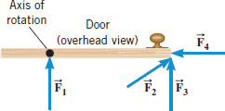
b. F₂
c. F₃
d. F₄

____5. For the above question, which pair of forces,
provide no torque about the axis of rotation?
a. F₁ and F₂ b. F₃ and F₄ c. F₁ and F₄ d. F₃ and F₂ e. F₁ and F₃

6-7) Five hockey pucks are sliding across frictionless ice. The drawing shows a top view of the pucks and the three forces that act on each one. As shown, the forces have different magnitudes , and are applied at different points on the pucks.
____6. Which one of the five pucks is in Equilibrium?
____7. Which one of the five pucks has a net torque of FR, clockwise, about the center?
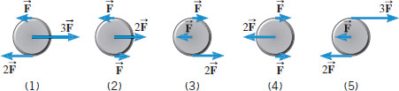

____8. A twin-sized air mattress used for camping has dimensions of 70 cm by 150 cm by 10 cm when blown up. The weight of the mattress is 17.0 kg. How heavy a person could the air mattress hold if it is placed in freshwater?
a. 88 kg b. 105 kg c. 122 kg d. 170 kg
____9. Two 'point' masses in the figure below are located along the x-axis, 3kg (5 m, 0) and 2 kg (-3 m, 0). Axis of rotation is along the y-axis. What is the moment of inertia of the masses about the axis of rotation?
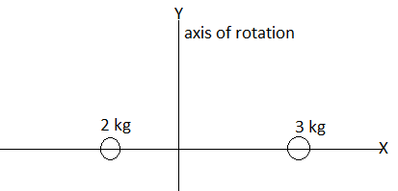
a. 18 kg.m² b. 57 kg.m² c. 75 kg.m² d. 93 kg.m²
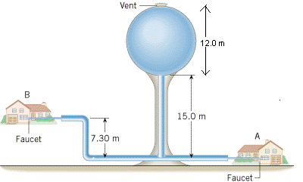
____10. The purpose of a water tower is to provide storage capacity
and to provide sufficient pressure in the pipes that deliver the water
to customers. The drawing shows a spherical reservoir, which is
vented to the atmosphere at the top and full. What height must be
used to find the gauge pressure at the faucet in house B?
a. 7.3 m b. 15 m c. 19.7 m d. 27 m e. 34.3 m

____11. What is the pressure difference between the top and bottom of a 645-m high skyscraper? Assume that the density of air is a constant 1.29 kg/m³.
a. 76 cm. of Hg b. 6321 Pa c. 76 Pa d. 832 Pa e. 8154 Pa

____12. Which one of the following is a correct statement of Pascal’s principle?
a. Any change in the pressure applied to a completely enclosed fluid is transmitted undiminished to all parts of the fluid and the enclosing walls.
b. Any fluid applies a buoyant force to an object that is partially or completely immersed in it; the magnitude of the buoyant force is greater than the weight of the fluid that the object displaces.
c. Gauge pressure is the pressure measured by a pressure gauge. It is the difference between the absolute pressure and atmospheric pressure.
d.
Any fluid applies a buoyant force to an object that is partially or completely immersed in it; the magnitude of the buoyant force is less than the weight of the fluid that the object displaces.
e. Any fluid applies a buoyant force to an object that is partially or completely immersed in it; the magnitude of the buoyant force equals the weight of the fluid that the object displaces.

____13. Sit-ups are more difficult to do with your hands placed behind your head instead of on your stomach. This is because,
a. The mass is greater when the hands are placed behind the head instead on the stomach.
b. The mass is smaller when the hands are placed behind the head instead on the stomach.
c. The moment of inertia is greater when the hands are placed behind the head instead on the stomach.
d. The moment of inertia is smaller when the hands are placed behind the head instead on the stomach.
II. A spring-mounted chair in which the astronaut sits, can be used to find the mass of an astronaut. The chair is then made to oscillate in simple harmonic motion. The spring used in one such device has a spring constant of 656 N/m, and the mass of the chair is 15.0 kg. The measured oscillation period is 2.81 s. Find the mass of the astronaut.

III. The length of nylon rope from which a mountain climber is suspended has a spring constant of 14,296 N/m. The mass of the climber and the equipment is 91 kg. How much would this rope stretch to break the climber’s fall if he free-falls 2.3 m before the rope runs out of slack?

IV. A traffic light of mass M is supported by
a uniform pole of mass m, hinged at A, and
a horizontal cable. Draw a free-body diagram
for the pole, identifying and showing all the
forces acting on it.
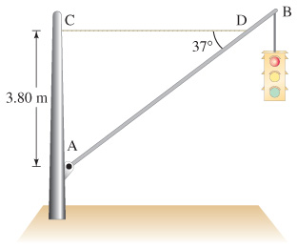
V. In an isometric exercise a person places a hand on a scale and pushes vertically downward, keeping the forearm horizontal. This is possible because the triceps muscle applies an upward force perpendicular to the arm, as the drawing indicates. The forearm weighs 25.0 N and has a center of gravity as indicated. The scale registers 115 N.
a. Draw a free-body diagram for the fore-arm.
b. Determine the magnitude of
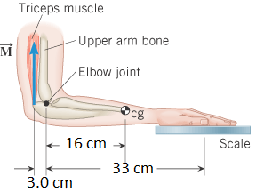

VI. The drawing shows a model for the motion of the human forearm in throwing a dart. Because of the force applied by the triceps muscle, the forearm can rotate about an axis at the elbow joint. Assume that the forearm has the dimensions shown in the drawing and a moment of inertia of 0.075 kg.m² (including the effect of the dart) relative to the axis at the elbow. Assume also that the force acts perpendicular to the forearm. Ignoring the effect of gravity and any frictional forces, determine the magnitude of the force needed to give the dart a tangential speed of 6 m/s in 0.15 s, starting from rest.
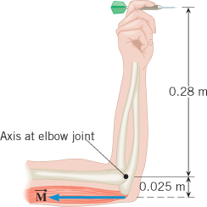

VII. Bernoulli’s Principle
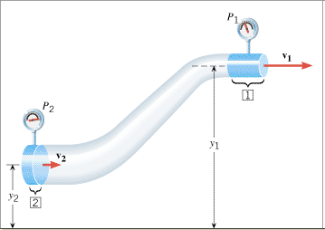
1. Define pressure.

2. Describe each of the terms in the Bernoulli’s equation below.
P =_____________________________ ρ = _________________________

v =_____________________________ y = _________________________

g = _____________________________

3. What is the unit for the term ρgy in the Bernoulli’s equation?

4. An airplane has an effective wing surface area of that is generating the lift force. In level flight the air speed over the top of the wings is , while the air speed beneath the wings is . The density of the air is 1.29 kg/m³.
a. Draw a free-body diagram for the plane.
b. What is the weight of the plane? 