|  |  |  |
| --- | --- | --- |
| PHYSICS 201  Equations Sheet | Translational Motion | Rotational Motion |
| LINEAR | ANGULAR |
| Time | t | T |
| Displacement | x; (x = rθ) | θ |
| Velocity | v = Δx/Δt; (v = rω) | ω = Δθ/Δt |
| Acceleration | a = Δv/Δt; (a = rα) | α = Δω/Δt |
| Kinematic Equations | v = v0 + at | ω = ω0 + αt |
| x = ½(v + v0)t | θ = ½(ω + ω0)t |
| x = v0t + ½ at2 | θ = ω0t + ½ αt2 |
| v2 = v02 + 2ax | ω2 = ω02 + 2αθ |
| Inertia | *m* = mass | *I* = Rotational inertia; |
| To create | force = F | torque = τ = LA·F |
| Newton's second law of motion | Σ**F** = m**a** | Σ**τ** = I**α** |
| Σ**F** = Δ**p**/Δt | Σ**τ** = Δ**L**/Δt |
| Work | *F·x* | *τ·θ* |
| Kinetic Energy | Translational Kinetic Energy = TKE = ½ mv2 | Rotational Kinetic  Energy = RKE = ½ Iω2 |
| Momentum | **p** = m·**V** | **L** = I·**ω** |
| Conservation of momentum | Σmivi = Σmfvf | ΣIiωi = ΣIfωf |

Acceleration due to gravity = g = 9.8 m/s2. 1 Revolution = 2π rad.

Area of a circle of radius r, Acircle = π r2 .Area of a rectangle of length l, and width w, Arec=l x w; Area of a triangle, Atriangle= 0.5 x base x height.  
  
Volume of a cylinder of radius r and height h; V= π r2h; Volume of a sphere = (4/3) π r3.

Frictional force = *Ffr=μkFN* Buoyant force: $F_{b}=ρ_{f}v_{f}g$ GPE = mgh

Hooke’s law: $\vec{F}=-k\vec{x}$ Elastic PE = EPE = $\frac{1}{2}kx^{2}$ Period = 1/Frequency  
Period of a simple pendulum: $T=2π\sqrt{\frac{L}{g}}$ Period of oscillating mass on spring: $T=2π\sqrt{\frac{m}{k}}$

The moment of inertia, I for a cylinder (or disk) of mass m and radius r is: $I=\frac{1}{2}mr^{2}$

**PHYS 201 Fall 2018 Test #3 Name:___________________________**

I. For the following multiple choice questions, write your answer in the line next to the question number.

____1. What is the angular speed in degree/hour of the hour hand of an analog watch?  
a. 6 b. 12 c. 15 d. 30 e. 36

____2. What is the angular speed in rad/s of the hour hand of an analog watch?

a. 1.75 x 10-3 b. 0.105 c. 8.33 x 10-3 d. 8.73 x 10-3 e. 1.45 x 10-4

____3. The radius of each wheel on a bicycle is 0.400 m. The bicycle travels a distance of 3.0 km. How many revolutions does each wheel make (wheels do not slip)?   
a. 7.5 b. 1200 c. 2400 d. 6000 e. 7500

____4. During a spin dry cycle of a washing machine, the motor speeds from 30 rad/s to 95 rad/s while turning the drum through an angle of 402 radians. How long it took to spin this angle?

a. 6.43 s b. 3.21 s c. 4.23 s d. 13.4 s e. 62.5 s

____5. A ball of radius 0.200 m is given an initial angular velocity of 15 rad/s. The ball rolls along a straight line for 5 seconds until it comes to rest. How far the ball travels during this time?   
a. 7.5 m b. 37.5 m c. 3 m d. 75 m e. 15 m f. 1.0 m

____6. A figure skater is spinning with an angular velocity of 18 rad/s. She then comes to a stop over a brief period of time. During this time, her angular displacement is 5.1 rad. Determine her average angular acceleration, in SI units.   
a. 3.5 rad/s2 b. 32 rad/s2 c. -3.5 rad/s2 d. -32 rad/s2

7-8) The drawing illustrates an overhead view of a door and its axis of rotation. The axis is perpendicular to the page. There are four forces acting on the door, and they have the same magnitude.   
7. Show the lever-arm for the force ***F3*** in the diagram.  
____8. Which pair of forces provide non-zero torque,  
about the axis of rotation shown?  
a. **F1** and **F2** b. **F3** and **F4** c. **F1** and **F4**   
d. **F3** and **F2** e. **F1** and **F3**

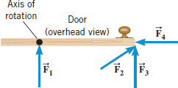

____9. Refer to the wheel system shown below. Its axis is at the center, perpendicular to the page. Assume F1 = 40-N, F2 = 60-N, inner radius = 50 cm, and outer radius = 110 cm.



What is the net torque acting on the wheel?

a. 46 N.m, clockwise b. 46 N.m, counter-clockwise

c. 86 N.m, clockwise d. 86 N.m, counter-clockwise

e. 4600 N.m clockwise f. 8600 N.m clockwise

10-11) A uniform meter stick is supported at the center of gravity. Balance is obtained when a 65 gram mass is suspended at the 15 cm mark and an unknown mass is suspended at 75 cm.   
10. Draw a free-body diagram for the meter stick.  
  
___11. How much is the unknown mass, above?  
a. 13 g b. 46 g c. 75 g   
d. 87 g e. 91 g

10.

**___12.** Two 'point' masses, 1 has a mass of 2 kg and   
2 has a mass of 4 kg, rotated as shown.   
The length l = 0.2 m and 2l = 0.4 m. Calculate the moment   
of inertia about the axis of rotation shown?   
a. 0 b. 0.08 kg.m2 c. 0.64 kg.m2d. 0.72 kg.m2 e. 2.72 kg.m2

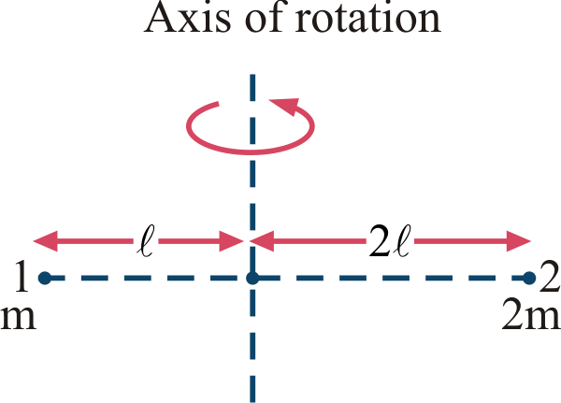

13-14) The stretching force VS. stretch curve for a Hooke’s law experiment is shown below.   
____13. What is the spring constant of the spring?   
a. 5 N/m b. 10 N/m c. 20 N/m   
d. 25 N/m e. 50 N/m   
____14. How much energy is stored in the spring,   
when it is stretched to 0.2 m?

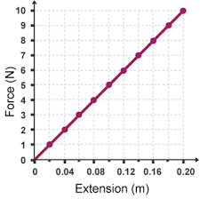

1. 1 N.m
2. 2 N.m
3. 5 N.m
4. 20 N.m
5. 25 N.m
6. 50 N.m

____15. What is the period, in millisecond, of the sound wave of frequency 1040 Hz?

1. 0.96 b. 9.6 c. 9.6 x 10-4 d. 10.4 e. 0.104

____16. The period of a simple pendulum of length 0.993 m is found to be 1.95 s at a location. Calculate the acceleration due to gravity at this location to 3 significant figures.

a. 9.80 m/s2 b. 9.83 m/s2 c. 9.90 m/s2 d. 10.3 m/s2 e. 10.6 m/s2

**____17. When a 54 kg man stands on a pogo stick, the spring is compressed 18 cm. What is the spring constant of the spring, in SI units? (g = 9.8 m/s2)  
3.0 b. 29.4 c. 300 d. 2940 e. 29400**

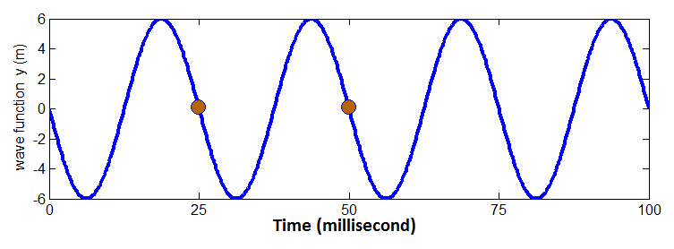  
____18. What is the amplitude, in m, for the wave shown above?  
____19. What is the period in millisecond for the wave shown above?  
____20. What is the frequency in Hz for the wave shown above?  
Answers for 15 & 16: a. 6 b. 12 c. 25 d. 40 e. 80  
______________________________________________________End of MC questions

II. Automobile Chevy volt, mass = 1750 kg (including its 4 wheels), moving with a velocity of 35 m/s.   
a. Calculate the translational kinetic energy of the car in SI units.

b. If each of the rolling wheels, assumed to be a uniform disk, has a mass of 15 kg and radius 0.30 m, calculate the rotational kinetic energy for one wheel.

c. Calculate the total (rotational & translational) kinetic energy of the car.

III. A playground merry-go-round (a disk) has a mass of 126 kg and a radius of 1.89 m and it is rotating with an angular velocity of 3.1 rad/s. What is

its angular velocity after a 17 kg child gets onto it by grabbing its outer

edge? The child is initially at rest. Express your answer in SI units.

IV. The drawing shows a model for the motion of the human forearm in throwing a dart. Because of the force ModifyingAbove Bold Upper M With right-arrow applied by the triceps muscle, the forearm can rotate about an axis at the elbow joint. Assume that the forearm has the dimensions shown in the drawing and a moment of inertia of 0.075 kg.m2 (including the effect of the dart) relative to the axis at the elbow. Assume also that the force ModifyingAbove Bold Upper M With right-arrow acts perpendicular to the forearm. Ignoring the effect of gravity and any frictional forces, determine the magnitude of the force ModifyingAbove Bold Upper M With right-arrow needed to give the dart a tangential speed of 5.5 m/s in 0.12 s, starting from rest.

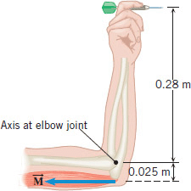

V. A 1200-N uniform horizontal beam of length 8.0 m is hinged to a vertical wall at one end and is supported by a cable at the other end as shown below. A fireman of mass 65-kg is standing on the beam at 5.0 m from the hinge.   
1. Draw a free-body diagram for the beam, showing all the forces acting on the beam, including the horizontal (Rx) and vertical (Ry) forces exerted by the hinge on the beam.

2. Break the tension in the cable into horizontal and vertical components.  
3. Write down two equations by balancing the forces in x and y directions.  
4. Write down the torque equation.  
5. Find the tension in the cable and the horizontal and vertical forces exerted by the hinge on the beam.

