PHYS 201 Test #2 Name:__________________________________

|  |  |  |  |  |  |
| --- | --- | --- | --- | --- | --- |
| 1. | 2. | 3. | 4. | 5. | Newton’s 2nd Law |
| $$x=\overline{v} t$$ | $$x=\frac{1}{2}\left(v_{0}+v\right)t$$ | $$v=v_{0}+at$$ | $$x=v_{0}t+\frac{1}{2}at^{2}$$ | $$v^{2}=v_{0}^{2}+2ax$$ | $$\sum{\vec{F}}=m\vec{a}$$ |

Force of friction:    
Acceleration due to gravity = g = 9.8 m/s2.

Newton’s law of gravitation is given by: 

Centripetal force is given by, 

Kinetic Energy is given by, 

Potential Energy is given by, 

Work done by a Force,    
  
Power = Work/Time.

Work-Energy Theorem: 

Linear momentum of an object of mass, *m* and velocity, ***v*** is given by: ***p*** = *m* x***v***.

Impulse is defined as the product of the force and time, ***J* = *F***x *t*.

Impulse-Momentum Theorem: 

Area of a triangle = 

PHYS 201   Test #2 Fall 2017            Name:_____________________________  
A. For the MC questions write your answers in the line next to the question number.  
Other questions/Problems provide your answers in the space below them.

____1. Which one of the following objects has the largest inertia?

a. space shuttle b. book c. bicycle d. car e. truck

____2. The push or pull on an object can be best described by what scientific term?

1. Friction b. motion c. gravity d. force e. mass

____3. Newton’s first law of motion states that a body in motion does what if it is not acted on by a net force?  
a. Comes to rest b. Changes direction  
c. Maintains a constant speed d. Increases inertia  
e. Maintains a constant velocity

____4. Which one of the following is Newton’s law of gravitation?

a. Every particle in the universe exerts a repulsive force on every other particle

b. Every particle in the universe exerts an attractive force on every other particle

c. An object will remain in a state of rest or of uniform motion in a straight line unless acted on by an outside net force.

d. The net force acting on an object is equals to the product of the mass of the object and the acceleration of the object.

e. When one object exerts a force on a second object, the second object exerts a force on the first that has an equal magnitude but opposite direction.

f. Frictional forces are in the opposite direction of motion.

____5. If a constant, nonzero force is applied to an object that is at rest, what can you say about the velocity and acceleration of the object while the force being applied?  
a. velocity changes, acceleration changes  
b. velocity remains constant, acceleration remains constant  
c. velocity remains constant, acceleration changes  
d. velocity changes, acceleration remains constant

____6. Which one of the following is also the unit joule, J?  
a. kg.m/s2 b. m3/(kg.s2) c. kg.m2/s2 d. kg.m2/s3 e. kg.m/s3 f. kg.m/s

____7. Which one of the following is an example for a non-conservative force?

a. elastic force b. frictional force   
 c. electric force d. gravitational force

____8. Which one of the following is a fundamental force?  
 a. tension b. normal force   
 c. frictional force d. gravitational force

_____9. Two masses (4-kg and 6-kg) are attached by a massless cord



passing over a massless, frictionless pulley of an Atwood's machine

and released. What will be the acceleration of the masses?  
a. 0.20 m/s2 b. 9.8 m/s2 c. 5.88 m/s2

d. 1.96 m/s2 e. 3.92 m/s2

____10. What is the angle between the acceleration and velocity of an object in uniform circular motion?   
a. 0 b. 300 c. 450 d. 900 e. 1800

____11. Which one of the following terms is used to indicate the natural tendency of an object to remain at rest or in motion at a constant speed along a straight line?  
a. Velocity b. Speed c. Inertia d. Force e. Acceleration

____12. Sally wants to push a box across the floor. She has a hard time getting the box to start moving, but finds it easy to push it the rest of the way. What can you infer from this example about the relationship between kinetic friction and static friction?

a. Kinetic friction is less than static friction.  
b. Kinetic friction is equal to static friction.  
c. Kinetic friction is greater than static friction.

____13. Which one of the following is an example of a completely inelastic collision?  
a. A hockey puck crashes into a wall and bounces backwards.  
b. A bullet is shot and lodges into a wooden block.  
c. Two bumper cars collide and split off in different directions.

____14. What is represented by the area under the Force VS. Time graph?

a. Displacement b. Work c. Acceleration d. Velocity e. Impulse

____15. A volleyball of mass 0.35 kg is spiked so that its incoming velocity of -15 m/s is changed to an outgoing velocity of +12 m/s. What impulse does the player apply to the ball?

a. 4.2 kg.m/s b. -5.3 kg.m/s c. 9.5 kg.m/s d. -9.5 kg.m/s e. 1.1 kg.m/s f. -1.1 kg.m/s

____16. The graph shows how the force component Upper F  cosine  theta along the displacement varies with the magnitude s of the displacement. Find the work done by the force.

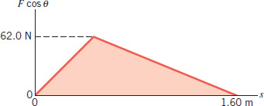

a. 24.8 J b. 49.6 J c. 62 J d. 99.2 J

_____17. A car, starting from rest, accelerates in the plus x direction as in the figure. It has a mass of 1150 kg and maintains an acceleration of +4.50 m/s2 for 5.00 s. Assume that a single horizontal force (not shown) accelerates the vehicle. Determine the average power, in kW generated by this force.

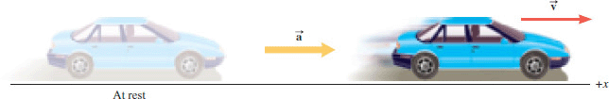

a. 5.18 b. 56.3 c. 58.2 d. 291 e. 5175 f. 58219

____18. Estimate the cost of electricity for operating a 6-W LED light bulb for 8 hours a day for 20 days a month for two years. Assume a cost of 9 cents per kWh.

A. $ 0.35 B. $ 1.04 C. $ 1.55 D. $ 2.07 E. $ 23

____19. When you charge your smart phone, which one of the energy transformations take place?  
a. Chemical energy is converted into electrical energy  
b. Chemical energy is converted into thermal energy  
c. Electrical energy is converted into sound energy  
d. Electrical energy is converted into thermal energy   
e. Chemical energy is converted into sound energy  
f. Electrical energy is converted into chemical energy

_____20. Two objects are involved in a completely inelastic one-dimensional collision. The net external force acting on them is zero. The table lists four possible sets of the initial momenta and kinetic energies of the two objects, as well as their final momenta and kinetic energies. Identify the set that violates the collision laws?

|  |  |  |  |  |  |
| --- | --- | --- | --- | --- | --- |
|  |  | Initial (Before Collision) | | Final (After Collision) | |
|  |  | Momentum | Kinetic Energy | Momentum | Kinetic Energy |
| a. | Object 1: Object 2: | +6 kg·m/s   +2 kg·m/s | 15 J   0 J | +8 kg·m/s | 9 J |
| b. | Object 1: Object 2: | +8 kg·m/s  -2 kg·m/s | 5 J 7 J | +6 kg·m/s | 7 J |
| c. | Object 1: Object 2: | -3 kg·m/s +4 kg·m/s | 1 J 6 J | +1 kg·m/s | 4 J |
| d. | Object 1: Object 2: | 0 kg·m/s -8 kg·m/s | 3 J 8 J | -7 kg·m/s | 10 J |

B. A skier is coasting down a 25° slope, at a constant velocity as shown below.   
1. Draw a free-body diagram for the skier, naming all the forces.

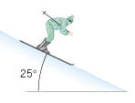

2. Determine the coefficient of kinetic friction between the skis and snow.

C. A 44-kg skater is moving due west at a speed of 3.2 m/s. A 67-kg skater is moving due south at a speed of 5.8 m/s. They collide and hold on to each other after the collision.  
a. Sketch a diagram of the above situation, showing the skaters before and after the collision.  
b. What type is this collision?______________________________  
c. What quantity is conserved in this collision?_________________

d. Find the velocity (speed and direction) of the skaters after the collision, assuming that friction can be ignored.

D. While driving along a country lane with a constant speed of 15 m/s, one encounters a dip in the road. The dip can be approximated as a circular arc of radius 55 m.   
1. Draw a free-body diagram for the car at the bottom of the dip.  
2. Calculate the normal force on the car (mass = 1200-kg) when the car is at the bottom of the dip?

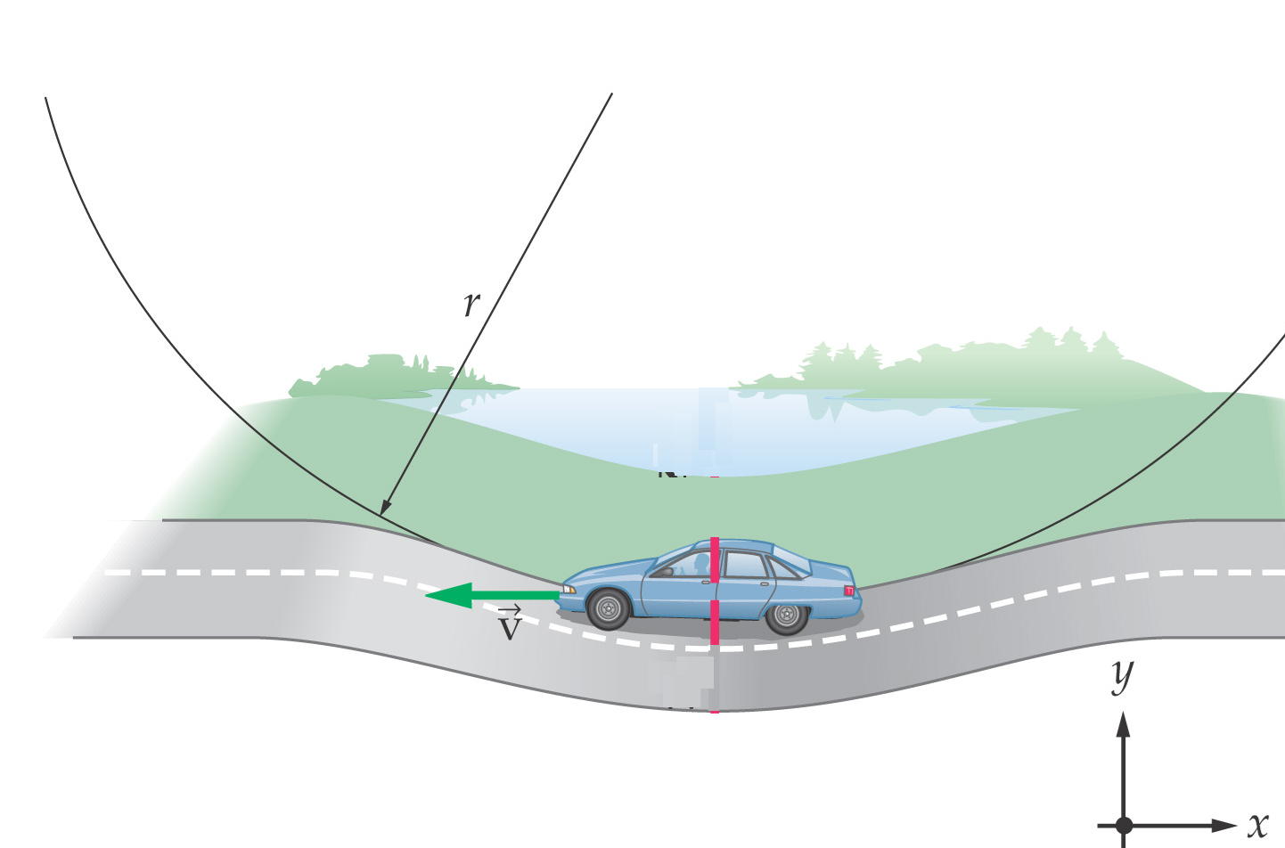

|  |  |
| --- | --- |
| |  | | --- | | E. A “swing” ride at a carnival consists of chairs that are swung in a circle by 15.0-m cables attached to a vertical rotating pole, as the drawing shows. Suppose the total mass of a chair and its occupant is m.  1. Draw a free-body diagram for the chair and its  occupant. 2. Identify the centripetal force._______________ | |

F. Newton’s law of gravitation is given by:    
1. Express the SI unit of the gravitational constant, *G*. in terms of kg, m, and s. ________

2. In another solar system a planet has twice the earth's mass and twice the earth's radius. Your weight on this planet is _______ times your earth-weight. Assume that the masses of the earth and the other planet are uniformly distributed.   
  
3. A satellite circles the Earth in an orbit whose altitude is equal to the radius of the Earth. Derive an expression for the speed of the satellite and calculate it.   
(Mass of Earth = M = 5.98 x 1024Kg, Radius of Earth = R = 6380 km)