PHYS 201     Equations Sheet Test #1     Chapters 1, 2, & 3. You may tear this sheet.  
1. Equations of kinematics:

|  |  |  |  |  |
| --- | --- | --- | --- | --- |
| 1. | 2. | 3. | 4. | 5. |
| $$∆x=\overline{v} t$$ | $$∆x=\frac{1}{2}\left(v_{0}+v\right)t$$ | $$v=v_{0}+at$$ | $$∆x=v_{0}t+\frac{1}{2}at^{2}$$ | $$v^{2}=v_{0}^{2}+2a∆x$$ |
| $$y=\overline{v_{y}} t$$ | $$y=\frac{1}{2}\left(v_{0y}+v_{y}\right)t$$ | $$v_{y}=v_{0y}+a_{y}t$$ | $$y=v_{0y}t+\frac{1}{2}a_{y}t^{2}$$ | $${v_{y}}^{2}=v_{0y}^{2}+2a_{y}y$$ |

Acceleration due to gravity = g = 9.8 m/s2, down

2. Conversion factors: 1 H = 3600 s, 1 Mile = 1608 m, 1 inch = 2.54 cm, 1 foot = 12 inch, 1 m = 3.281 ft.  
1 m = 100 cm, 1 cm = 10 mm, 1 m = 1000 mm, 1 km = 1000 m

3. Areas:

|  |  |  |
| --- | --- | --- |
| Rectangle | Triangle | Circle |
|  |  |  |

4. Pythagorean theorem and Trigonometry:

|  |  |  |  |  |
| --- | --- | --- | --- | --- |
| Pythagorean Theorem | *sin* *θ* | *cos* *θ* | *tan* *θ* | Components of a vector: |
|  |  |  |  | Adjacent component = Cos  Opposite component = Sin |

5. Graphical analysis of motion:

|  |  |  |  |
| --- | --- | --- | --- |
|  |  |  |  |
| Slope | Velocity | Acceleration | XXXXXXXXXXXXXXX |
| Area | XXXXXXXXXXXXX | Displacement | Change in Velocity |

6. Addition of velocities: $\vec{V_{PG}}=\vec{V_{PT}}+\vec{V_{TG}}$

## PHYS 201 Fall 2025 Test #1 Name:_________________________

A. Select the correct answer for the following multiple choice questions and write your answer in the line next to the question number.

____1. In 2019, the SI base unit kelvin is re-defined using these fundamental constants:

* 1. Planck constant, Avogadro constant, and the elementary charge.
  2. Planck constant, elementary charge, and speed of light in vacuum.
  3. Planck constant, hyperfine transition frequency of the cesium 133 atom, and speed of light in vacuum.
  4. Planck constant, Boltzmann constant, and the hyperfine transition frequency of the cesium 133 atom.
  5. Planck constant, Boltzmann constant, and speed of light in vacuum.

____2. What is the SI base unit for temperature?  
a. 0K b. 0F c. 0C d. K e. F f. C

____3. Which one of the following is a SI derived unit?

a. kg b. cm3 c. mol d. kg/m3 e. g/cm3

____4. The speed limit on a college campus is 15 MPH. Express this speed in ft/s.   
(1 M = 5280 ft, 1 H = 3600 s)  
a. 6.7 ft/s b. 10.4 ft/s c. 15 ft/s d. 22 ft/s

____5. Which one of the following is a vector?

a. displacement b. time interval c. speed d. mass e. distance

____6. What is the angle between the vectors **A** and - 3**A** when they are drawn from a common origin?

a. 00 b. 900 c. 1800 d. 2700 e. 3600

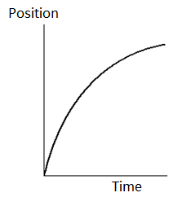

____7. For the motion described in the graph,   
decide whether the moving object is  
a) accelerating   
b) decelerating   
c) moving at a constant velocity  
d) moving at a constant speed

____8. Three vectors **A, B,** and **C** are shown

below in each of the diagrams.  
Which one represents the relationship: **C + A= B ?**

____9. A ball (I) is rolled along the surface of a table and leaves the edge horizontally. At the same instant the ball I leaves the table, a second ball (II) is dropped from rest at the edge of the table. In the absence of air resistance, which ball will strike the ground first?  
a. I b. II c. both at the same time  
  
____10. In the above question which ball will have the higher speed at the ground level?  
a. I b. II c. both will have the same speed

11-12) A car traveling at 65 km/h, overtakes a 0.26 km long train traveling in the same direction on a track parallel to the road. The velocity of the train is 52 km/h, eastward.

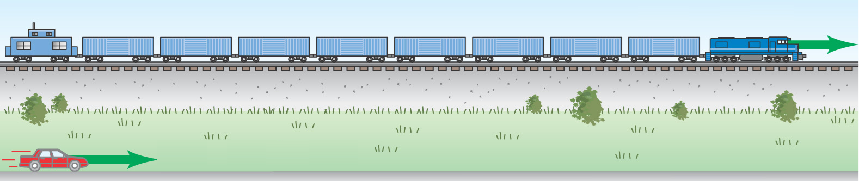

____11. What is the velocity of the car relative to the train?  
a. 65 km/h eastward b. 52 km/h eastward c. 13 km/h westward

d. 117 km/h eastward e. 117 km/h westward f. 13 km/h eastward

____12. How long does it take the car to pass the train?

a. 12 s b. 14 s c. 18 s d. 72 s

_____13. Four vectors are shown in the cartesian coordinate

System. (Magnitudes are: A = 8.00 m, B = 15.0 m, C = 12.0 m,

and D = 10.0 m). What is the +x component of the vector C?  
a. 8.6 m

b. 6.9 m

c. 9.8 m

d. 12.3 m

e. – 8.6 m

f. – 6.9 m

g. – 9.8 m

h. – 12.3 m

_____________________End of MC questions________________________________________  
  
B. Deal with the one-dimensional motion, duration of 105 s, where the velocity is graphed as a function of time.   
a. What is the instantaneous velocity at 15 s?  
b. What is the instantaneous acceleration at 45 s?   
c. What is the displacement from 0 s to 55?

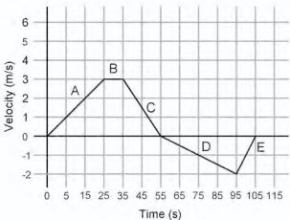

C. Equations of Kinematics for constant acceleration are given below:

|  |  |  |  |  |
| --- | --- | --- | --- | --- |
| 1. | 2. | 3. | 4. | 5. |
|  |  |  |  |  |

1. Define acceleration and derive the 3rd equation.

2. Derive the 4th equations using the equations 2 & 3.

3. A car traveling at 18 m/s hits a bridge abutment. A passenger in the car moves forward a distance 0.95 m while being brought to rest by an inflated air bag. Determine the deceleration of the passenger?

4. A ball is shot vertically upward from the surface of another planet. A plot of *y* versus *t* for the ball is shown below, where *y* is the height of the ball above its starting point and *t* = 0 at the instant the ball is shot.   
a. What is the highest height reached by the ball? ___________

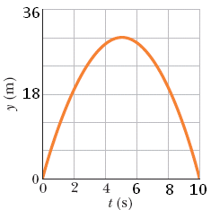

b. How long it took to reach the highest point?____________

c. Determine the initial velocity of the ball?

d. Determine the free-fall acceleration on the planet?

|  |  |  |  |  |
| --- | --- | --- | --- | --- |
| 1. | 2. | 3. | 4. | 5. |
| $$y=\overline{v_{y}} t \\ x=\overline{v_{x}} t$$ | $$y=\frac{1}{2}\left(v_{0y}+v_{y}\right)t$$ | $$v_{y}=v_{0y}+a_{y}t$$ | $$y=v_{0y}t+\frac{1}{2}a_{y}t^{2}$$ | $${v_{y}}^{2}=v_{0y}^{2}+2a_{y}y$$ |

D. During a fireworks display, a shell is shot into the air with an initial speed of 60.0 m/s at an angle of 65.0º above the horizontal, as illustrated in the figure. The fuse is timed to ignite the shell just as it reaches its highest point above the ground. Ignore air resistance. The acceleration due to gravity = 9.8 m/s2, down.

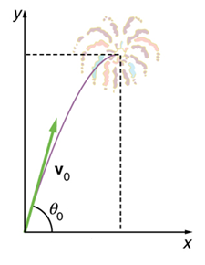

(a) Find the horizontal and vertical components of the   
initial velocity, Vox and Voy.

(b) Calculate the height at which the shell explodes.

(c) How much time passed between the launch of the shell and the explosion?

(d) What is the horizontal displacement of the shell when it explodes?

(e) Plot the vertical velocity as a function of time from the time it is shot till it explodes.