PHYS 201 F2023 Equations Sheet (may be teared & re-stapled) Name:_____________________
1. Equations of kinematics:
1. | 2. | 3. | 4. | 5.
$$x=\overline{v} t$$ | $$x=\frac{1}{2}\left(v_{0}+v\right)t$$ | $$v=v_{0}+at$$ | $$x=v_{0}t+\frac{1}{2}at^{2}$$ | $$v^{2}=v_{0}^{2}+2ax$$
Acceleration due to gravity = g = 9.8 m/s², down
2. Conversion factors:
1 H = 3600 s, 1 Mile = 1608 m, 1 inch = 2.54 cm, 1 foot = 12 inch, 1 m = 3.281 ft.
1 m = 100 cm, 1 cm = 10 mm, 1 m = 1000 mm, 1 km = 1000 m
3. Areas:
Rectangle | Triangle | Circle

4. Pythagorean theorem and Trigonometry:
Pythagorean Theorem | sin θ | cos θ | tan θ | Components of a vector:
$$c^{2}=b^{2}+a^{2}$$ | $$Sin θ=\frac{opp}{hyp}=\frac{a}{c}$$ | $$Cos θ=\frac{adj}{hyp}=\frac{b}{c}$$ | $$Tan θ=\frac{opp}{adj}=\frac{a}{b}$$ | Adjacent component = Cos  Opposite component = Sin
5. Graphical analysis of motion:
Slope | Velocity | Acceleration | XXXXXXXXXXXXXXX
Area | XXXXXXXXXXXXX | Displacement | Change in Velocity
6. Addition of velocities: $\vec{V_{PG}}=\vec{V_{PT}}+\vec{V_{TG}}$

PHYS 201 Fall 2023 Test #1 Name:_________________________
A. Select the correct answer for the following multiple choice questions and write your answer in the line next to the question number.

____1. In 2019, the SI base unit mole was re-defined using this fundamental constant:

  - Planck constant.
  - Elementary charge.
  - Hyperfine transition frequency of the cesium 133 atom.
  - Boltzmann constant.
  - Speed of light in vacuum.
  - Avogadro constant.

____2. What is the SI base unit for temperature?
a. K b. ⁰F c. ⁰C d. ⁰K e. F f. C

____3. Which one of the following is a SI derived unit?
a. kg b. m³ c. mol d. A e. m f. cm/s

____4. Which one of the following is a scalar?
a. displacement b. acceleration c. velocity d. weight e. distance

____5. What is the angle between the vectors 2A and 3A when they are drawn from a common origin?
a. 0⁰ b. 90⁰ c. 180⁰ d. 270⁰ e. 360⁰

____6. For the motion described in the graph, decide whether the moving object is
a) accelerating
b) decelerating
c) moving at a constant velocity
d) moving at a constant speed
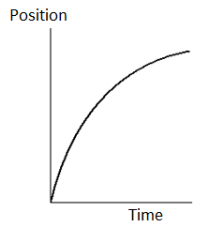

____7. Velocity is defined as,
____8. Acceleration is defined as,
Answers for 7 & 8
a. Rate at which the speed changes
b. Rate at which the velocity changes
c. Rate at which the distance changes
d. Rate at which the displacement changes

____9. Speeding tickets are issued using the,
a. average speed b. average velocity c. average acceleration
d. instantaneous speed e. instantaneous velocity f. instantaneous acceleration

____10. Which pair of the following physical quantities are zero at the highest point of the trajectory of a two-dimensional projectile motion?
a. horizontal velocity and vertical velocity
b. horizontal acceleration and vertical velocity
c. vertical acceleration and vertical velocity
d. horizontal velocity and horizontal acceleration

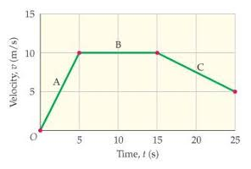

11-13) Deal with the one-dimensional motion of a race,
duration of 25 s, where the velocity is graphed as a function
of time, shown on the right.
____11. What is the instantaneous velocity of the runner at 5 s?
a. 5 m/s b. 10 m/s c. 7.5 m/s d. -7.5 m/s

____12. What is the instantaneous acceleration of the
runner at 20 s?
a. 0 m/s² b. 2.0 m/s² c. 0.5 m/s² d. -0.5 m/s² e. -2 m/s²
____13. How far is the race?
a. 25 m b. 50 m c. 100 m d. 200 m e. 250 m
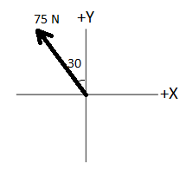
____14. What is the +X component of the force 75N shown in the
diagram, which is in the 2nd quadrant and makes 30⁰ with the +Y axis?
a. 37.5 N b. 65 N c. -37.5 N
d. -65 N e. 75N f. -75 N

____15. A ball (I) is rolled along the surface of a table and leaves the edge horizontally. At the same instant the ball I leaves the table, a second ball (II) is dropped from rest at the edge of the table. In the absence of air resistance, which ball will strike the ground first?
a. I b. II c. both will strike at the same time
____16. In the above question which ball will have the lower speed at the ground level?
a. I b. II c. both will have the same speed
17-18) A car traveling at 35 m/s overtakes a 150 m long train traveling in the same direction on a track parallel to the road. The velocity of the train is 30 m/s, eastward.
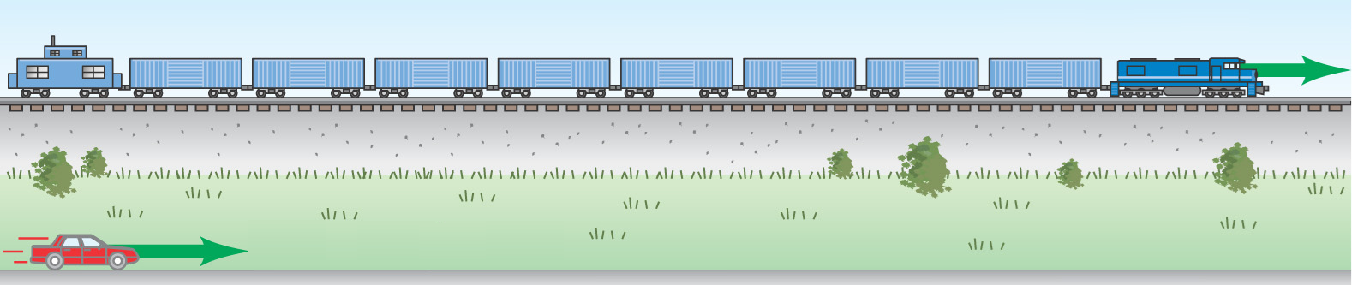

____17. What is the velocity of the car relative to the train?
a. 65 m/s eastward b. 5 m/s eastward c. 35 m/s eastward
d. 65 m/s westward e. 5 m/s westward f. 30 m/s eastward

____18. How long does it take the car to pass the train?
a. 2.3 s b. 4.3 s c. 5.0 s d. 30 s e. 300 s
B. Equations of Kinematics for constant acceleration are given below:
1. | 2. | 3. | 4. | 5.
$$x=\overline{v} t$$ | $$x=\frac{1}{2}\left(v_{0}+v\right)t$$ | $$v=v_{0}+at$$ | $$x=v_{0}t+\frac{1}{2}at^{2}$$ | $$v^{2}=v_{0}^{2}+2ax$$
1. Derive the 4th kinematic equation using the kinematic equations 2 & 3.

2. A car traveling at 18 m/s hits a bridge abutment. A passenger in the car moves forward a distance of 0.95 m, while being brought to rest by an inflated air bag. Determine the deceleration of the passenger?

3. A ball is shot vertically upward from the ground. It goes up and returns to the ground in 12 s. Ignore air resistance.
a. Determine the initial velocity of the ball?

b. What is the maximum height reached by the ball?

c. Plot the vertical displacement (y) versus t for the ball inside
the box.

1. | 2. | 3. | 4. | 5.
$$y=\overline{v_{y}} t \\ x=\overline{v_{x}} t$$ | $$y=\frac{1}{2}\left(v_{0y}+v_{y}\right)t$$ | $$v_{y}=v_{0y}+a_{y}t$$ | $$y=v_{0y}t+\frac{1}{2}a_{y}t^{2}$$ | $${v_{y}}^{2}=v_{0y}^{2}+2a_{y}y$$
C. A ball is thrown toward a wall at speed 25.0 m/s and at angle θ = 34.0⁰ above the horizontal as shown below. The wall is at a horizontal distance d = 32.0 m from the release point of the ball.
(a) Determine the horizontal and vertical components of the
initial velocity.
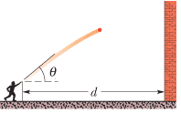

(b) How much time the ball takes to hit the wall?

(c) How far above the release point does the ball hit the wall?

(d) What are the (1) horizontal and (2) vertical components of its
velocity as it hits the wall?

(e) When it hits, has it passed the highest point on its trajectory? Explain your answer.

