PHYS 201 Equations Sheet Test #1 Chapters 1, 2, & 3.
1. Equations of kinematics:
1. | 2. | 3. | 4. | 5.
$$x=\overline{v} t$$ | $$x=\frac{1}{2}\left(v_{0}+v\right)t$$ | $$v=v_{0}+at$$ | $$x=v_{0}t+\frac{1}{2}at^{2}$$ | $$v^{2}=v_{0}^{2}+2ax$$
Acceleration due to gravity = g = 9.8 m/s², down
2. Conversion factors:
1 H = 3600 s, 1 Mile = 1608 m, 1 inch = 2.54 cm, 1 foot = 12 inch, 1 m = 3.281 ft.
1 m = 100 cm, 1 cm = 10 mm, 1 m = 1000 mm, 1 km = 1000 m
3. Areas:
Rectangle | Triangle | Circle

4. Pythagorean theorem and Trigonometry:
Pythagorean Theorem | sin θ | cos θ | tan θ | Components of a vector:
$$c^{2}=b^{2}+a^{2}$$ | $$Sin θ=\frac{opp}{hyp}=\frac{a}{c}$$ | $$Cos θ=\frac{adj}{hyp}=\frac{b}{c}$$ | $$Tan θ=\frac{opp}{adj}=\frac{a}{b}$$ | Adjacent component = Cos  Opposite component = Sin
5. Graphical analysis of motion:
Slope | Velocity | Acceleration | XXXXXXXXXXXXXXX
Area | XXXXXXXXXXXXX | Displacement | Change in Velocity
6. Addition of velocities: $\vec{V_{PG}}=\vec{V_{PT}}+\vec{V_{TG}}$

PHYS 201 Fall 2021 Test #1 Name:_________________________
A. Select the correct answer for the following multiple choice questions and write your answer in the line next to the question number.

____1. In 2019, the SI base unit mole was re-defined using this fundamental constant:

  - Planck constant.
  - Elementary charge.
  - Hyperfine transition frequency of the cesium 133 atom.
  - Boltzmann constant.
  - Speed of light in vacuum.
  - Avogadro constant.

____2. What is the SI base unit for temperature?
a. K b. ⁰F c. ⁰C d. ⁰K e. F f. C

____3. Which one of the following is a SI derived unit?
a. kg b. cm³ c. mol d. A e. cm/s f. m/s

____4. Which one of the following is a scalar?
a. displacement b. acceleration c. velocity d. weight e. distance

____5. What is the angle between the vectors A and -3A when they are drawn from a common origin?
a. 0⁰ b. 90⁰ c. 180⁰ d. 270⁰ e. 360⁰

____6. For the motion described in the graph,
decide whether the moving object is
a) accelerating
b) decelerating
c) moving at a constant velocity
d) moving at a constant speed
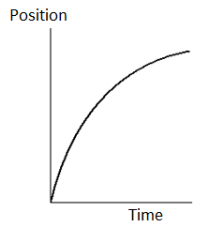
____7. Velocity is defined as,
____8. Acceleration is defined as,
Answers for 7 & 8
a. Rate at which the speed changes
b. Rate at which the velocity changes
c. Rate at which the distance changes
d. Rate at which the displacement changes

____9. Speeding tickets are issued using the,
a. average speed b. average velocity c. average acceleration
d. instantaneous speed e. instantaneous velocity f. instantaneous acceleration

____10. Which pair of the following physical quantities are zero at the highest point of the trajectory of a two-dimensional projectile motion?
a. horizontal velocity and vertical velocity
b. horizontal acceleration and vertical velocity
c. vertical acceleration and vertical velocity
d. horizontal velocity and horizontal acceleration

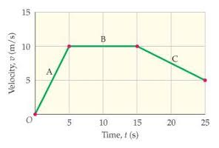

11-14) Deal with the one-dimensional motion of a race,
duration of 25 s, where the velocity is graphed as a function
of time, shown on the right.
____11. What is the instantaneous velocity of the runner at 5 s?
a. 5 m/s b. 10 m/s c. 7.5 m/s d. -7.5 m/s

____12. What is the instantaneous acceleration of the
runner at 20 s?
a. 0 m/s² b. 2.0 m/s² c. 0.5 m/s² d. -0.5 m/s² e. -2 m/s²
____13. What is the average acceleration for the race?
a. 0 m/s² b. 0.2 m/s² c. 0.5 m/s² d. 2.0 m/s² e. 5.0 m/s²
____14. How far is the race?
a. 25 m b. 50 m c. 100 m d. 200 m e. 250 m
____15. A ball (I) is rolled along the surface of a table and leaves the edge horizontally. At the same instant the ball I leaves the table, a second ball (II) is dropped from rest at the edge of the table. In the absence of air resistance, which ball will strike the ground first?
a. I b. II c. both at the same time
____16. In the above question which ball will have the lower speed at the ground level?
a. I b. II c. both will have the same speed
17-18) A car traveling at 85 km/h overtakes a 0.75 km long train traveling in the same direction on a track parallel to the road. The velocity of the train is 75 km/h, eastward.
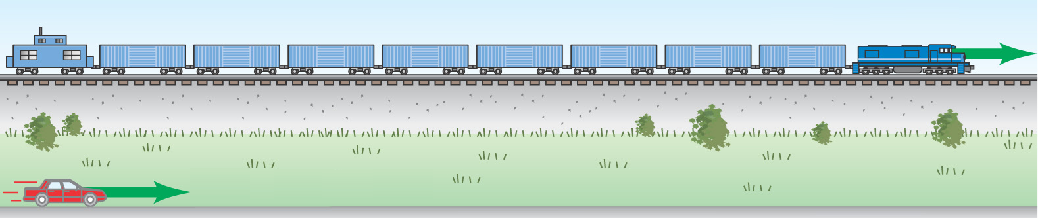

____17. What is the velocity of the car relative to the train?
a. 85 km/h eastward b. 75 km/h eastward c. 160 km/h westward
d. 160 km/h eastward e. 10 km/h westward f. 10 km/h eastward

____18. How long does it take the car to pass the train?
a. 0.53 min b. 0.75 min c. 3.3 min d. 4.5 min e. 5.4 min
B. Equations of Kinematics for constant acceleration are given below:
1. | 2. | 3. | 4. | 5.
$$x=\overline{v} t$$ | $$x=\frac{1}{2}\left(v_{0}+v\right)t$$ | $$v=v_{0}+at$$ | $$x=v_{0}t+\frac{1}{2}at^{2}$$ | $$v^{2}=v_{0}^{2}+2ax$$
1. Derive the following kinematic equation using the kinematic equations 2 & 3.
$x=vt-\frac{1}{2}at^{2}$

2. A stuntman sitting on a tree limb wishes to drop vertically onto a horse galloping under the tree. The initial speed of the horse is 10.0 m/s and the man is initially 3.00 m above the level of the saddle. Due to the rustling noise of the leaves, the moment the stuntman drops, the panicked horse accelerates at 4.0 m/s². The acceleration due to gravity = 9.8 m/s², down.
a. How long is the stuntman in the air?

b. What must be the horizontal distance between the saddle and the limb when the man makes his move, to accomplish the stunt?

1. | 2. | 3. | 4. | 5.
$$y=\overline{v_{y}} t \\ x=\overline{v_{x}} t$$ | $$y=\frac{1}{2}\left(v_{0y}+v_{y}\right)t$$ | $$v_{y}=v_{0y}+a_{y}t$$ | $$y=v_{0y}t+\frac{1}{2}a_{y}t^{2}$$ | $${v_{y}}^{2}=v_{0y}^{2}+2a_{y}y$$
C. During a fireworks display, a shell is shot into the air with an initial speed of 60.0 m/s at an angle of 65.0º above the horizontal, as illustrated in the figure. The fuse is timed to ignite the shell just as it reaches its highest point above the ground. Ignore air resistance. The acceleration due to gravity = 9.8 m/s², down.
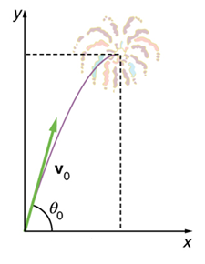
(a) Find the horizontal and vertical components of the
initial velocity, V_{ox} and V_{oy.}

(b) Calculate the height at which the shell explodes.

(c) How much time passed between the launch of the shell and the explosion?

(d) What is the horizontal displacement of the shell when it explodes?

