When you sit, Leave space between your neighbors.
No Phone or Internet Use during the Exam.
Use only a Calculator and a pen or pencil.
Tear this page and use it as your worksheet for MC questions. For the open ended questions/problems show your work in the space provided under the question/problem.

PHYS 201 Fall 2018 Test #1 Name:_________________________
A. Select the correct answer for the following multiple choice questions and write your answer in the line next to the question number. You can write on this exam.

____1. Today, the standard meter is defined as,
____2. Today, the standard kilogram is defined as,
Answers for 1 & 2
  - one ten-millionth of the distance from the north pole to the equator of the Earth.
  - the distance between two fine lines on a standard meter bar made of platinum-iridium.
  - the length traveled by light in vacuum during the time interval of 1/299792458 of a second.
  - 1 650 763.73 wavelengths of a particular orange-red light emitted by atoms of krypton-86 in a gas discharge tube.
  - the time taken by 9192631770 light oscillations of a particular wavelength emitted by a cesium-133 atom.
  - the standard bar made of platinum-iridium alloy
  - the standard cylinder made of platinum-iridium alloy

____3. What is the SI base unit for temperature?
a. ⁰K b. ⁰F c. ⁰C d. K

____4. Which one of the following is a SI derived unit?
a. kg b. cm³ c. mol d. A e. m³

____5. Which one of the following is not a SI base unit?
a. second b. ampere c. killogram d. killometer e. mole
____6. Imagine you measure the length of a stick 5 times and obtain the following measurements: 4.40 m, 4.43m, 4.47m, 4.39m, and 4.30m. The stick’s actual length is 4.41 m. How would you characterize the accuracy and precision of your measurements?
a. high accuracy, high precision b. high accuracy, low precision
c. low accuracy, high precision d. low accuracy, low precision
____7. The speed limit on a college campus is 15 MPH. Express this speed in kmPH.
(1 M = 1609 m = 1.609 km)
a. 6.7 kmPH b. 16 kmPH c. 24 kmPH d. 34 kmPH
____8. Which one of the following is a scalar?
a. distance b. acceleration c. velocity d. weight e. displacement

____9. What is the angle between the vectors A and -3A when they are drawn from a common origin?
a. 0⁰ b. 90⁰ c. 180⁰ d. 270⁰ e. 360⁰
____10. A ball (I) is rolled along the surface of a table and leaves the edge horizontally. At the same instant the ball I leaves the table, a second ball (II) is dropped from rest at the edge of the table. In the absence of air resistance, which ball will strike the ground first?
a. I b. II c. both at the same time
____11. In the above question which ball will have the greater speed at the ground level?
a. I b. II c. both will have the same speed
____12. Speeding tickets are issued using which one of the following?
a. Average velocity b. Instantaneous velocity
c. Average speed d. Instantaneous speed
____13. Three vectors A, B, and C are shown below in each of the diagrams. Which one represents the relationship: A + B + C = 0 ?
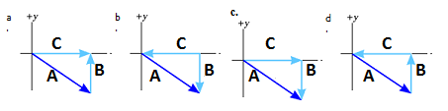
14-15) A car traveling at 85 km/h overtakes a 0.75 km long train traveling in the same direction on a track parallel to the road. The velocity of the train is 75 km/h, eastward.
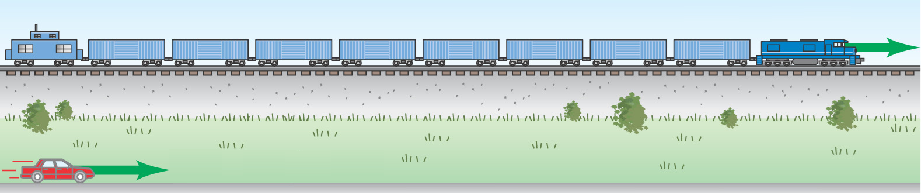

____14. What is the velocity of the car relative to the train?
a. 85 km/h eastward b. 75 km/h eastward c. 160 km/h westward
d. 160 km/h eastward e. 10 km/h westward f. 10 km/h eastward
____15. How long does it take the car to pass the train?
a. 0.53 min b. 0.75 min c. 3.3 min d. 4.5 min e. 5.4 min

____16. For the motion described in the graph,
decide whether the moving object is
a) accelerating
b) decelerating
c) moving at a constant velocity
d) moving at a constant speed
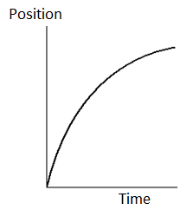
.
____17. Velocity is defined as,
____18. Acceleration is defined as,
Answers for 17 & 18
a. Rate at which the speed changes
b. Rate at which the velocity changes
c. Rate at which the distance changes
d. Rate at which the displacement changes
19-24) Deal with the one-dimensional motion of a race, duration of 25 s, where the velocity is graphed as a function of time, below.
___19. The name of the graph is,
a. time versus velocity b. velocity versus time

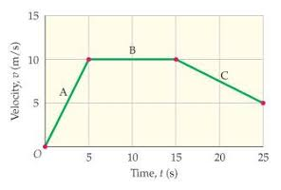
____20. What is the instantaneous acceleration of the
runner at 3 s?
a. -2 m/s² b. 2.0 m/s² c. 0.5 m/s² d. -0.5 m/s²
____21. What is the instantaneous velocity of the runner
at 20 s?
a. 5 m/s b. 10 m/s c. 7.5 m/s d. -7.5 m/s
____22. What is the instantaneous acceleration of the
runner at 20 s?
a. 0 m/s² b. 2.0 m/s² c. 0.5 m/s² d. -0.5 m/s² e. -2 m/s²
____23. What is the average acceleration for the race?
a. 0 m/s² b. 0.2 m/s² c. 0.5 m/s² d. 2.0 m/s² e. 5.0 m/s²
____24. How long is the race?
a. 25 m b. 50 m c. 100 m d. 200 m e. 250 m

____25. The figure below illustrates the concept of satellite launch where the trajectories for increasing launch speeds are shown.
Which path is that of a satellite?
a. A b. B c. C d. D e. E
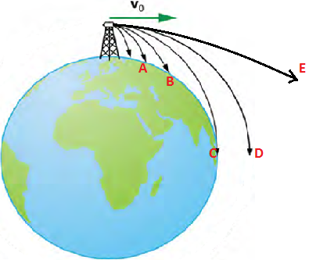

______________________________end of MC questions___________________

B. For the three vectors shown below (magnitudes: A = 14, B = 18, C = 15) complete the table:
Vector | X-component | Y-component
A
B
C
D
A + B + C+D
Also show the vector A+B+C+D in the diagram.

C. Equations of Kinematics for constant acceleration are given below:
1. | 2. | 3. | 4. | 5.
$$x=\overline{v} t$$ | $$x=\frac{1}{2}\left(v_{0}+v\right)t$$ | $$v=v_{0}+at$$ | $$x=v_{0}t+\frac{1}{2}at^{2}$$ | $$v^{2}=v_{0}^{2}+2ax$$
1. Derive the 5th equations using the equations 2 & 3.

2. A jet plane lands with a speed of 100 m/s and can decelerate at a maximum rate of 5.00 m/s² as it comes to rest.
a) From the instant the plane touches the runway, what is the minimum time needed before it can come to rest?

b) What is the length of the minimum runway necessary for landing?

c) Can this plane land on a small tropical island airport where the runway is only 0.800 km long?

1. | 2. | 3. | 4. | 5.
$$y=\overline{v_{y}} t \\ x=\overline{v_{x}} t$$ | $$y=\frac{1}{2}\left(v_{0y}+v_{y}\right)t$$ | $$v_{y}=v_{0y}+a_{y}t$$ | $$y=v_{0y}t+\frac{1}{2}a_{y}t^{2}$$ | $${v_{y}}^{2}=v_{0y}^{2}+2a_{y}y$$
D. A basketball free-throw is shot with an initial velocity 15.0 m/s at a launch angle of 38.0⁰. The hoop’s vertical height from the launch point, y = 3.20 m. Ignore air resistance. The acceleration due to gravity = 9.8 m/s², down.
1. Sketch the trajectory of the ball in the figure.
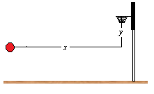
2. Find the horizontal and vertical components of the
initial velocity, V_{ox} and V_{oy.}

3. What is the vertical velocity of the basketball at the hoop?

4. What is the hang time of this shot?

5. What is the hoop’s horizontal distance from launch point, x = ?

6. How much time it takes to reach the highest point of the trajectory?

