When you sit, Leave space between your neighbors.
No Phone or Internet Use during the Exam.
Use only a Calculator and a pen or pencil.
Tear this page and use it as your worksheet for MC questions. For the open ended questions/problems show your work in the space provided under the question/problem.

PHYS 201 Fall 2017 Test #1 Name:_________________________
A. Select the correct answer for the following multiple choice questions and write your answer in the line next to the question number.
____1. Today, the standard meter is defined as,
  - one ten-millionth of the distance from the north pole to the equator of the Earth.
  - the distance between two fine lines on a standard meter bar made of platinum-iridium.
  - the length traveled by light in vacuum during the time interval of 1/299792458 of a second.
  - 1 650 763.73 wavelengths of a particular orange-red light emitted by atoms of krypton-86 in a gas discharge tube.
  - the standard bar made of platinum-iridium alloy
  - the standard cylinder made of platinum-iridium alloy

____2. Today, the standard second is defined using the__________atomic clock.
a. Irridium b. Rubidium c. Cesium d. Platinum e. Radium f. Quartz
____3. Speeding tickets are issued using the,
a. average speed b. average velocity c. average acceleration
d. instantaneous speed e. instantaneous velocity f. instantaneous acceleration
____4. What is the SI base unit for mass?
a. g b. mg c. m d. km e. kg
____5. The slope of the position versus time graph gives,
a. time b. displacement c. acceleration d. position e. velocity
____6. For the motion described in the graph,
decide whether the moving object is
a) accelerating
b) decelerating or
c) moving at a constant velocity.
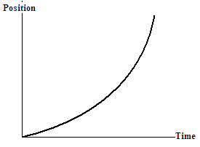

____7. The figure below shows three paths for a football kicked from ground level. Ignoring the effects of air, rank the paths, according to initial horizontal velocity component, greatest first.
- 1>2>3
- 2>3>1
- 3>2>1
- All tie (1=2=3)
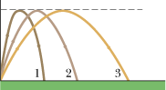
___8. For the motion shown, determine the velocity at 12 s.
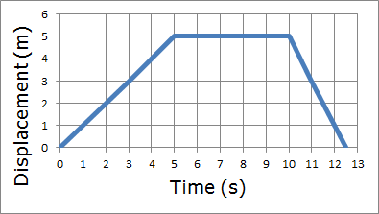
- 0 m/s
- 1 m/s
- -1 m/s
- 2 m/s
- -2 m/s

____9. Which pair of the following physical quantities are zero at the highest point of the trajectory of a two dimensional projectile motion?
a. horizontal velocity and vertical velocity
b. horizontal acceleration and vertical velocity
c. vertical acceleration and vertical velocity
d. horizontal velocity and horizontal acceleration
_____10. A plane is diving as shown below with a velocity of 120 m/s at an angle of 15⁰ below horizontal. What is the vertical component of the plane’s velocity?
a. 31 m/s, up
b. 31 m/s, down
c. 116 m/s, up
d. 116 m/s, down
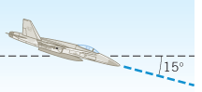
____11. Bryan Allen pedaled a human-powered aircraft across the English Channel from the cliffs of Dover to Cap Gris-Nez on June 12, 1979. He flew for 169 min at an average velocity of 3.53 m/s in a direction 45° south of east. What was his total displacement?
- 35.8 km, 45° S of E
- 350.8 km, 45° S of E
- 35.8 km, 60° S of E
- 350.8 km, 60° S of E
- 597 m, 45° S of E
___12. A tree is 6 feet 5 inches tall. Express this height in meter.
(1 m = 3.281 ft and 1 ft = 12 inch)
a. 2.16 m b. 1.83 m c. 1.96 m d. 1.98 m e. 21 m
____13. Which one of the following is a scalar?
a. velocity b. displacement c. acceleration d. mass e. weight
____14. Which one of the following is a vector?
a. speed b. distance c. temperature d. pressure e. force
____15. What is the angle between the resultant and equilibrant of a vector?
a. 0⁰ b. 90⁰ c. 180⁰ d. 270⁰ e. 360⁰
____16. In which of the following equations the units on the left side is not consistent with the units on the right side? (t = time, x = displacement, v = velocity, a = acceleration)
a. b. v = 3ax c. d. x = vt e. v = at
17-18) A swimmer, capable of swimming at a speed of 3.0 m/s in still water, starts to swim directly across a 2.7-km-wide river. However, the current is 2.0 m/s due east, and it carries the swimmer downstream.
____17. How far downstream will the swimmer be upon reaching the other side of the river?
a. 1.1 km b. 1.8 km c. 2.7 km d. 3.2 km e. 4.5 km
____18. Instead of reaching downstream, the swimmer wants to get to the spot exactly opposite of the starting place. At what angle, west of north, the swimmer needs to swim to accomplish this?
a. 42⁰ b. 34⁰ c. 48⁰ d. 56⁰ e. 90⁰
__________________________________________________End of MC questions___________
B. A helicopter is lifting off from the ground and is moving vertically upward. The graph shows its vertical velocity v_{y} versus time.
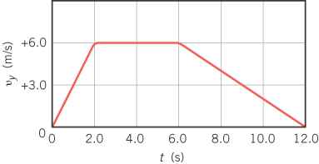
1. What is the instantaneous vertical acceleration of the helicopter at 8.0 s?

2. How high is the helicopter after 12.0 s have elapsed?
C. Equations of Kinematics for constant acceleration are given below:
1. | 2. | 3. | 4. | 5.
$$x=\overline{v} t$$ | $$x=\frac{1}{2}\left(v_{0}+v\right)t$$ | $$v=v_{0}+at$$ | $$x=v_{0}t+\frac{1}{2}at^{2}$$ | $$v^{2}=v_{0}^{2}+2ax$$
1. Derive the 5th equation using the equations 2 & 3.

2. The brakes on your automobile are capable of creating a deceleration of 4.5 m/s². If you are going 39 m/s and suddenly see a state trooper,
a. what is the minimum time in which you can get your car under the 25 m/s speed limit?
b. How far you travel during this time?

3. A speeding motorist travelling at 45 m/s passes a stopped police car. At the moment the car passes, the police car starts from rest and accelerates at a constant rate to pursue the motorist. The speeding motorist continues with the constant speed until caught by the police car 15 s later. Determine the acceleration of the police car.

Equations of Kinematics for constant acceleration are given below: g = 9.8 m/s², down.
1. | 2. | 3. | 4. | 5.
$$x=\overline{v} t$$ | $$x=\frac{1}{2}\left(v_{0}+v\right)t$$ | $$v=v_{0}+at$$ | $$x=v_{0}t+\frac{1}{2}at^{2}$$ | $$v^{2}=v_{0}^{2}+2ax$$

D. A basketball is shot with an initial velocity of 8.0 m/s and launch angle of 40⁰, which follows the trajectory shown. The ball enters the basket 0.92 s after it is launched.
1. What are the horizontal and vertical components of the initial velocity?
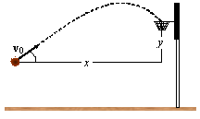

2. What are the distances x and y?

3. How much time it takes to reach the highest point of the trajectory?

E. For the three vectors shown below (magnitudes: A = 14, B = 18, C = 15) complete the table:
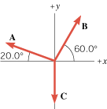 | Vector +X component +Y component  B = 18  A = 14  C = 15  B + A + C

