When you sit, Leave space between your neighbors
No Phone and Internet Use during the Exam
Use only a Calculator and a pen or pencil
Tear this page and use it as your worksheet

PHYS 201-002 Test #1 Name:_________________________
A. Select the correct answer for the following multiple choice questions and write your answer in the line next to the question number.
____1. In 2019, the SI base unit kelvin is re-defined using these fundamental constants:
  - Planck constant, Avogadro constant, and the elementary charge.
  - Planck constant, elementary charge, and speed of light in vacuum.
  - Planck constant, hyperfine transition frequency of the cesium 133 atom, and speed of light in vacuum.
  - Planck constant, Boltzmann constant, and the hyperfine transition frequency of the cesium 133 atom.
  - Planck constant, Boltzmann constant, and speed of light in vacuum.

____2. What is the SI base unit for temperature?
a. ⁰K b. ⁰F c. ⁰C d. K
____3. Which one of the following is a SI derived unit?
a. kg b. m/s c. mol d. A e. s
____4. Speeding tickets are issued using the,
a. average speed b. average velocity c. average acceleration
d. instantaneous speed e. instantaneous velocity f. instantaneous acceleration
____5. The slope of the position versus time graph gives,
a. time b. displacement c. acceleration d. position e. velocity
____6. For the motion described in the graph,
decide whether the moving object is
a) accelerating
b) decelerating
c) moving at a constant speed
d) moving at a constant velocity
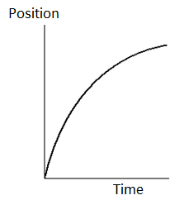

7-8) The figure below shows three paths for a football kicked from ground level. Ignore the effects of air.
___7. Rank the paths, according to initial horizontal velocity component, greatest first.
___8. Rank the paths, according to initial vertical velocity component, greatest first.
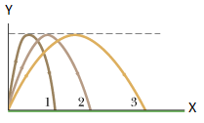
Answers for 7 and 8:
- 1>2>3
- 2>3>1
- 3>2>1
- All tie (1=2=3)

____9. A person looking out the window of a stationary train notices that raindrops are falling vertically down at a speed of relative to the ground. When the train moves to the right at a constant velocity, the raindrops make an angle of
when they move past the window, as the drawing shows.
How fast is the train moving?
(Use relative velocity principles)
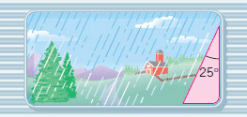
a. 2.1 m/s b. 2.3 m/s c. 4.5 m/s d. 5.0 m/s
____10. What is the angle between the vectors A and 2A
when they are drawn from a common origin?
a. 0⁰ b. 90⁰ c. 180⁰ d. 270⁰ e. 360⁰
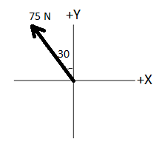
____11. What is the +X component of the force 75N shown in the diagram,
which is in the 2nd quadrant and makes 30⁰ with the +Y axis?
a. 37.5 N b. 65 N c. -37.5 N
d. -65 N e. 75N f. -75 N
____12. Which one of the following is a scalar?
a. velocity b. displacement c. acceleration
d. weight e. time interval
____13. Which one of the following is a vector?
a. speed b. distance c. acceleration
d. temperature e. pressure

____14. Imagine you measure the length of a stick 5 times and obtain the following measurements: 4.40 m, 4.43m, 4.47m, 4.39m, and 4.30m. The stick’s actual length is 5.80 m. How would you characterize the accuracy and precision of your measurements?
a. high accuracy, high precision b. high accuracy, low precision
c. low accuracy, high precision d. low accuracy, low precision
____15. The speed limit on a college campus is 25 MPH. When a student drives her car at the speed limit, how far she will go in two seconds? (1 M = 1609 m and 1 H = 3600 s)
a. 11 m b. 22 m c. 25 m d. 50 m e. 56 m
____16. A tree is 6 feet 5 inches tall. Express this height in cm.
(1 inch = 2.54 cm and 1 ft = 12 inch)
a. 216 cm b. 183 cm c. 196 cm d. 198 cm e. 210 cm
____17. In the revised SI, the Planck constant h is equal to exactly 6.626 070 15 × 10⁻³⁴ J.s. Express it with only 5 significant figures:
a. 6.626 × 10⁻³⁴ b. 6.62607 × 10⁻³⁴ c. 6.6260 × 10⁻³⁴ d. 6.6261 × 10⁻³⁴
B. Equations of Kinematics for constant acceleration are given below:
1. | 2. | 3. | 4. | 5.
$$x=\overline{v} t$$ | $$x=\frac{1}{2}\left(v_{0}+v\right)t$$ | $$v=v_{0}+at$$ | $$x=v_{0}t+\frac{1}{2}at^{2}$$ | $$v^{2}=v_{0}^{2}+2ax$$
1. Derive the 4th equation using the equations 2 & 3.

2. A car traveling at 18 m/s hits a bridge abutment. A passenger in the car moves forwards a distance of 0.95 m while being brought to rest by an inflated air bag. Determine the deceleration of the passenger?

3. A ball is shot vertically upward from the surface of another planet. A plot of y versus t for the ball is shown below, where y is the height of the ball above its starting point and t = 0 at the instant the ball is shot.
a. What is the highest height reached by the ball? ___________
b. How long it took to reach the highest point?_____________
c. Determine the initial velocity of the ball? [Use kinematic equations]
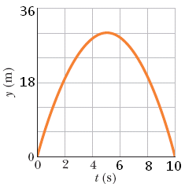

d. Determine the free-fall acceleration on the planet?
[Use kinematic equations]

Equations of Kinematics for constant acceleration are given below: g = 9.8 m/s², down.
1. | 2. | 3. | 4. | 5.
$$x=\overline{v} t$$ | $$x=\frac{1}{2}\left(v_{0}+v\right)t$$ | $$v=v_{0}+at$$ | $$x=v_{0}t+\frac{1}{2}at^{2}$$ | $$v^{2}=v_{0}^{2}+2ax$$
C. You throw a ball toward a wall at speed 25.0 m/s and at angle θ = 34.0⁰ above the horizontal as shown below. The wall is distance d = 42.0 m from the release point of the ball.
(a) Determine the horizontal and vertical components of the
initial velocity.
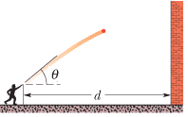

(b) How much time the ball takes to hit the wall?
(c) How far above the release point does the ball hit the wall?

(d) What are the (1) horizontal and (2) vertical components of its velocity as it hits the wall?

(e) When it hits, has it passed the highest point on its trajectory? Explain your answer.

