PHYS 101 Graphing Motion: Questions/Problems Name:___________________________

____1. What does a car speedometer measure?
____2. What does a car odometer measure?
Answers for 1&2
a. average velocity b. average speed c. distance
d. instantaneous speed e. instantaneous velocity f. displacement

____3. Which one of the following is a vector?
a. speed b. distance c. temperature d. mass e. velocity

____4. What is given by the slope of the velocity versus time graph?
____5. What is represented by the area under the velocity versus time graph?
Answers for 11 & 12
a. time b. displacement c. acceleration d. speed e. velocity
6-11) The velocity of a snowmobile increases with time as shown below.
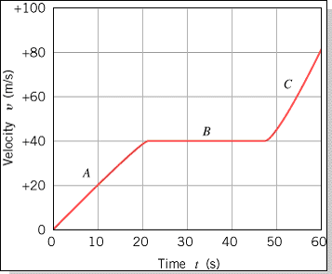
____6. What is the instantaneous velocity of the snowmobile at 10 s?
a. 0 m/s b. 10 m/s c. 20 m/s d. 30 m/s e. 40 m/s

____7. The snowmobile accelerates during which segment(s)?
a. A & B b. B & C c. A,B,&C d. A & C e. B

____8. What is the average acceleration between 0 and 20 seconds?
____9. What is the average acceleration between 0 and 60 seconds?
___10. What is the instantaneous acceleration at 30 second?
Answers for 8-10
a. 0 m/s² b. 1.0 m/s² c. 1.3 m/s² d. 1.5 m/s² e. 2.0 m/s²

____11. Estimate how far the snowmobile travels during the 60 seconds?
a. 11 m b. 100 m c. 200 m d. 1100 m e. 2200 m

