PHYS 101 Problems in Rotational Motion
1. An automobile engine is described as operating at 5000 rpm, meaning its crankshaft completes 5000 revolutions per minute. Express this angular velocity in radians per second.

2. Starting from rest, the tub of a washing machine reaches an angular speed of 6 rad/s, with an average angular acceleration of 4 rad/s².
a. How long does it take the spin cycle to come up to speed?
b. How far it turns during this time?
3. A torque of 30 N m is applied to a disk that has a moment of inertia of 5.0 kg m². What is the resulting angular acceleration of the disk?

4. Refer to the wheel system shown below. Its axis is at the center, perpendicular to the page. Assume F1 = 40-N, F2 = 60-N, inner radius = 50 cm, and outer radius = 110 cm. 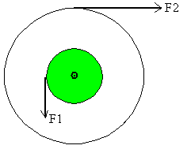
a. What is the torque exerted by F1?
b. What is the torque exerted by F2?
c. What is the net torque acting on the wheel system?
5. Two boys are in a see-saw which is pivoted at its center of gravity, as shown below. What must be the length, L in order for the see-saw to be horizontally flat?
