PHYS 101H Free Body Diagrams
1. A skier is coasting down a 25° slope, at a constant velocity as shown below.
Draw a free-body diagram for the skier, naming all the forces.

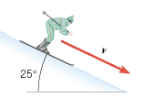

2. A car is turning along an un-banked curve with friction. Draw a free-body diagram for the car, naming all the forces. Identify the centripetal force.
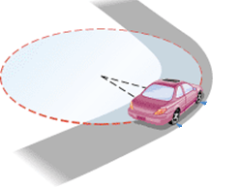

3. A car is turning along a banked-frictionless exit ramp. Draw a free-body diagram for the car, naming all the forces. Identify the centripetal force.
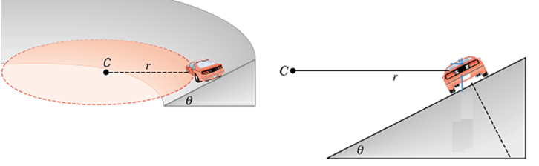

4. A car of mass, m is traveling at a constant speed as shown below. First on a flat road, then along a dip, and then on a hill. Draw free-body diagrams for each of the following three cases.
