II. A helicopter is lifting off from the ground and is moving vertically upward. The graph shows its vertical velocity v_{y} versus time.
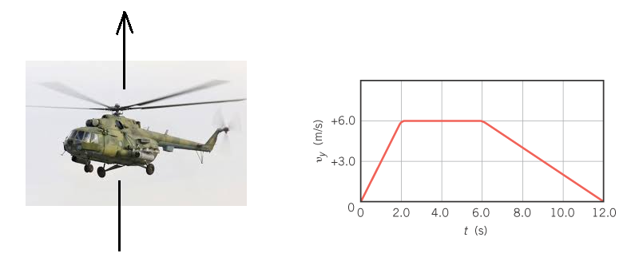
1. What is the instantaneous vertical acceleration of the helicopter at 8.0 s?

2. How high is the helicopter after 12.0 s have elapsed?

III. The force applied to a tennis ball (mass = 0.065 kg) during a serve is shown below as a function of time.
- Determine the impulse applied to the ball.
- What is the magnitude of the velocity after the serve?
