1. The boy is trying to lift the crate which has a weight of 300 N as shown in the diagram. What is the minimum pull he needs to exert to lift the crate?

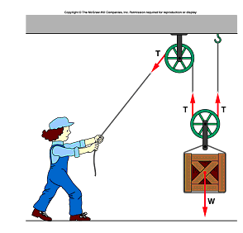

____2. A pendulum is swinging in an arc.   
At the top of the arc it has,  
a. Gravitational potential energy

b. Elastic potential energy

c. Translational Kinetic energy  
d. Rotational Kinetic energy

Newton’s Law of Universal Gravitation is given by:   
  
____3. Express the SI unit of G.  
a. N.kg/m2 b. N.m2/kg2 c. N.m/kg2 d. N.kg2/m2 e. N/kg2 f. N.m/kg



_____4. According to the Law of Universal Gravitation, when the distance between the centers of two objects is doubled and the masses remain constant the force between the objects is multiplied by a factor of: a. 1 b. 2 c. 4 d. ¼ e. ½

_____5. According to the Law of Universal Gravitation, when the distance between the centers of two objects is doubled and each of the masses also doubled, the force between the objects is multiplied by a factor of: a. 1 b. 2 c. 4 d. ¼ e. ½

6. The roller coaster of total mass 75-kg, shown below starts from rest at the 100 m height. What is the velocity at the 75 m height, if it loses 8500-J of energy due to friction?

|  |
| --- |
|  |